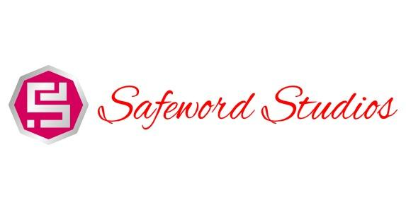
DESIGN DOCUMENT:
Delivery Wars:
Making the Cut

Created by: Michael Johnson, Jeremy Lanman, Farrah Johnson, Andrew Kurtz, Kyle Kolash
Last modified:5/9/16

Table of Contents
DESIGN DOCUMENT:
Table of Contents
Design History
Version 1.00
Version 1.10
Version 1.20
Version 1.30
Version 1.40
Game Overview
Where does the game take place?
What is the story?
What is the main focus?
How many characters/units/pieces does the player control?
Game Theory
Mechanics
Feature Set
General Features
Game Components
Rules & Mechanics
Game Setup
Turn Sequence
General Rules
Detailed Rules for Specific Pieces
Troll cards
Power-Ups
Resources
General:
Specific:
The Lists
Flowcharts
End Game Conditions
Rules Questions & Strategies
What is the Primary means of completing the game?
Describe an alternate means of attaining a winning condition?
How can trading be used to your advantage?
How does Busted work?
How does Herobrine work?
What is a list token?
How does User’s Demand work?
How Troll card effects work?
List cards
Resource cards

Design History
The Design History of our game entails some of the hindsight that we, as a team and as developers, have discovered with our game. The original concept involved actual delivery companies, such as UPS and Gamefly, making deliveries in a race. Victory included delivering all of their packages and fighting wacky battles against other players, this idea, ultimately, was not scrapped but hugely expanded and altered. The expansion allowed the game to become more robust and allow for multiple opportunities for trading and sabotaging other players. The following versions include the necessary changes. The changes were made due to feedback from designers, playtests, design issues, and general necessity.

Version 1.00
Version 1.00 includes some tuning and tweaking after making the initial pass at the design. Here is what was changed.

- Constructed game story idea, with the intention of making a game that incorporates game making mechanics, corporate ladders, and humor.
- Constructed a resource system so that players will gain resources on a list in order to impress the Producer. Resources are located at departments and will be represented with a card.
- Added Power-Up and Troll (buff and debuff) cards that will be used as our combat system, in the place of a traditional damage system.
- Added five departments as playable, names TDB.
- Decided on 8-bit style of art.
- Movement is now static instead of having to roll or draw for how many movement spaces per turn.

Version 1.10
Version 1.10 includes some tuning and tweaking after making the initial pass at the design. Here is what was changed.

- Fleshed out the game map. The map now consists of multiple departments that contain the resources the player will need to gather. The central location is the starting point.
- Added a trading system. Players can now trade as the final part of their turn (i.e. after movement and picking up a resource). The player knows what they are trading, but does not know what the other player is trading. The players can only trade resources.
- Power-Up/Troll cards are now instant. They must be applied during the turn they were drawn.
- Power-Up/Troll cards are now targetable. The player picks up the card, and regardless of whether or not it is a Power-Up or a Troll card, they may choose whom the buff/debuff effects.
- Massively overhauled the mechanics of the game including collection of resources, movement specifics, and the strength of Power-Up/Troll cards.
- Added a “critical chance” aspect to the resource gathering. Upon obtaining resources, a die can be rolled which, if it meets the criteria, the player will obtain an extra resource that can be used on their list or in a trade.
- Added a second round so that each player would need to complete two lists in order to win.

Version 1.20
Version 1.20 includes some tuning and tweaking as we worked through the flow chart and got things ready to turn in. Here is what was changed.

- Made some adjustments to card wording.
- Created the Setup Flowchart.
- Began work on main game Flowchart.
- Completed Nerd Rage concept art.
- Completed Flooded Board concept art.
- Completed Brain Freeze concept art.
- Added 2 Trolls Cards and updated existing Troll and Power-Up cards.

Version 1.30
Version 1.30 includes some tuning and tweaking as we worked through the flow chart made decisions on art styles, and card designs. Here is what was changed.

- Completed final version of the story.
- Added in the Dimensions map.
- Finished up the flow charts as well as made some changes.
- Added in things to be discussed at meeting tonight.
- Completed game overview, updated it with story.
- Completed game features and modified a few conditions.
- Modified the general rules. Found some inconsistencies.
- Completed Can I haz Yur Stuff? Concept art.
- Completed Tied Up concept art.
- Completed User’s Demand concept art.
- Completed False Tile concept art.
- Completed the end game conditions.
- Added Department “Racial” abilities.
- Completed Busted concept art.
- Completed Bad Bytes concept art.
- Completed Documents concept.
- Completed Trollitis concept.
- Completed Energy Drink concept.
- Completed Industrial Shredder concept.
- Completed User’s Demand concept.
- Completed Word Processor concept.
- Created lists that the players will need to complete.

Version 1.40
Version 1.40 includes some final tuning and tweaking as we prepare this version for turn in.

- Updated the Table of Contents to reflect all the changes made to it.
- Added in Resource cards for Specific and General.
- Created an example card for Power-Up, Troll, and Resource cards.
- Completed concept for Beta Test.
- Completed concept for Equipment Upgrade.
- Completed concept for Herobrine.
- Completed concept Keyboard Warrior.
- Completed concept for Medic!
- Completed concept for Pass the Buck.
- Completed concept for Producer’s Wisdom.
- Completed concept for Speedrun.
- Clarified the deck concept for Troll and Power-Up cards in the Setup portion.
- Fixed miscellaneous map errors.
- Altered IT and HR buildings. They no longer give resources and instead serve as the Troll card buildings. Which can possibly mess with a player’s optimum route. This was mainly to solve a math issue with Troll/Power-Up cards.

Version 1.50
Version 1.50 includes some final tuning and tweaking as we prepare this version for turn in.
- Added concept for Bug Software
- Added concept for Computer image
- Added concept for Game Engine
- Added concept for I.P
- Added concept for Snacks image

Version 1.60
Version 1.60 includes some final tuning and tweaking as we prepare this version for turn in.
- Added concept for Muse
- Added concept for Photoshop
- Added concept for QA Tester
- Added concept for Schedule
- Added concept for Scripts
- Added concept for Trends

Version 1.70
Version 1.70 includes some final tuning and tweaking as we prepare this version for turn in.
- Added revisions to grammar and sentence structure
- Clarified the differences between interns in the story
- Clarified the player objective in the story
- Clarified Power-Up and Troll cards in the mechanics and general features section
- Changed the outline of the map to include card draw spots to add variety to gameplay and more strategic value
- Modified the card ratios to add more balance and strategy
- Clarified and modified the trade mechanic to make it more robust and valuable
- Clarified some general rules

Game Overview

Where does the game take place?
The game takes place inside of Take a Byte Studios, a small but on-the-rise game studio looking to make its mark on the industry. The studio is looking to fill an open position internally!

What is the story?
In a world ravaged by war, poverty, and greed, one company stood alone in the darkness. One company was a beacon for hope and change. One company realized it couldn’t do anything about the destruction, and decided to make video games instead. This is that company. Welcome to Take a Byte Studios, nerd. You are but a puny intern, clawing their way up the ladder. But hark, what light through yonder window breaks? An opening! The almighty Producer has just announced a job opening in the studio and one lucky intern shall become the next poorly paid employee. As an intern, your objective is to kiss as many behinds as you can to win favor with your department and gain glorious attention from the producer by completing a list of arbitrary tasks. With five different interns in five different departments battling for the position, will you be able to use your useless skills to impress the Producer?

Marketing “Marty” Intern: As a marketing intern, your skill lies with your ability to swoon investors. The truth is a bad baby and must sit in timeout. You live your intern life following the Five D’s of telling the truth: Dodge, Dive, Dip, Duck and Dodge. As the silver tongued devil you are, you must schmooze your way through your list in order to impress the Producer. Marty has an in with the marketing department and starts the game with some of their required marketing resources and has a higher chance to gain more marketing resources via criticals.

Quality Assurance “Queen” Intern: “As a quality assurance intern, your job is to assure the quality of your internship. As a QA intern, you must say many sentences. Good sentences. Great, even. All your sentences must have words. Some are big words, some small, but all your sentences will have words in them. And you’re for that, by the way. They’re good words. You’ve worked with them before. But in the end, as an intern, your sentences still must contain words.” Doonald Frump. Queen has an in with the quality assurance department and starts the game with some of their required quality assurance resources and has a higher chance to gain more quality assurance resources via criticals.

Art “Arty” Intern: Art interns may not be the smartest of the interns, but they know how to say bizarre enough words to make them look smart. Most may call you “quirky” as a polite way of saying, “dude, you’re straight weird.” The good news is that, despite your peculiarity, you know how to sacrifice for your work. Everything from your time, your relationships, your money, and even the blood of your first born. Arty has an in with the art department and starts the game with some of their required art resources and has a higher chance to gain more art resources via criticals.

Programmer “Dexter” Intern: Congratulations! You are the smartest person in the room! Unfortunately, you’re also the most socially awkward. Hours and hours spent behind your computer screen have expanded your mind, increased your brain function, and weakened your frail little nerd body. But never fear! As a programming intern, you will still have to complete your deliveries despite your crippling social anxiety. Have fun! Dexter has an in with the programming department and starts the game with some of their required programming resources and has a higher chance to gain more programming resources via criticals.

Design “Destiny” Intern: As a design intern, you have an extremely short attention span. You don’t like mustard on your sandwich because it makes the aliens have longer lifespans than humans. The good news is that you are a jack of all trades. You have to be peculiar like an art intern and smart like a programmer, without being too artsy or too smartsy. You hope to have a leg up on your peers, but you soon realize that the Producer doesn’t actually know your name. Get out there and impress the Producer! Destiny has an in with the design department and starts the game with some of their required design department resources and has a higher chance to gain more design department resources via criticals.

What is the main focus?
The main focus of the game is for the interns to outperform one another in order to have the chance at impressing the producer enough to gain employment at the Take a Byte Studios. Each intern must learn to navigate the turbulent environment of a functioning studio, and assimilate themselves into the normal work flow. This is done by completing Lists that are drawn from the stack that have been created by the Producer. By being the first to finish two of the Producer’s Lists, you are declared an official employee of Take a Byte Studios.

How many characters/units/pieces does the player control?
The player will control one game token that represents their Intern. The player will attain cards that depict resources and have the opportunity to collect other cards from the map or other players that may either be helpful or negative to their current task. Lastly they will interact with a die, 10 sided percentile, to determine if the player can critically collect resources or not.

5Game Theory
Symmetry – Delivery Wars: Making the Cut would be classified as an asymmetric game because each intern will have a different list of resources that needs to be collected. Each intern also has a different starting position to show another asymmetric element.

Play Style –The play style that is in Delivery Wars: Making the Cut would be competitive. This is due to each player trying to complete his or her list of resources needed before the other. There are two more competitive elements displayed; when a player can cause chaos to another via Troll cards or win via the ability to trade with other players. Trading allows for moment to moment informal alliances and players may freely choose to cooperate there is, however, only one winner.

Summation –Delivery Wars: Making the Cut would be classified as a non-zero-sum game. This would be because of the competitiveness of the resource collecting and use of Power-Up/Troll cards. The trading mechanic in the game is a non-zero-sum element because each player will receive a resource in return as a result. Whether or not it will be useful will not be immediately determined because each trade is anonymous.

Perfect/Imperfect Information –There are both perfect and imperfect information apparent in Delivery Wars: Making the Cut. Each player can see the other player’s intern game piece and can make a guess at which direction they are headed. All the Power-Up/Troll cards in the game make for imperfect information because each player does not know what the card consists of until drawn. The main goal of the game, which is each intern’s list of resources, is also imperfect information. This is due to the fact that each player must keep their list concealed from other eyes, after all an intern wants to finish their list first in order to get the job.

Mechanics
- Movement - All interns are allotted 5 spaces (in cardinal directions, no diagonals) they can move per turn unless otherwise affected by another feature of the game such as a debuff card or over-encumbered status effect. This is a meaningful choice because the player can choose where they want to go if it is within the allowed amount of spaces that can be used per turn.

- Initiative- This mechanic gives the intern the ability to draw an extra card, at a chance for it to be a buff or debuff. These spots are located in front of the departments and have to be interacted with in order to obtain the resources required to complete the tasks assigned to you by the producer. This is a meaningful choice because you have to decide to take the risk associated with activating the event that follows interaction.

- Power-Up/Troll - This is handled by players drawing and utilizing cards that can power-up or troll other players. The abilities generated by these cards are active from the moment you draw it. You decide who it hits, and this can create situations where strategy can be applied. Though the drawing is random, players can only use them on the turn they are drawn. Players simply draw cards from the top of the pile. That choice makes it meaningful to the player drawing the card who is targeted.

- Trading (Cards)- The trading is made face-down therefore players are only aware of what they are trading away and not what they are getting. This, once again, makes their choice of what card to trade a strategic element, and what card they are getting a random element. The meaningful choice here is when the player chooses which player and which card they want to trade.

- Collecting - When players collect a resource, a percentile die is rolled. This could give the player the opportunity to gain extra resources to trade or barter with in the conference room. This is a random element as the player has no choice on if they get extra resources. However, it is the player’s choice on what to do with the surplus supplies.

- Teleportation- When a trade is initiated from the conference room, if a player is not in the room the player not in the room is transported to the room so that the trade can be made. Trades cannot be made with people who are stunned, frozen or otherwise in a Troll status. This is a meaningful choice because the player has the option to accept and be moved or not and stay put. There can be some strategy associated with accepting trades to move closer to a place you actually want to go on the map due to the conference room’s location.

Feature Set

General Features
Delivery Wars: Making the Cut is a 3-5 Player game that teaches teamwork, strategy, and resource management. This game is a strategy game with card-based elements. In playing this game you take on the role of an intern who has been given a routine task around the office to complete for the producer. We hope to inspire new young people into the gaming industry.

- Geek Culture: We choose Geek culture as both a tongue-and-cheek reference and as a basis on which to build this game because of the familiarity for us. For example, we use a Power-Ups mechanic to help you succeed, much like similar mechanics we would see in games such as Mario or Zelda with the “?” blocks and chests. There are also Troll mechanics to hinder your progress much like you would see in online games such as Ninja Looters in an MMO and Chat Trolls that cause griefing amongst players in other online games. Some good examples are the “Sorry” card in the game of Sorry or the “Draw four” card in Uno.
- 8-Bit Art Style: Delivery Wars: Making the Cut makes use of an 8-Bit art style to pay homage to retro video games and appeal to gamers and geeks alike on a uniform scale.
- Resource management: One of the key functions of this game, you must think about where you want to go and how long it will take you get there.
- Take a Byte Studios: Unlike other games, this game endeavors to simulate a Game Studio in a fun and attractive way.

Game Components
- 1 22x25 Grid Game mat
- 30 Power-Up cards (3 copies x 10 unique cards)
- 10 Troll Cards (1 copy X 10 unique cards)
- 10 Objective Resource Lists
- 5 Character tokens to represent each department
- 1 10 sided percentile die
- 20 Cards to represent General Resources (5 copies x 4 unique resource types)
- 10 Cards to represent Specific Department resources (2 copies x 5 unique resource types)
- 4 multi-colored washable markers to draw the game board
- 5 glass counters of any color to represent list completion

Rules & Mechanics

Game Setup
Using the square side of the map, construct the map according to the included images. The “?” spots on the map indicate spots where Power-Up/Troll cards will be drawn. Each player will also roll the 10 sided percentile die to determine how many resources to collect from the Department, during their collection phase. The Power Up/Troll cards go at the top of the Map above the spot for IT. A die will be rolled to determine the player starting order. Place each player token at the central location: The Conference Room. Place all Power-Up/Troll cards on their designated pile location. Place all Department Specific Resource cards in their respective Department pile (Blue “Resource” rectangles). Then deal out the General Resources to all major departments, with the exception of the Producer’s office, IT, and HR. Lastly, shuffle all of the piles.

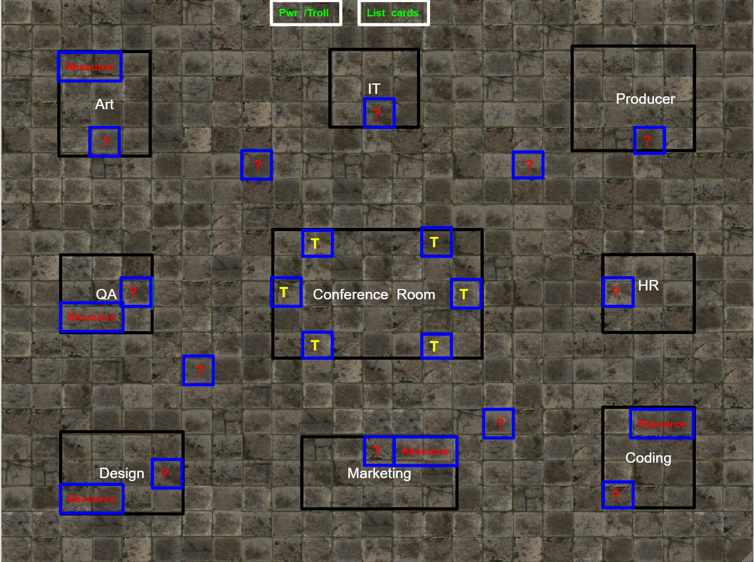

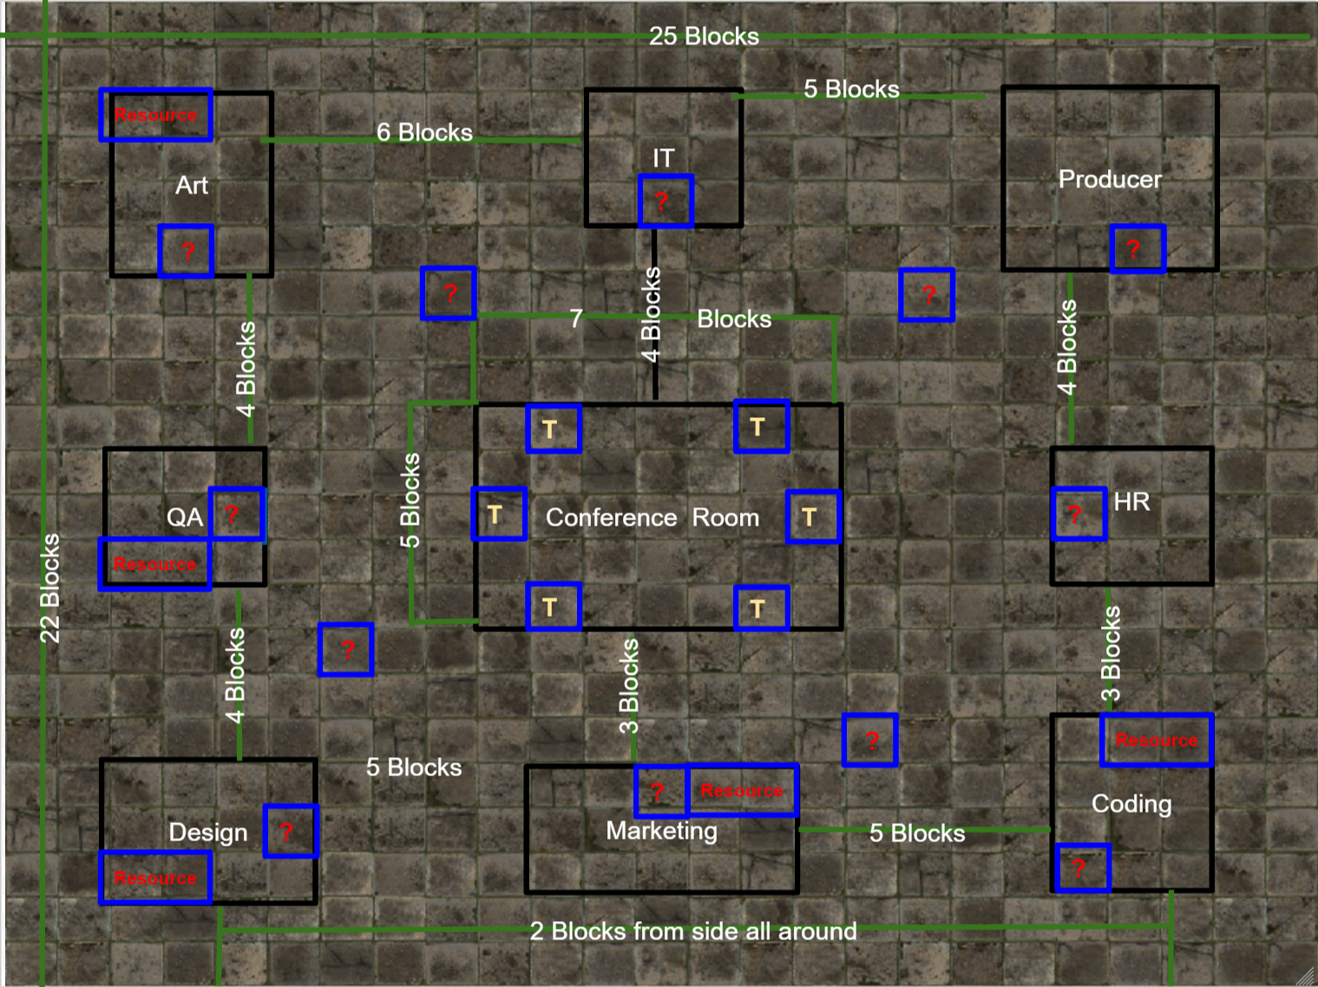

Turn Sequence
Upkeep- Removes one Troll effect on the players that have been targeted by a Troll card that was casted upon them. The also removes current Power-Ups on the current player.
Movement- The player can move up to 5 spaces (in cardinal directions, no diagonals) unless currently affected by a card’s ability.
Draw Power-Up/Troll card- If a player enters a “?” spot they draw a card during this phase. The drawn card must be played at this time, either on you or an opposing player.
Collection- The player may collect a resource if they are inside a department. They then roll to see if they critically collect.
Trade- Trade with other players is intended to lose a resource you don’t need and gain a resource you might. You may choose to offer up a card you don’t need face-down as a “mystery” or tell the other player what you are offering, it is your choice. This allows the player to choose open trading or a system with the element of chance built into it. Trades with other players ONLY happen if you are inside of the Conference Room.

Upkeep- During the upkeep if player has an active Troll card from last turn and it is due to expire, remove the effect from the affected player. This cycle includes stuns, teleportation, negative movement counters, loss of turn. Also this include Power-up effects like: extra movement, extra resource generation, invulnerability to effects etc. If you do not have an active task sequence draw a new one from the pile.

Movement- The player can move up to 5 spaces on their turn in cardinal directions (no diagonals) unless affected by a card that has restricted it, or increased it. When entering a department your movement ends regardless of how many spaces you have left.

Draw Power-Up/Troll card- This is drawn from a pile of cards and the effect is immediately activated. The player has the option of where this effect lands. Then it must target someone and its effect must be applied no matter what state the player is in. This card will overwrite that effect.

Collection- If the player is inside a department, they may collect a resource. They may not collect a resource from a department they have collected from until they collect from a different department. (E.x. I just collected from the Design department, I must collect from another department before I can collect from Design again.) Once a player has collected a resource, they then roll the 10 sided percentile die. Players have a base 20% (“90” & “00” on the die) chance to critically collect and generate an additional resource. This chance can be altered by Power-Up cards. This action generation gives players extra resource cards to trade with others and to stockpile for the current lists. It was made random because it is a secondary element that supports another secondary element.

Trade- The player may only initiate trades with other players inside the Conference Room unless the card “User’s Demand” or “Can I Haz Yur Stuff?” has been played. If the user asks a player to trade they may choose to trade or not if they are outside of the Conference Room, doing so will move the non-Conference Room player to the room automatically. If the player refuses the trade nothing happens and the trade turn is over for the player. During the trade Players exchange resource cards face down and do not share what card they are giving up for trade, unless affected by “Can I Haz Yur Stuff?” or “User’s Demand.” After trading your turn is over.

General Rules
- Players cannot trade resources they do not have.
- Players can only initiate trade on their turn.
- If trade is initiated and you are not in conference room move straight there.
- Players must use power-up/troll cards on the turn that they are obtained.
- Players cannot occupy the same space on the board.
- Player must get an 80 or higher on the percentile dice unless it is modified by a buff card in order to gain additional resources in the “critical chance” roll after obtaining a resource from a building.
- Trading can only be done at the end of your turn, and can only be initiated if the person starting the trade is in the conference room.
- All Power-Up/Troll cards are effective for the length on the card, no player can teleport another player to the conference room if that player is affected by a stun.
- Players move 5 spaces per turn unless modified by a card or racial.
- Roll percentile dice to see who goes first. In case of a tie a roll off will decide.
- If the Power-Up/Troll cards run out shuffle the deck and replace the cards.
- Upon completion of a list (speaking to the producer and drawing a new list) return the resource cards to the original location.
- You cannot obtain resources from the same department on back collections.
- Cards that modify movement take effect on the next turn’s movement phase.
- Players hold onto the Power-Up/Troll cards in front of the player’s space until the effect has ended. This is simply to show that the effect is active, not that the player owns the card.

Detailed Rules for Specific Pieces

Troll cards
Flooded Board x1 - Uh Oh, Mountain Dew in the keyboard. Select a Player, you must get a new keyboard from IT.
Brain Freeze x1 - Too much slushee. Select a Player, they lose the resources for one item on their list.
Tied Up x1- Shoes tied together. Select a Player, they move 2 less squares during their next turn.
False Tile x1 - The floor disappeared sending you plummeting to your death. Go back to where you started this turn.
Can I Haz Yur Stuff? x1 - It’s Mine, all Mine! Take all resources from another player. Turn ends on use.
User’s Demand x1 - The User(s) have spoken. Forces a trade upon another player or between players
Bad Bytes x1 - Found a potential bug. Send selected player to QA.
Trollitis x1- Infected! Infect a player with Trollitis forcing them to skip their turn.
Busted! x1 - You (can only target player that drew) have been caught goofing off. Teleport to the producer's office and lose 1 resource.
Industrial Shredder x1 - It’s Shredder! Shred the selected player’s list, forcing them to draw a new one.

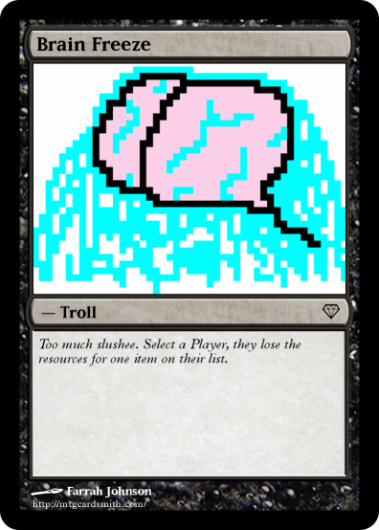

Power-Ups
Energy Drink x3 - Caffeine boost. Allowed to move 3 additional spaces on your next turn.
Nerd Rage x3 - You are enraged. Immune to Trolls until your next turn.
Keyboard Warrior x3 - You are bestowed the lessons of Key-Fu. Nullify one active Troll effect. If no effects are present +1 maximum movement for your turn.
Speedrun x3 - You’re running in the hallway. Move twice the number of available moves.
Producer’s Wisdom x3 - Get a tip from the Producer. When used, you need 1 fewer items on your list upon submission.
Pass the Buck x3 - Troll Distribution. Transfer a current Troll effect to another player. If no Troll effect is present, +1 Movement.
Herobrine x3 - You are the Herobrine. Teleport to any location. Collection only takes place at teleportation destination.
Medic! x3 - I need a healer! Instantly obtain one item from your list.
Beta Test x3 - Your game is in Beta! Skip to next list, if on final list draw a new card.
Equipment Upgrade x3 - Everything is Quantum! +10% crit chance on resource collection.

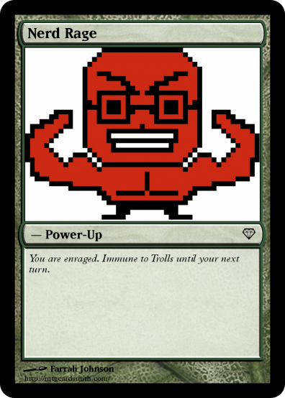

Resources

General:
- Computers
- Soda
- Snacks
- Documents

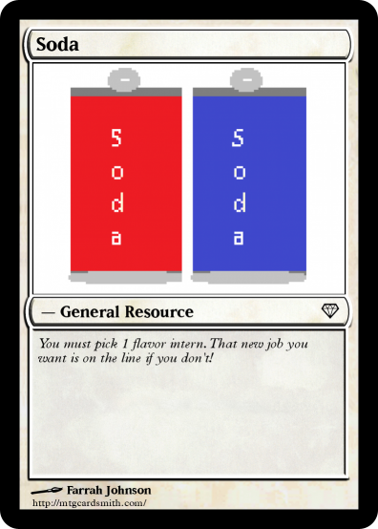

Specific:
- I.P. (Marketing)
- Trends Analysis (Marketing)
- QA Testers (Quality Assurance)
- Bug Tracking Software (Quality Assurance)
- Muse (Artists)
- Photoshop (Artists)
- Game Engine (Programmers)
- Scripts (Programmers)
- Schedule (Designers)
- Word Processor (Designers)

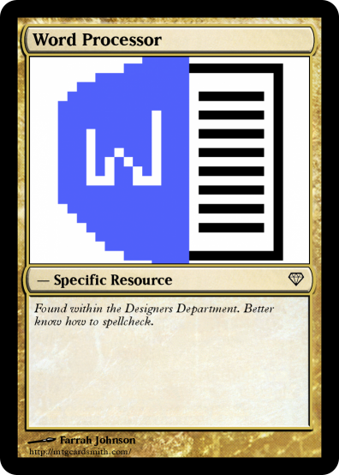

The Lists
The list that you have to complete varies based on the number of people playing the game. Below is how it breaks down for each number of player.

3 players - 3 General, 1 Department specific items
4 players - 3 General, 2 Department specific items
5 players - 4 General, 2 Department specific items

If there are 3 players, players need only obtain the under the “3 Players:” section. If 4 players are present, then players must obtain the items from the “3 Players:” list as well as the additional item in the “4 Players:” list. This also applies the same when there are 5 players, thus players collect all of the items on the list.
Note: Lists are located at the end of this document.

Department Intern’s Unique Attributes:

Marketing “Marty” Intern: +2 Marketing resource of the player’s choice at start (prior to list acquisition) plus 30% crit rate on Marketing resources.
QA “Queen” Intern: +2 QA resources of the player’s choice at start (prior to list acquisition) plus 30% crit rate on Quality Assurance resources.
Art “Arty” Intern: +2 Art Resource at start (prior to list acquisition) plus 30% crit rate on Artists resources.
Programming “Dexter” Intern: +2 Programming resource at start (prior to list acquisition) plus 30% crit rate on Programming resources.
Design “Destiny” Intern: +2 Design resource at start (prior to list acquisition) plus 30% crit rate on Designer resources.

Flowcharts
Game Setup
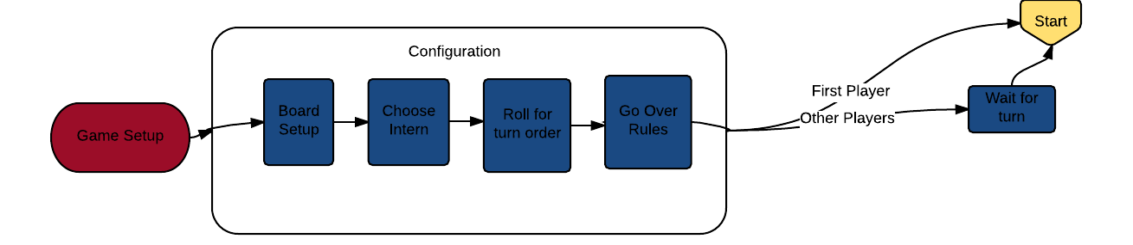
Upkeep Phase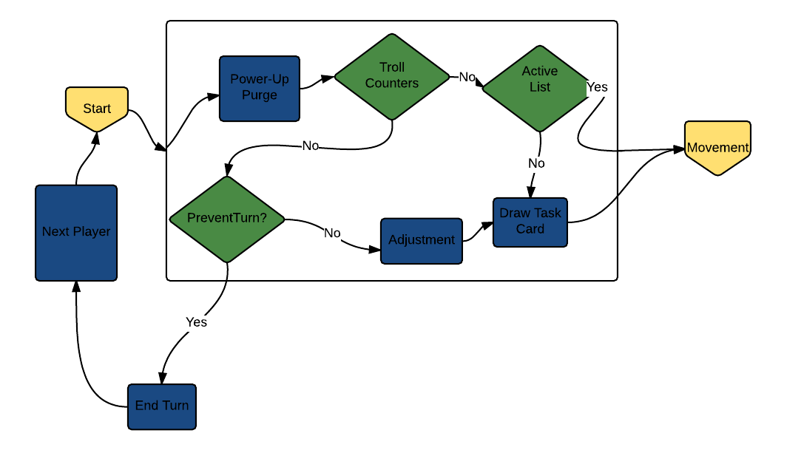

Movement Phase
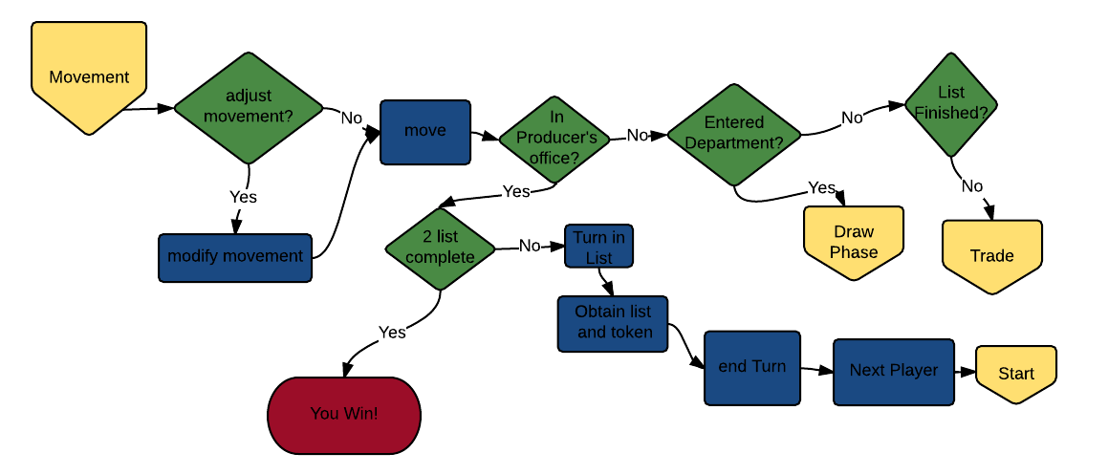
Collection Phase
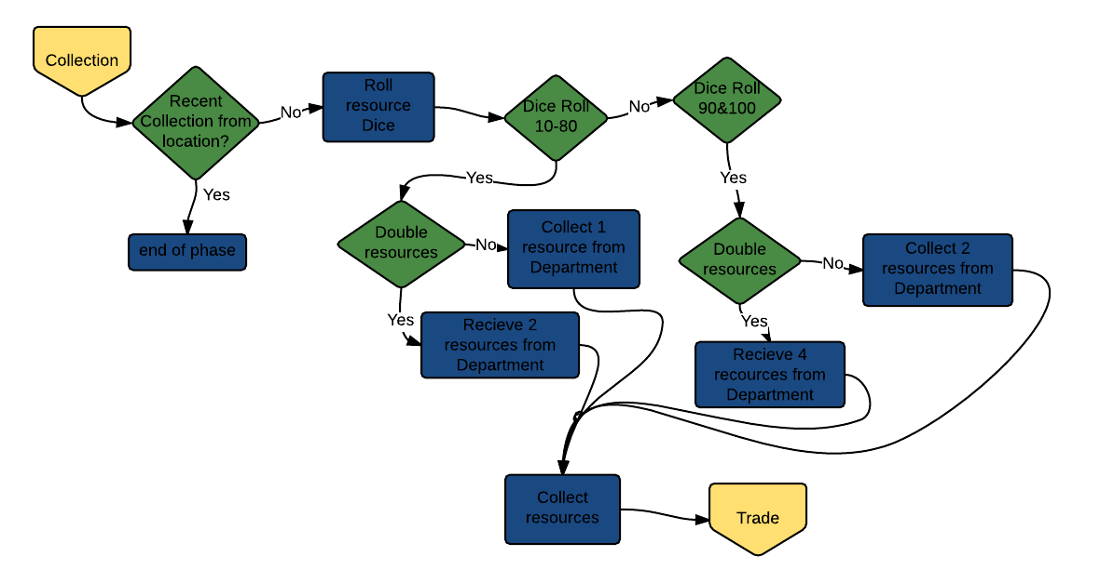
Draw Phase: Power-up/Troll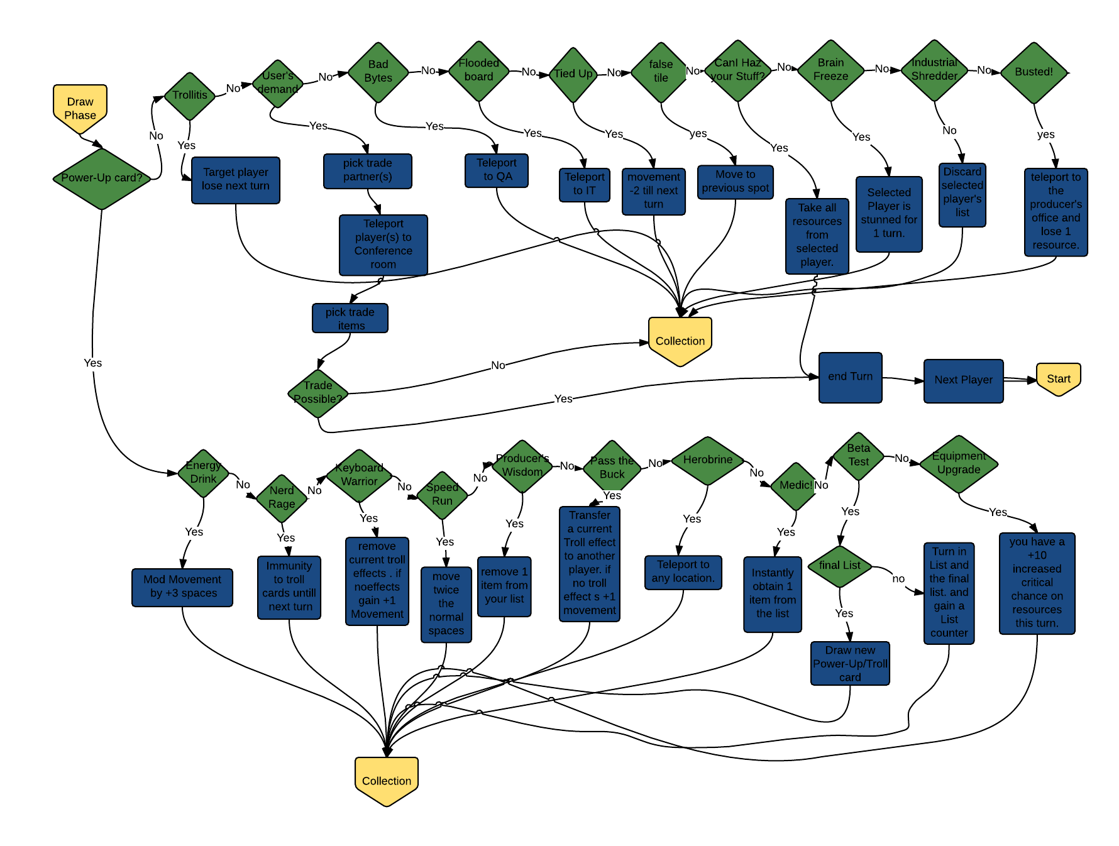

Trade Phase
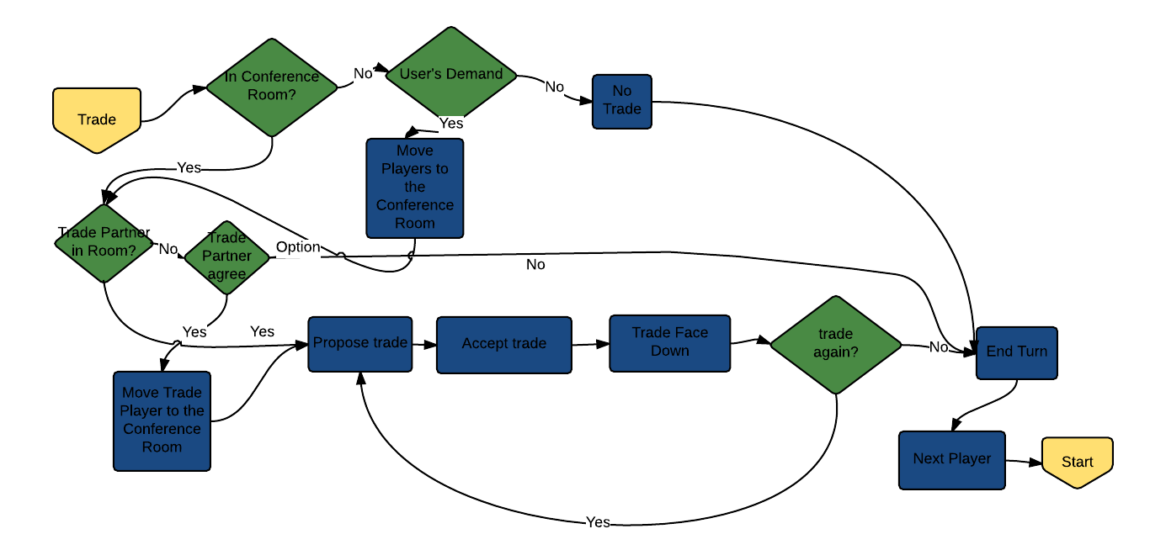

End Game Conditions
The game is won when a player successfully collects all the resources on two separate lists that the producer has asked the interns to do. Once you have completed the first list you must then head to the producer’s office. Once there, show your list and related resources to the other players and prove that you have the resources to complete it. You then return the list to the stack and shuffle it in. At the same time, you return the resources back to the department for reallocation later. The second list works much the same way but, after you have proven the list is complete the game is over and you are declared victorious.

Rules Questions & Strategies

What is the Primary means of completing the game?
Look at the list and plan out the best route to achieve the quickest means of gathering the resources required.

Describe an alternate means of attaining a winning condition?
Use the conference room to create trades and bounce back and forth between two departments to gain additional resources to trade with.

How can trading be used to your advantage?
Accept and offer trade strategically as the movement of the player to the Conference room can be used as a movement strategy to achieve your goals.

How does Busted work?
The player to the left of the player that draws the card selects one resource at random from the player’s hand and returns it to the department.

How does Herobrine work?
Teleports you to any location then you can only collect from where you are post teleportation.

What is a list token?
It is a token that you receive upon completing the first list. This can be achieved either through the normal route out or through the Beta test card. It acts as a counter to keep track of completed lists.

How does User’s Demand work?
You pick a person to trade with. You are then both teleported to the conference room. You then trade with that person 1 card, if possible; if not, you end your turn.

How Troll card effects work?
The card is in effect for the player or person targeted until the caster’s turn come around again. At that point the card is removed and the player affected is released from the effect.

List cards

3 Players:  - Computer  - Soda  - Snacks  - I.P. | 4 Players:  - Trends  5 Players:  - Game Documents

3 Players:  - Soda  - Snacks  - Game Documents  - Q.A. Tester | 4 Players:  - Bug Software  5 Players:  - Computer

3 Players:  - Computer  - Soda  - Game Documents  - Muse | 4 Players:  - Photoshop  5 Players:  - Snacks

3 Players:  - Computer  - Snacks  - Game Documents  - Game Engine | 4 Players:  - Scripts  5 Players:  - Soda

3 Players:  - Game Documents  - Soda  - Computer  - Schedule | 4 Players:  - Word Processor  5 Players:  - Snacks

3 Players:  - Game Documents  - Soda  - Snacks  - Trends | 4 Players:  - Game Engine  5 Players:  - Computer

3 Players:  - Snacks  - Computer  - Soda  - Photoshop | 4 Players:  - Trends  5 Players:  - Game Documents

3 Players:  - Computer  - Snacks  - Game Documents  - Scripts | 4 Players:  - Q.A. Tester  5 Players:  - Soda

3 Players:  - Soda  - Snacks  - Computer  - Word Processor | 4 Players:  - I.P.  5 Players:  - Game Documents

3 Players:  - Computer  - Soda  - Game Documents  - Bug Software | 4 Players:  - Muse  5 Players:  - Snacks

Resource cards