Attraction GDD

The Cronies

Game Vision:

Summary:
Attraction is a 2D action platformer wherein the player uses magnetism and energy to traverse their environment, defeat enemies and clear all of the levels. The player begins the game with the ability to use magnetism to pull or push anything effected by magnetism. As the player clears levels, they will be rewarded with the ability to climb walls, hang from ceilings, magnetize non-magnetic objects, and fire their hands as projectiles, all of which use energy (a finite resource that is regained over time).

Target Audience:
Attraction’s target audience is hardcore gamers and fans of Megaman games or similar titles. Our target age-range is teens to young adults 12 - 24.

Market Comparison

Comparison
Attraction fits most closely into the side-scrolling action platformer genre. Our game has similar elements to games such as Axiom Verge, Mega Man, and Cave Story, such as:
- Emphasis on platforming and puzzles.
- Multiple levels with freedom of which level to pursue first (except in the case of the final level).
- Upgrades as rewards for progress (but not strictly necessary to complete each level).
- Varied bosses and enemies themed to fit the level.

Unique Slant
Attraction is most defined by its magnetism feature, which allows the player to manipulate their opponents and environment in new and unusual ways. In similar titles, the player typically has no control over any of the movement of anything (other than themselves), which makes the fact that the player can in Attraction that much more appealing. In addition, our upgrades focus less on raw offensive capabilities and more on providing new ways to traverse the environment and evade or defeat enemies.

Risk Management

Scope
Attraction is currently planned to have four levels (each expected to take around 10-15 minutes to complete). It will have a magnetism system (allowing the player to push/pull certain enemies and objects) and an energy system that regulates player movement along walls and ceilings, as well as their ability to fire projectiles.

The following features will be present:
- Able to magnetize non-magnetic objects
- Able to cling to ceilings and walls using magnetism
- Able to fire projectiles
- An Energy bar to regulate certain movement and ability-use.
- Basic 2D movement capabilities (cardinal directions and jumping)
- Collectibles/Hidden Objects (that give score)
- Magnetism
- Puzzles (that utilize the magnetism mechanic)

Viability

The greatest risk in making this project is that our team might be unable to create a well-functioning magnetism system, which would heavily limit our gameplay. In the event that we are unable to make the magnetism system work at an acceptable level, we plan to simplify the magnetism system so that only one object may be magnetic at any given time. The player would be able to magnetize one object, push/pull that object along cardinal directions only, and then demagnetize it so that they could then magnetize another object. This would make the system much more approachable and easy to code and could still allow for viable gameplay options.

Story & Aesthetics
Story:
The year is 2057. The nations of men and their technology have advanced with the times. Industry has boomed and evolved with the knowledge of how to work new and advanced materials into new-age goods. Along with the new age of technology, so too were robots made, both for domestic and military purposes. Recent events have culminated into a conflict between great powers using the new weapons of war at their disposal. Destruction and turmoil are rampant. The player finds themselves caught within a portion of one such conflict and wind up being knocked unconscious amidst the confusion and struggle for survival. They wake up in an unfamiliar building surrounded by medical equipment and with their hands replaced with metallic replacements. As they come to grips with this, the player (name tbd) notices an inscription on their hands that signifies their creator (fill this in when we come up with a wicked cool name for them) and the player begins traveling across the wreckage of the urban environment in search of answers as to how they survived and why their hands were replaced.

Aesthetics:
Audio:
We’re looking to have our music have a dark tone to match the visual atmosphere of the game world (see below). In addition, some notable predecessors in this genre have had 8-bit or retro tracks and we decided tracks/clips of a similar nature would fit. Below are some examples we look to for inspiration when considering general audio feel for the game:
https://www.youtube.com/watch?v=g49sK_rLrVg
https://www.youtube.com/watch?v=rFGc5HVEbgQ

Graphics/Visuals:
We’re looking to both maintain the tone that the story sets (dark, post-disaster), while still keeping to the pixelated, retro roots of many older titles in the genre. As such, we’re going to be going for a grittier tone than would normally be present in similar games. Lighting will often be natural or limited indoors and many portions of the environment will be broken or in various states of disrepair. Examples of the kind of tone/feel we’re going for are below:
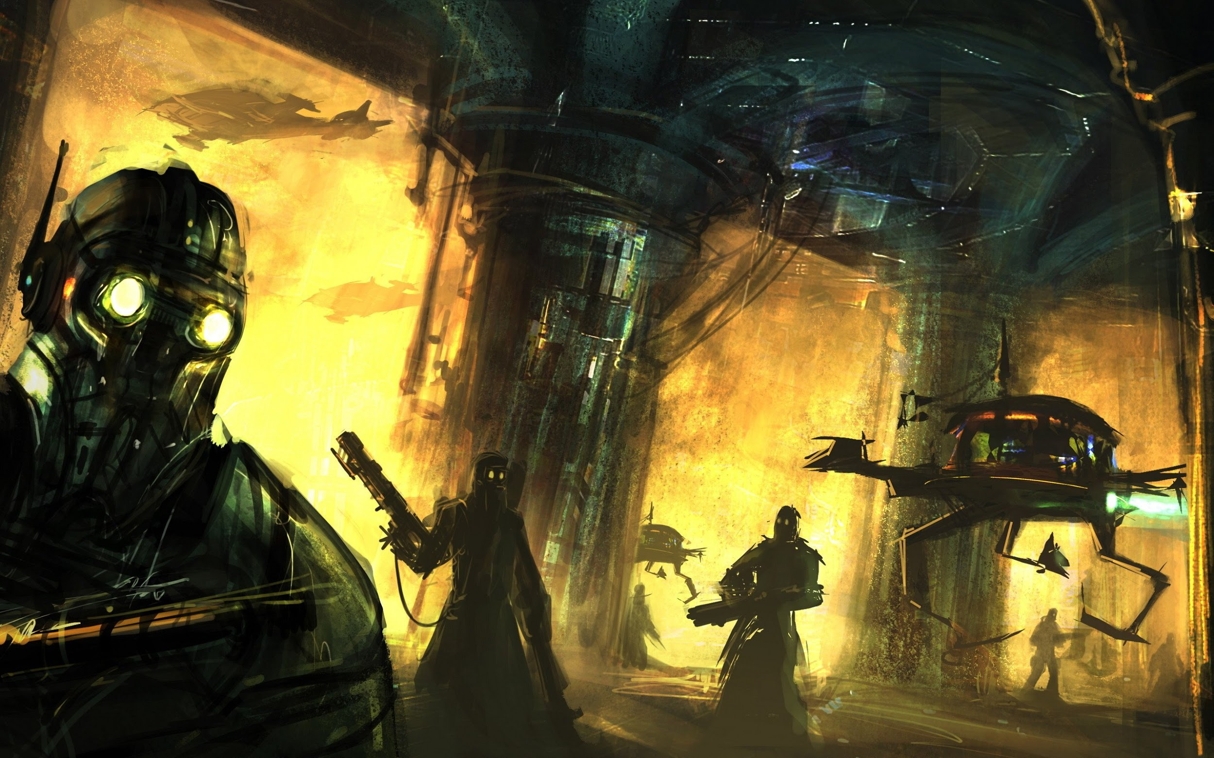
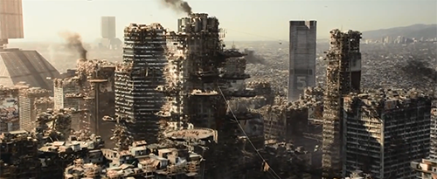
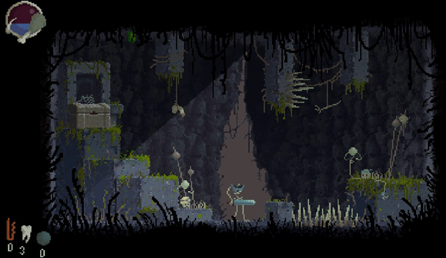
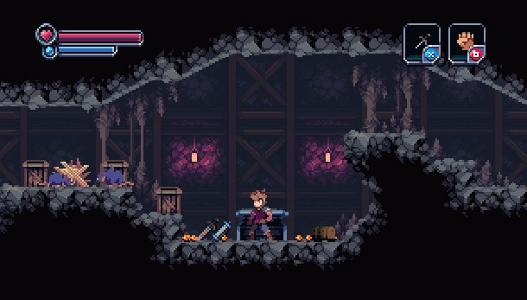
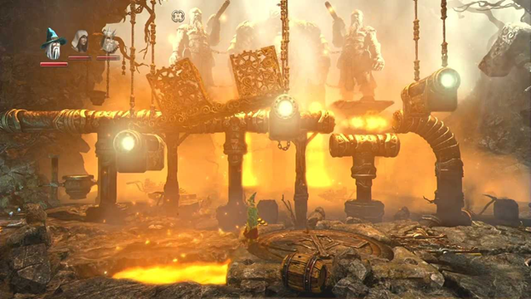
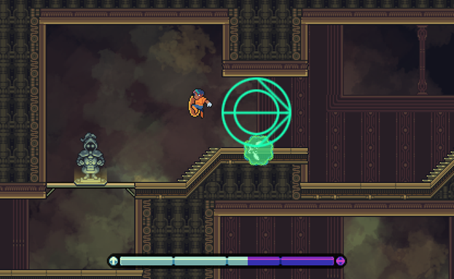

Player Goals/Win-Loss Conditions

The player’s short-term goal is to clear the first three levels. To do so, they will have to avoid environmental hazards, defeat enemies, and solve puzzles to reach the end of the level. In addition, the player can gather collectibles throughout each level to increase their score. Each level ends in a boss fight and will reward the player with a portion of the key to the final level and a new ability.

The player’s long-term goal is to defeat the boss at the end of the final level and have the highest score possible (which may only be accessed after completing the first three levels). If the player manages to clear all four levels, the player wins. If the player loses all of their lives, the player loses all progress within the current level, is taken back to the level selection screen, and are reset to full lives. There is no concrete game-over or be-all end-all loss condition.

Environment Breakdowns:
Flowchart:
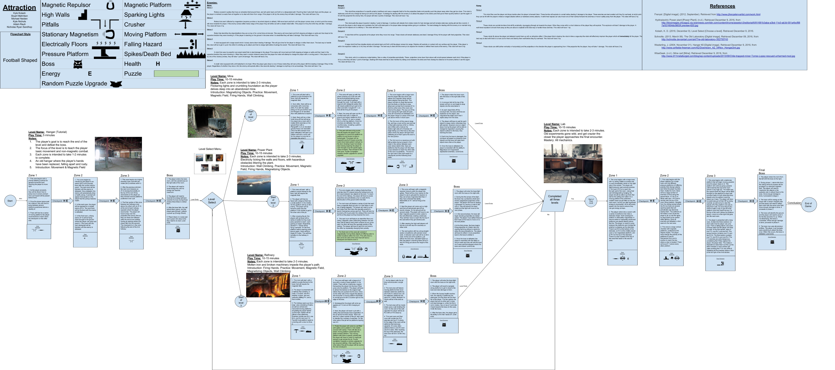
To see the above flowchart detailing all of the levels and how they link together, see the link below.

Link to full flowchart: https://docs.google.com/drawings/d/1E1g2U7qandp4lUd8DhDgzmTdWIj0S6rmxQz4qCo9s54/edit?usp=sharing.

Level Breakdown:

Name: Hangar (Tutorial)
Overview:
The hangar is the first level and is intended to teach the player the basic controls and skills needed to play the game.

Flowchart:
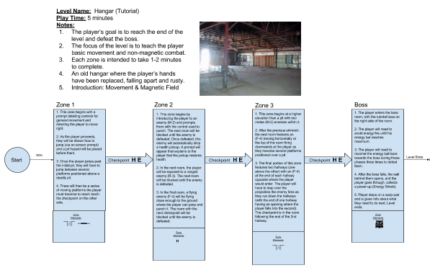

Name: Mines
Overview:
This level features flickering lights and crumbling foundations as the player delves deep into an abandoned mine.
Introduction: Magnetizing Objects. Practice: Movement, Magnetic Field, Firing Hands, Wall Climbing.

Flowchart:
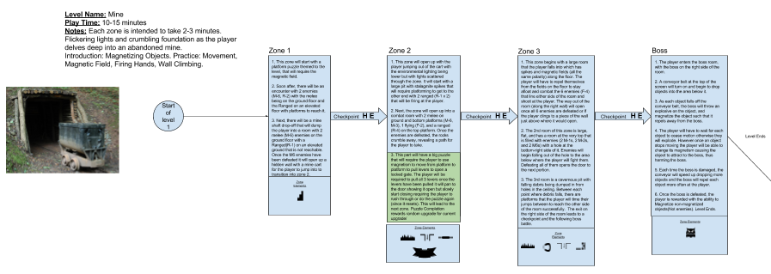

Name: Power Plant
Overview:
This level features electricity licking the walls and floors with hazardous obstacles littering the plant.
Introduction: Wall Climbing. Practice: Movement, Magnetic Field, Firing Hands, Magnetizing Objects.

Flowchart: 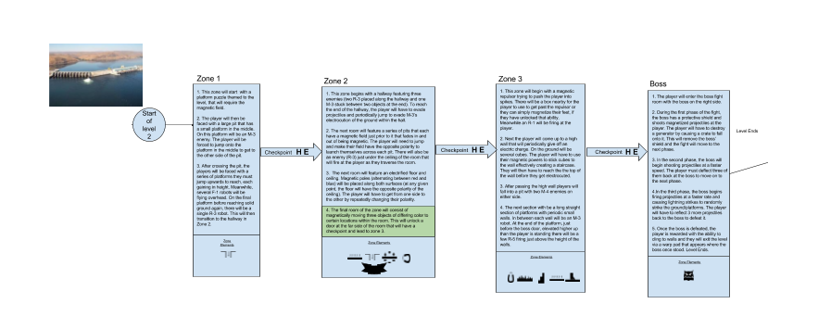

Name: Refinery
Overview:
This level features molten iron and broken machinery that impedes the player’s path.
Introduction: Firing Hands. Practice: Movement, Magnetic Field, Magnetizing Objects, Wall Climbing.

Flowchart: 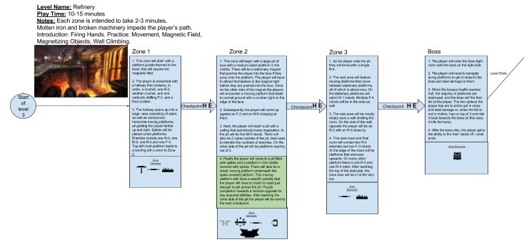

Name: Lab (Final)
Overview:
This level is a lab fallen into disrepair with old experiments that have gone wild and get crazier the closer the player gets to the final encounter.
Mastery: All mechanics.

Flowchart:
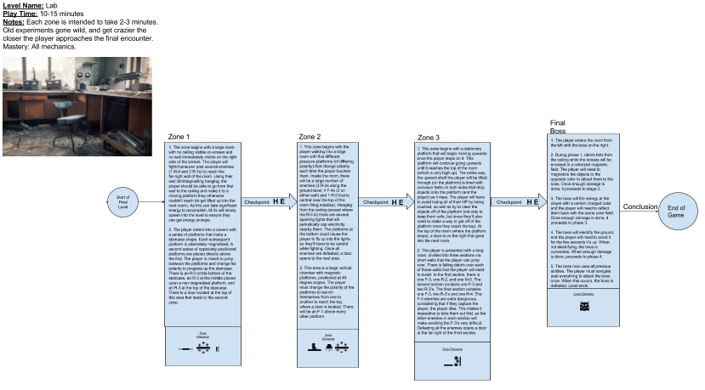

Features, Mechanics, and Systems:

Component Matrix:

The following spreadsheet shows all components in the game that interact with others and establishes how they are expected to do so:
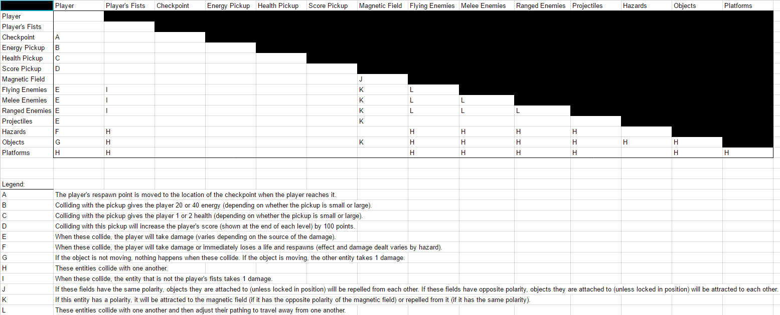

The following link will allow you to see the spreadsheet within google sheets (at full size):
https://docs.google.com/spreadsheets/d/16RJBaX2Lg_c7LNRNa_U8L6r7NRrfHaNtHb3VsdyRH_g/edit?usp=sharing

Combat:

The player can fight enemies through punching them, causing objects to be magnetically flung and/or fall on them, and pushing enemies into environmental hazards (such as spikes). The player’s punch will be short (melee) range (until they gain the ability to fire their fist) and deal 1 damage to any enemies hit by it. When the player is hit/touched by an enemy (or an enemy’s projectile), if an object pulled or pushed by magnetism touches them, or if an object falls on them, the player will sustain damage. Damage is as follows:

Enemy hits/touches the player: Differs based on enemy (see “Enemies”).
An environmental object in motion and/or falling touches the player: 1 damage.

Whenever the player is hit, they will become invulnerable to further damage for 2 seconds (in order to prevent the player from being killed by an unfortunate series of simultaneous hits). A player begins play at a maximum value of 6 life. In the event that a player touches a hazard that instantly kills them (such as spikes), they will die regardless of whether temporary invulnerability is still active. If this value is otherwise reduced to zero by damage, the player respawns at their latest checkpoint (see “Player Death, Lives, and Checkpoints). This system is in place so that the player can fight enemies (with or without the use of magnetism) and still have enough health and allow the player to sustain damage from several sources before dying (so as to make the game more approachable and forgiving).

Energy:

The player will have an energy resource that is expended as they use their magnetism abilities (see “Magnetism”). This resource will have a maximum value of 100 and will start at that maximum value at the start of a level (or when the player respawns). Once expended, energy is recovered through collecting pick-ups (small or large, which restore 20 energy/1 health and 40 energy/2 health respectively) scattered throughout the level and sometimes drop when enemies are defeated. Energy and Health will also be fully restored any time the player dies or reaches a new checkpoint. This system is in place to cause the player to think critically about how they use their energy over the course of play.

Magnetism:

Many of the player’s abilities use or interact with magnetism. When first starting the game, the player will not have these abilities and will earn them after completing levels. As they earn upgrades (see “Upgrades), they will be able to do the following:

Fire their Hands:

The player can gain the ability to fire their hands in a cardinal direction based on what movement buttons are being held at the moment they fire. The magnetic fields that the player normally creates in a radius around their avatar are linked to the avatar’s hands, so firing the hands fires the corresponding magnetic pole and radius of effect. This feature is in place so that, once the ability is unlocked, the player can send their magnetic field away from them to influence objects/enemies from a distance (rather than strictly up-close). This gives the player a new way to approach the challenges they face.
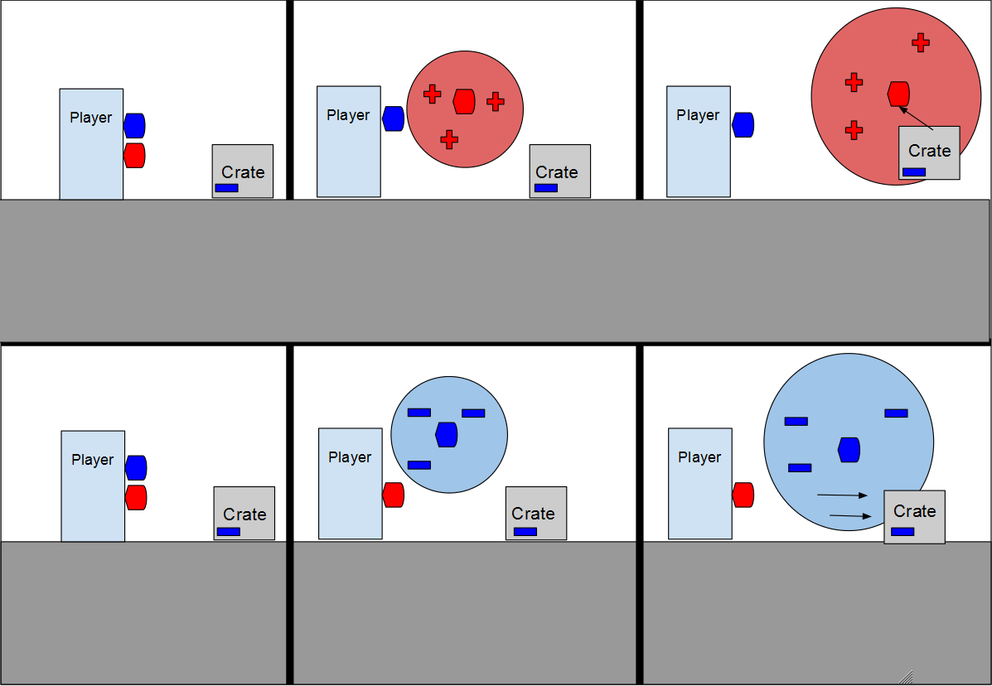

Magnetic Field:

The player can gain the ability to create a magnetic field in a radius around their avatar (a red or blue field) that attracts objects with fields of the opposite color and repels objects with fields of the same color (E.G. blue repels blue and attracts red).
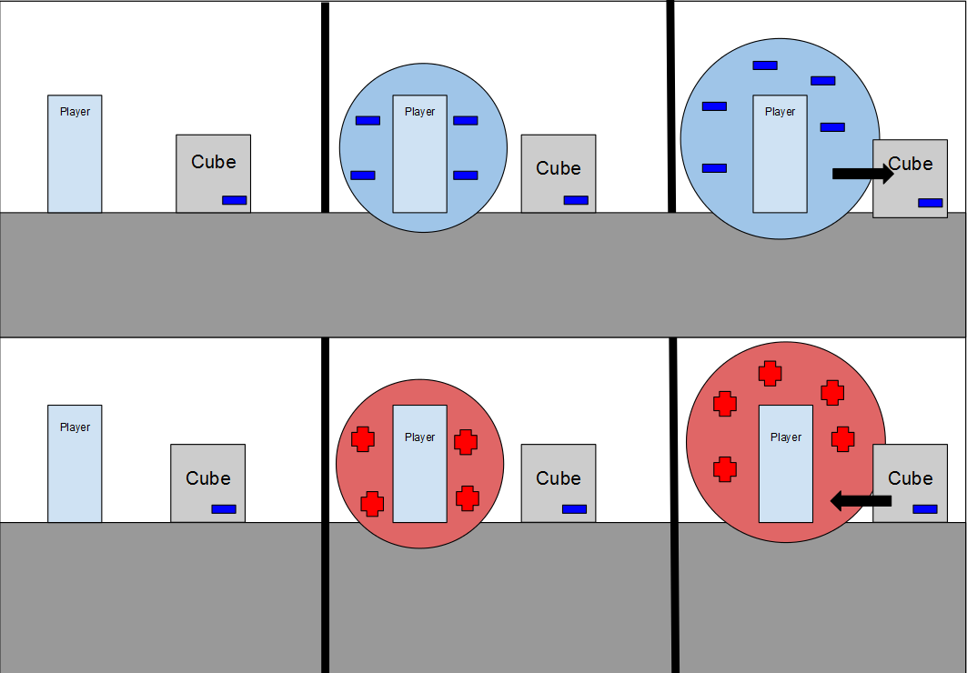

Magnetizing Objects:

The player can gain the ability to magnetize previously non-magnetic objects and enemies. When activated, a pulse will spread outwards from the player’s avatar that makes non-magnetized objects magnetic for a short time (~5-10 seconds). Affected objects are able to be influenced by any other magnetic abilities that wouldn’t normally do anything. This feature is in place so that the player can give themselves more options of how to approach challenges through making more objects capable of being manipulated by the player.
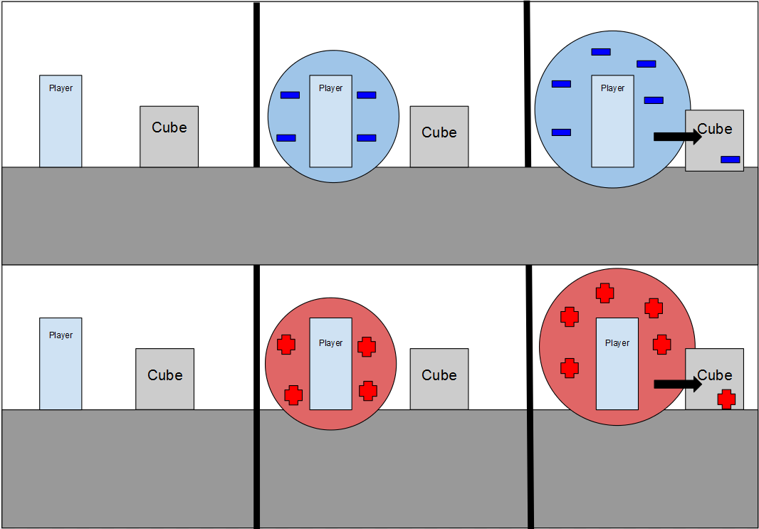

Ceiling Hanging/Wall Climbing:

The player can gain the ability to cling to metal walls and ceilings. To do this, the player will toggle the ability to do so (see “Control Scheme” for specific inputs) on and off (with energy being spent over time while it is active). While it is active, the player will be able to walk on metal walls and ceilings until the ability is toggled off or all energy is expended. This feature is in place to give the player more options at their disposal when traversing the environment or outmaneuvering enemies.
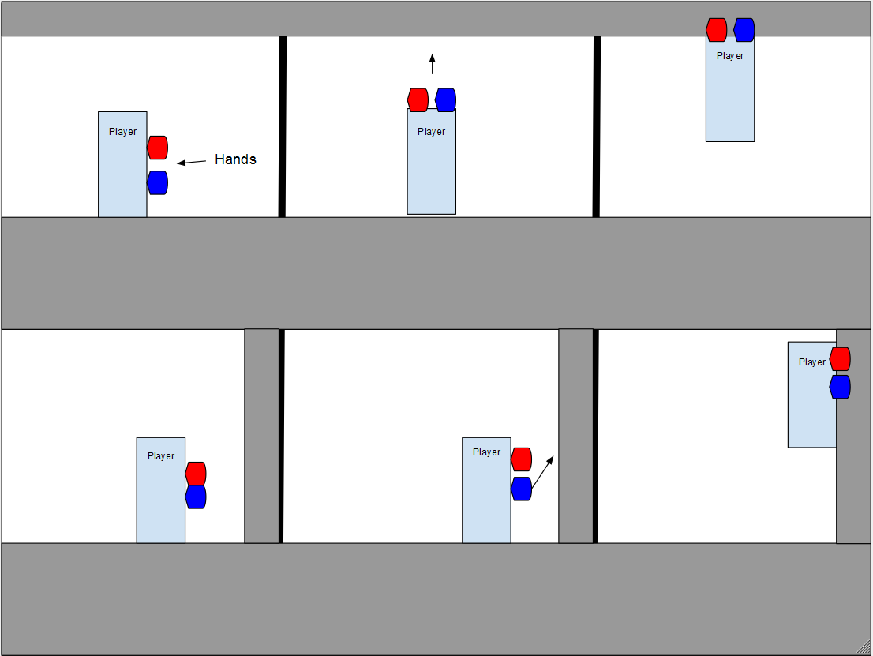

Movement:

The player’s movement is going to be in the cardinal directions and they will have the ability to jump. If the player is clinging to a wall (see “Magnetism”), the player will face away from the wall so that they may still fire their hands (if they have the ability to do so). When the player is clinging to the ceiling, they may change their facing (left/right), move left or right while attached, and be unable to jump. While attached to a wall or ceiling, the player will be unable to detach from it without toggling off their ability to cling to it. The inclusion of ceiling and wall traversal is intended to give the player more navigation options.

Puzzles:

Puzzles will be placed throughout the levels that the player will need to use their magnetic abilities to solve (this will add more purpose and critical thinking to the use of these abilities). The puzzles will focus on either getting objects out of the player’s way, bringing objects to particular locations, or navigating treacherous terrain. Examples of puzzles include the following:

- Moving an object into the path of an enemy to contain them in a specific area.
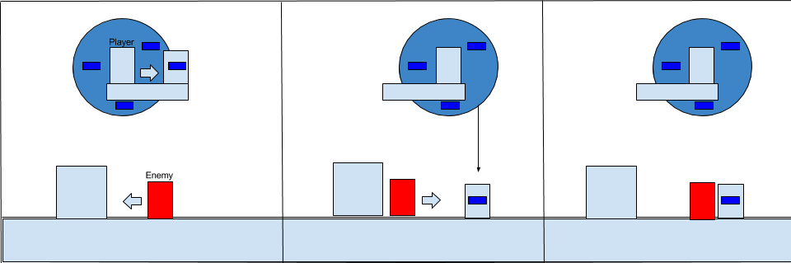
- The player approaches a ledge with another ledge directly above theirs with magnetic crates falling down a pit at set intervals indefinitely following a wall. The player needs to get from their ledge to the ledge above them in order to progress the level. In order to do so, the player has a few options depending on the upgrades they have available.
  - If they have magnetic hands that can be launched, they can fire their hand onto the far wall, which will attract a box to stick to the wall, allowing the player to leap onto and above to the next ledge. If a crate hits the magnetized crate, it will knock it down.
  - If the player doesn’t have the above upgrade, they can jump onto a falling crate and then quickly jump to the upper ledge.

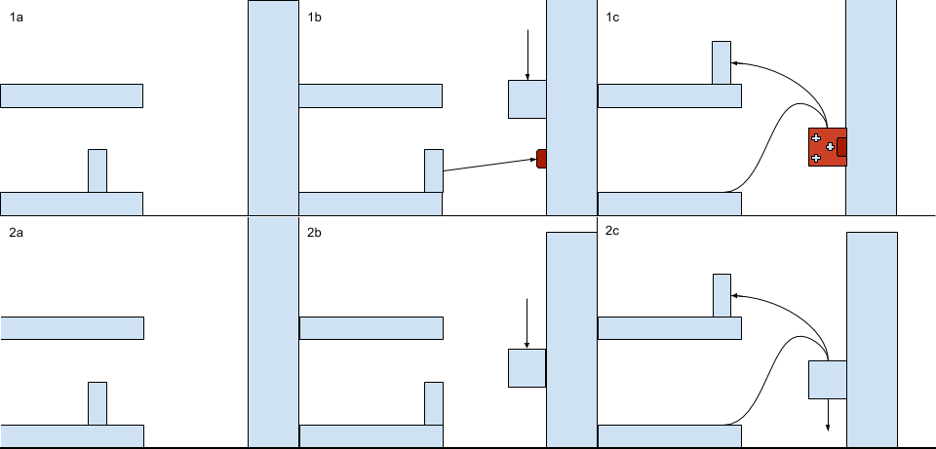

- The player must get to the other side of a spike pit by using magnetism to push/pull their way across the pit by attracting/repelling themselves to magnetic fields in the area.
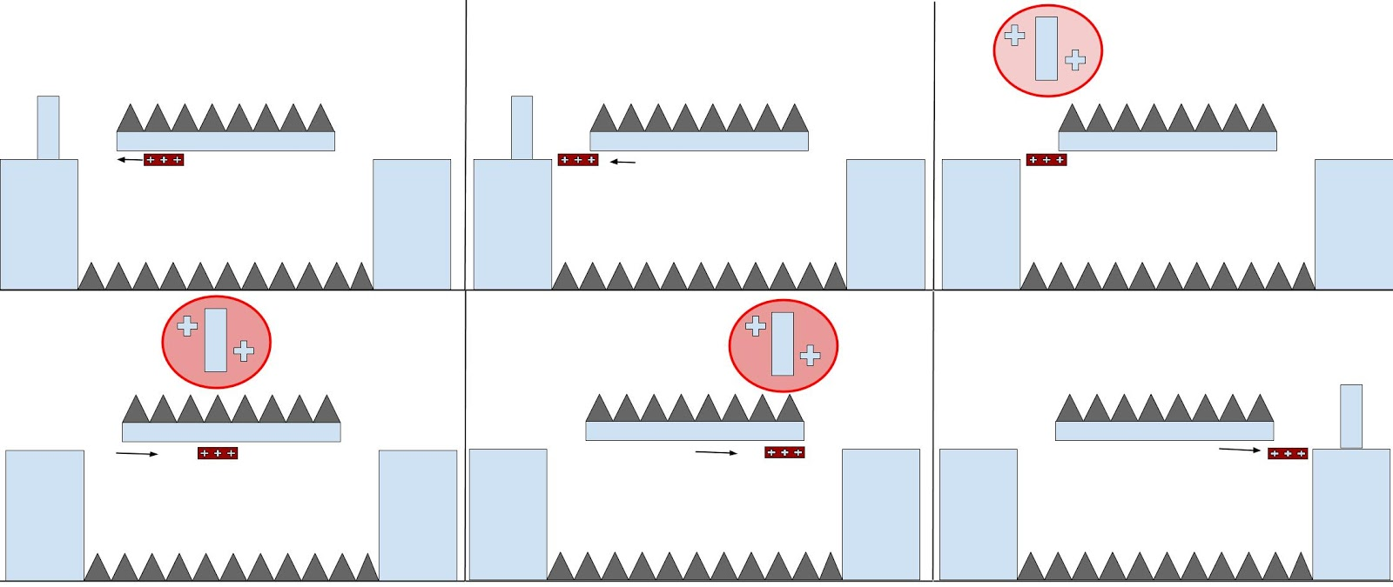

- The player must get multiple objects to specific points within a large area and must use magnetism and careful thinking to get the objects to their designated areas without blocking (or losing) any of the blocks from reaching their designated area.

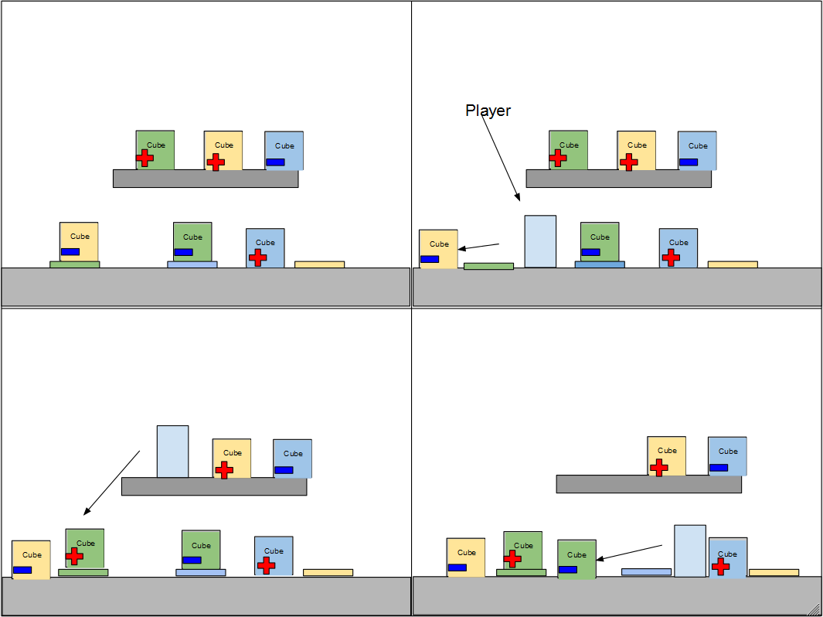
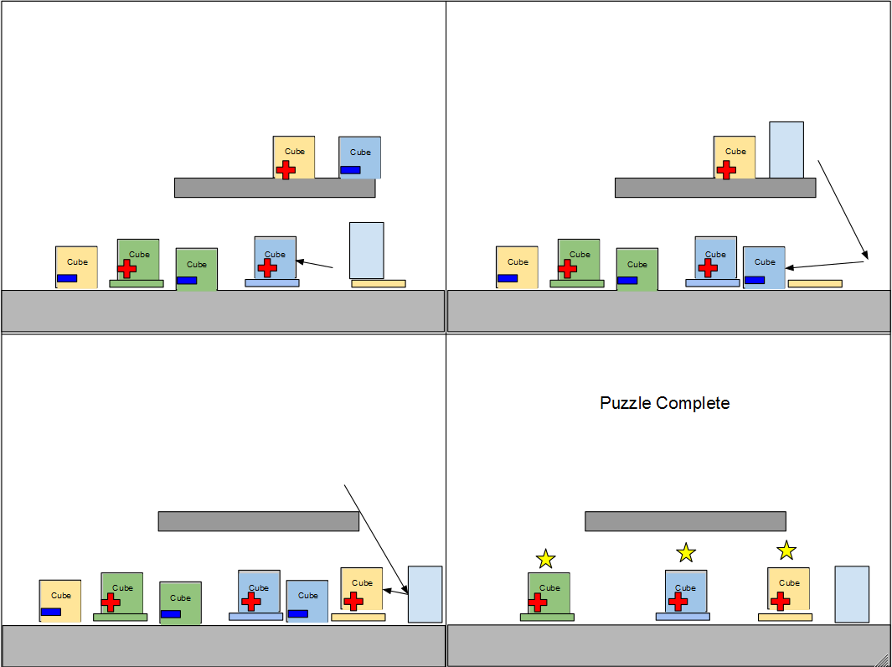

Player Death, Lives, and Checkpoints:

Players will start the game with three lives, when the player dies in a level they will reset to their last checkpoint or to the beginning of the level if they have not yet reached one. Their life counter will go down by one and their health and energy will be completely replenished. If a player’s life counter reaches zero, all progress within a level is reset and they are moved back to the level select screen. Checkpoints will be scattered throughout a level and, once a player touches a checkpoint, they will respawn there if their lives are above zero.

Upgrades:

Every time the player completes a level (except the final level), they will be rewarded with a baseline magnetism ability based on which level they completed (see “Magnetism”). Once an ability is unlocked, reaching specific milestones in future levels will provide energy-cost reductions to an unlocked ability (at random). The unlocking of features after completing a level is a reward for the player that allows them to approach future levels in differing ways based on how they proceed through the game. The inclusion of energy cost reductions gives the player smaller rewards for progressing through the game and will also influence level choice since the player will have more chances to get cost reductions on abilities they have had longer.

Enemies:
(Specific names to be added as development progresses)
(Not all enemies will be present in every level).

Melee:

Melee-1

Robots covered in spikes that have an attraction field around them, and will patrol back and forth on a designated path. Punching them hurts both them and the player, so the player is inclined to evade them all together or to deal with them from range. If the player is hit by this enemy they will take 2 damage. This robot will have 2 hp.

Melee-2
Robots that aren’t affected by magnetism (requires punches or launched objects to defeat). Will move back and forth until the player comes close, at which point the enemy will move towards the player. If the enemy comes within melee range of the player they will strike out with a simple metal knife. If the player is hit by the knife they will take 1 damage. This robot will have 2 hp.

Melee-3
Robot that electrifies the object/platform they are on top of for a short time at intervals. This enemy will move back and forth stopping at ledges or walls and then head in the opposite direction they were traveling in. If the player is standing on the ground in the area when it is electrified they will take 2 damage. This robot will have 3 hp.

Melee-4
A robot equipped with a large sword which it slowly slams down dealing 4 damage. This will give time for the player to dodge or strike them down. The best way to handle this robot will be to get in quick hits while it’s winding up its attack and then to dodge right before it swings the sword. This robot will have 4 hp.

Melee-5
A robot that uses its powerful over-sized metal fists to deal damage to the player.This enemy will move back and forth stopping at ledges or walls and then head in the opposite direction they were traveling in. When they reach a certain distance away from the player the robot will attempt to charge the player with a running punch. If the player is hit by one of the robots punches, they will take 1 point of damage. This robot will have 2 hp.

Melee-6
A small robot equipped with a drill attached to its head. When the player gets close to one of these robots they will ram at the player drill-first dealing 2 damage if they hit the player. Regardless of whether they miss or hit, the enemy will explode after a few seconds dealing 1 damage to anything in its surroundings. This robot will have 1 hp.

Ranged:

Ranged-1
This robot fires projectiles of a specific polarity (red/blue) and uses a magnetic field to fire the projectiles faster and possibly push the player away when they get too close. This robot is stationary and will only change its facing as it aims at the player. A strategy for dealing with this enemy is to attract the player to the enemy and then punch them quickly before it can fire again. If hit with the projectile this enemy fires, the player will take 3 points of damage. This robot will have 1 hp.
Ranged-2
This robot pulls the player towards it dealing 1 point of damage. It combos with attacks from melee robots for high damage and will remains stationary (acting almost like a turret). It only pulls the player a short range and maintains the hold until destroyed or the player takes damage before going on cooldown. The best strategy for dealing with this enemy is to maintain long range and fire objects at it to destroy it. This robot will have 3 hp.
Ranged-3
A robot that will fire a projectile at the player when they move into range. These robots will remain stationary and deal 2 damage if they hit the player with their projectiles. This robot will have 1 hp.
Ranged-4
A large robot that fires missiles slowly and patrols back and forth until the player comes into range. Missiles will explode on contact with any surface and the player. If the player is within the explosion radius (or is hit) they will take 3 damage. The best way to deal with this enemy is to repulse the missiles or deflect them back at the enemy. This robot will have 3 hp.

Ranged-5
This robot, which is a stationary rocket battery, fires a volley of projectiles periodically. These projectiles come down from above with small spaces between each shot. If the player is hit by a shot they will take 1 point of damage. Dealing with these enemies is best handled by taking cover between the shots and then closing the distance to the enemy before it can fire again. This robot will have 2 hp.

Flying:

Flying-1

This robot flies over the player and drops bombs when the player is beneath them. These bombs will explode in a small radius dealing 2 damage to the player. These enemies are best evaded until they fly overhead, at which point they can be hit with the player’s melee or ranged attacks before (or between) enemy attacks. A well-timed repulse can also knock one of their bombs forward into enemies or move it safely away from the player. This robot will have 2 hp.

Flying-2

These robots are suicide bombers that will fly erratically; zig-zagging through air towards the player. When they come within a short distance of the player they will explode. This explosion will deal 3 damage to the player. A well-timed repulsion to knock them away as they are about to explode is the best way to handle these enemies. This robot will have 1 hp.

Flying-3

These robots fly above the player and attempt to pick them up with an attraction effect. If the player fails to destroy the robot in time a cage atop the robot will effectively imprison the player which will immediately kill the player. The best way to deal with them is to look out for them and destroy them well before they fly overhead. This robot will have 3 hp.

Flying-4
These robots can shift (either vertically or horizontally) and fire projectiles in the direction the player is approaching from. If the projectile hits the player, they will take 1 damage. This robot will have 2 hp.

Bosses:

Tutorial Boss:
This initial boss’s purpose is to ensure the player understands their basic magnetism ability by the end of the tutorial. He must be defeated by repelling his projectiles back against him.
- Damage Phase - All Phases
  - In all phases, the enemy hops about firing non-magnetized energy with increased frequency depending on the current phase, unless entering the magnetized Phases listed below. If the player takes damage during the numerical phases, it resets to the start of that phase, if the enemy takes damage, it progresses to the next phase.
  - The enemy has a progress bar that fills between phases. When full, they enter the appropriate numerical phase (enemy health dependent). When they do, it depletes, and can only be filled only during damage phases.
  - Non-Magnetic energy does 1 damage to the player.
  - Magnetic energy does 2 damage to the player.
- Phase 1
  - The enemy fires a Red Ball of magnetized energy that can be punched back with a Repel Punch. The energy ball will be ping-ponged between the boss and the player until the boss misses and takes a hit. Attempting to hit the energy ball with Attract Punch or regular punch results in the player taking damage, resetting the boss energy progress bar back to the Damage Phase until he attempts to use the Red Ball again. Reduces the enemy health by 1/3 (2/3 remaining).
- Phase 2
  - The enemy fires a Blue Ball of magnetized energy that can be punched back with an Attract Punch. The energy ball will be ping-ponged between the boss and the player until the boss misses and takes a hit. During this phase, the ball moves faster with each hit. Attempting to hit the energy ball with Repel Punch or regular punch results in the player taking damage, resetting the boss energy progress bar back to the Damage Phase until he attempts to use the Blue Ball again. Reduces the enemy health by 1/3 (1/3 remaining).
- Phase 3
  - The enemy fires a Blue or Red Ball (only one) of magnetized energy that can be punched back with an Attract Punch. The energy ball will be ping-ponged between the boss and the player until the boss misses and takes a hit. During this phase, the ball moves faster with each hit and switches color when the boss hits it (If red, switches to blue and vice versa). Attempting to hit the energy ball with the wrong attack results in the player taking damage, resetting the boss energy progress bar back to the Damage Phase until he attempts to use the Blue Ball again. Reduces the enemy health by 1/3 (0/3 remaining).

Reward: Ability to create a magnetic field centered on the player.

Boss 1:
(Mines)
At the start of the fight, objects begin falling from conveyor belts at the top of the screen into the area below. As objects enter the fighting area, the boss magnetizes them, throws explosives onto them, and repels them from themselves. If they hit the player while in motion, they will explode and harm them (1 damage). Once they stop moving, they visually change and a button emerges somewhere on the object that the player can jump on/punch. Hitting the button on an object changes its magnetism and makes it to where the object is instead attracted to the boss when it tries to repel objects away from it (otherwise the object explodes after several seconds).

Doing this successfully causes the object to explode against the boss which harms it, makes it invulnerable for several seconds, and destroy all of the objects on-screen by roaring. Each time the player successfully hurts the boss, the conveyor belts dropping items into the area speed up, the boss flings objects away from him more often, and less of the objects have the button emerge from them (making it harder to get to one that could be used to hurt the boss). The amount of objects that have the button emerge is as follows:

- Boss hit 0 times: All objects repelled by the boss.
- Boss hit 1 time: Half of the objects repelled by the boss.
- Boss hit 2 times: One-third of the objects repelled by the boss (rounded down).

This continues until the boss is harmed 3 times, at which point it is destroyed and the player gains a new ability (see “Reward” below).

Reward: Magnetize non-magnetized objects (Not enemies)

Boss 2:
(Power Plant)
- Phase 1
  - This phase, the boss will have a protective shield that is powered by a small generator. The boss will be shooting electromagnetic energy (this will deal 1 damage) that is dodgeable or reflectable, but will not damage the generator or shield. The only way to destroy the shield is to destroy the generator with a giant supply crate that is on a shelf above the generator that can be pulled and dropped on the generator, thus starting the second phase.
- Phase 2
  - In this phase, the boss has become angry with the player for destroying its generator. The boss starts firing the electromagnetic energy at a faster pace. The player will need to reflect these projectiles back at the boss to hurt it. Once the player has successfully hit the boss 3 times, the boss will transition to the 3rd phase.
- Phase 3
  - In this phase, the boss has become filled with rage to the point that energy is starting to spark off of it. The boss will fire projectiles at a very rapid rate, to the point that the player will not be able to reflect them all, and will have to dodge them. There will also be a lightning beam (this will deal 2 damage) that will strike random locations that will give a shadow before striking down a few seconds later. Once the player hits the boss 3 more times, the boss will overload and be destroyed, thus giving the player their reward.

Reward: Ability to attract to and climb on walls

Boss 3:
(Refinery)
- Phase 1
  - During this phase, the boss will throw objects at the player on a ground, middle and high ground depending on which layer the player is currently on when the boss winds up for the attack. The player will need to navigate up and down on the different platforms to get close to the boss and then execute attacks against them. After a few hits, the boss will signify for the player to run away, and after a short delay, will do a medium range AoE pushback and damaging attack (2 damage). The player will then repeat the action until the boss reaches half health.
- Phase 2
  - When the bosses health reaches half health, the boss will do a ground slam, and destroy any platforms on their half of the screen as well as all medium and high platforms. When this happens, the boss will charge their fist and fire it towards the player (doing 1 damage, if it hits the player). The player then has two options.
    - They can dodge the attack and attack the boss like before.
    - They can hop on top of the fist when it’s no longer in motion. If they mount it, they can ride it back towards the boss, and when it reaches the boss, it will defeat the boss.

Reward: Launch Ability (Fires off Hands)

Final Boss:
- Phase 1 - Mine Phase
  - The boss starts off by having a magnetized shield that will change from being red or blue after a preset time. During this phase there will be metal debris falling from the ceiling when the boss calls in for support. This will act like an ability the boss will use after a preset time. After the metal debris lands it will last for a few seconds before disappearing. If the player is able to magnetize the debris to the opposite attraction of the boss’s shield, the debris will fly at the boss damaging the shield. Once the shield has been hit 3 times, the boss’ shield is destroyed and shifts to phase 2.
- Phase 2 - Power Plant Phase
  - During this phase, the boss will start shooting electromagnetic projectiles (that deal 1 damage) at the player that will be red or blue charges at random. The player will need to reflect these projectiles back at the boss by having the polarity that is matching the polarity of the projectile being launched at the player. Everytime the boss is hit this way, the speed at which the boss shoots the projectiles are increased. Once the boss is damaged 3 times this way, the boss enrages and shifts to phase 3.
- Phase 3 - Refinery Phase
  - When this phase starts, the boss destroys all of the platforms in the boss room. The boss will use an ability that is charged up giving the player time to notice that will electrify the ground. The player will need to use the wall climb ability to dodge this attack or suffer 2 damage when in contact with the ground. After the boss uses this ability, it is stunned for a few seconds to recharge allowing the player to attack the boss with either ranged fist attacks or running up and punching it. Once the boss is damaged 3 times, the boss will go into a last ditch effort and completely overloads and starting phase 4.
- Phase 4 - Desperate Phase
  - The boss now has all of the prior abilities. The room has metal debris constantly falling from the ceiling. The boss will be shooting the projectiles at a rapid rate and the channeling speed for the electrifying ground ability decreased and is no longer stunned. If the boss is damaged 1 time, the boss explodes and is defeated.

Save Game System:

This system will activate when the player completes one of the primary levels. The player will be prompted to save or not. The player will be given access to one of three save slots in which to save their game data in. The Player will also have the ability to save minor progress when looking at the level select screen. This can only be done during this time and not while you are active in a current level. The tutorial will not cause a save interaction to be triggered. The player will be able to save at the level select screen once they have completed the Tutorial and have attained the barrier ability, When a save is triggered the player will be prompted to select a slot in which to save. The player will use the Up and Down features of the controller or key to interact with the slots. Before each save is finalized they will be prompted with a “Are you sure kind of notification” before the file is written/overwritten.
Obstacles:

Magnetic repulsor. It launches the player into spikes. It requires magnetizing the player’s feet or placing an object over it so that you can cross.

High walls require magnetizing cubes to make ledges to climb, or skillful jumping between walkable walls to pass.

Pitfalls exist wherein if the player falls into them, it kills them and reduces them by one full life to the nearest checkpoint or the beginning of the level.

Stationary magnetic pushes/pulls.
Electrically charged floors/walls.
Floors/walls that quickly magnetize once the player touches them and either launch the player away or pull the player towards them (slowing their movement).
Floors/walls that periodically acquire and lose magnetism. These could be used for platforming areas requiring good timing and/or that rush the player.
Sparking lights that periodically spark and can deal damage to the player

Crushers that slam down and cause death to the player.

Moving platforms (vertical or horizontal).

Falling hazards, such as rocks or lava, that occur over pitfalls.

Spikes, cause instant death.

User Interface:

Front End( Main Menu):
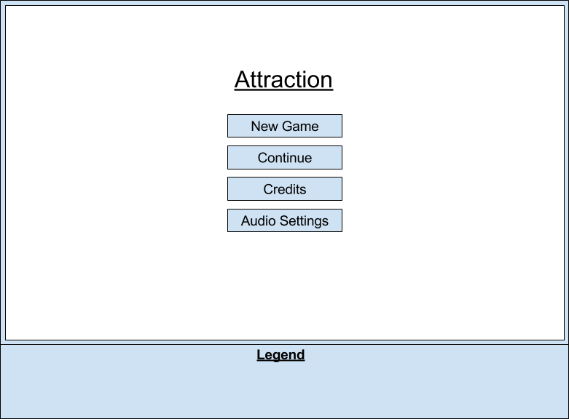
Credits:
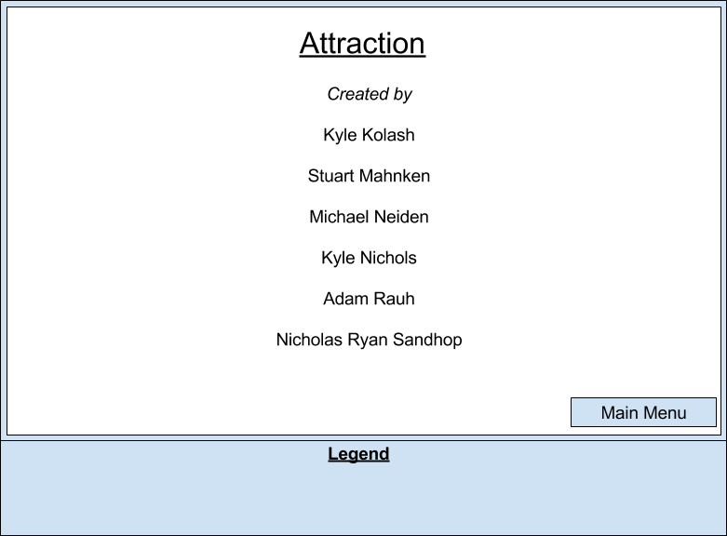
Audio Menu:
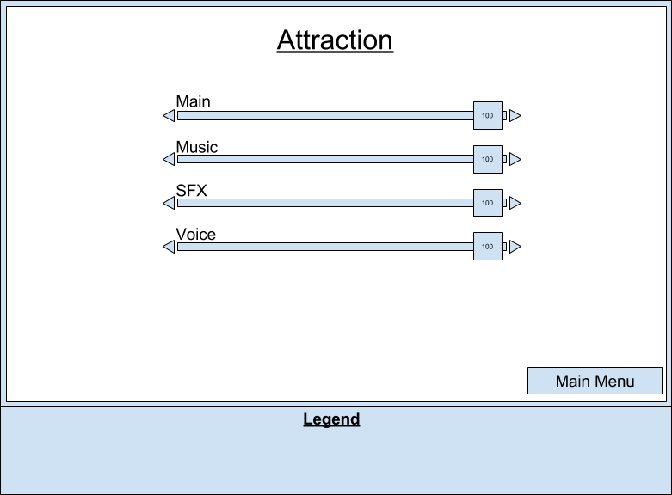
During Gameplay:
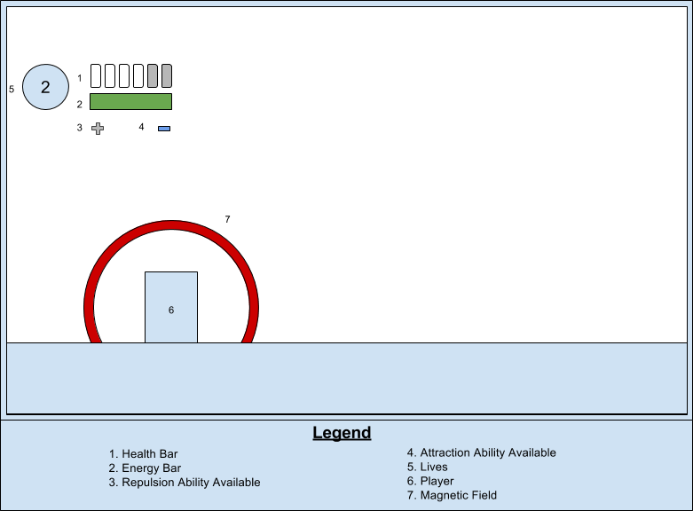

Pause Menu:
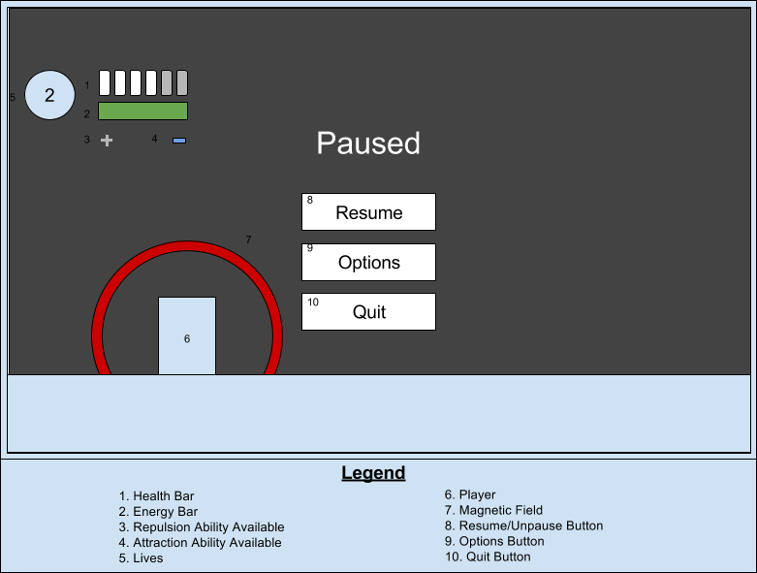
Upgrade Menu (stretch goal):
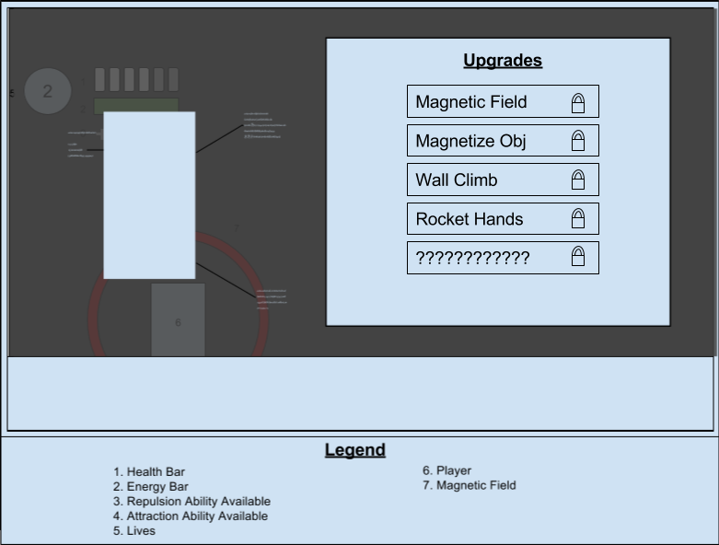

Control Scheme:
(Recommended use of Keyboard over Gamepad)
Keyboard (No Mouse)
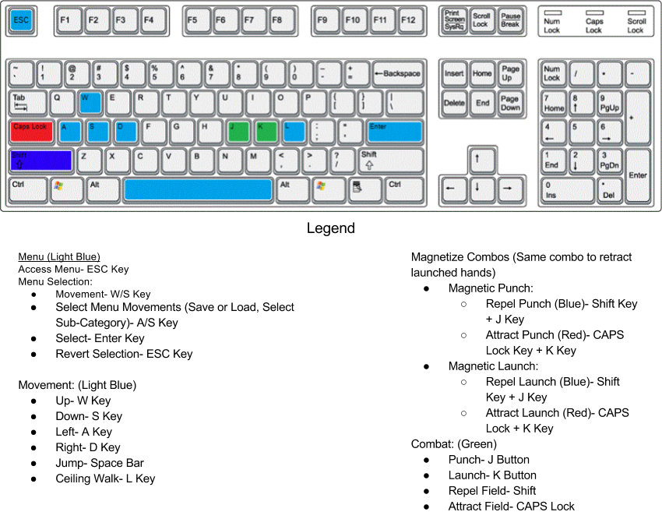
Gamepad

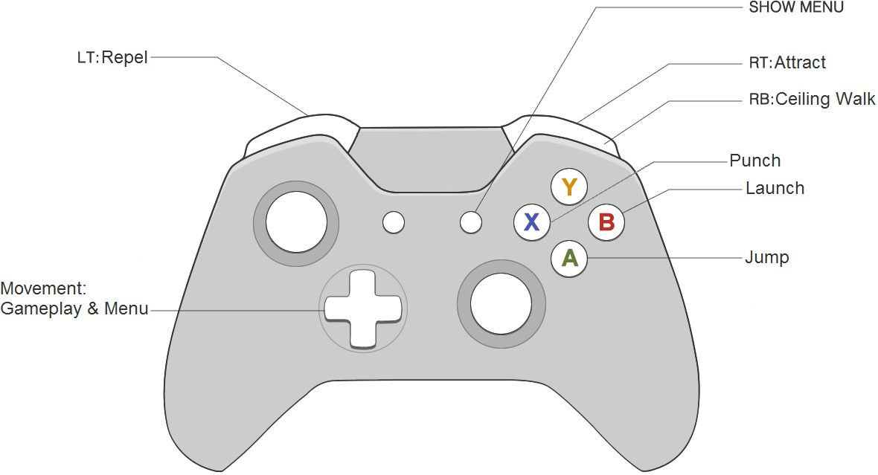
References:
Anonymous. (2016). Xbox One Controller Buttons. Retrieved 3 December 2016, from
http://collegiateattire.com/wp-content/uploads/2016/06/xbox-one-controller-buttons-diagram-xboxone-controller.jpg

Anonymous. (2011). Keyboard. Retrieved 3 December 2016, from
https://fairuzelsaid.files.wordpress.com/2011/09/keyboard.gif

