The Shadow

Cloak Syndicates
Thief Picture
*Picture used as a basic representation of the box’s art style.

Produced by:

Kyle Kolash
Michael Johnson
Andrew Kurtz
Jamie Jenkins
Description

The game is about The Shadow Cloak Syndicates (Octex, Kyron, Shyvin, and Dharvo). You are trying to build up your reputation through acts of robbery for your Syndicate. This will inturn give you Reputation Points that you can use to purchase Thief Tools which you combine together to help you pull off the larger jobs or even the big job at the end of the game. The bigger the job the better the Reputation Points but, also the harder to get into and steal the item. Your reputation as a Thief is on the line. The game play consists of 2-4 players assuming the role of any one of the syndicates. The game is based on the Players collecting (stealing) specific resources targeted by their individual Syndicate leaders. When Players turn in their theft target, they get Reputation Points which they use to purchase Thief Tools. With their Reputation Points players can purchase more advanced thieving Thief Tools to attempt more difficult robberies. Finally, players can combine their purchased Thief Tools to make the greatest of accessories needed for the most daring of raids. Can you gain the respect of your peers by breaking into City Hall or by breaking into the Safe Storage Bank. Will you just get caught in the act or get away scott-free?

Designer’s Intent:

- Suggested for players ages 12 and up
- Recommended number of players is 2-4
- Mostly geared toward a male audience
- Competitive game title without the standard means of “combat”
- Objective based strategies focused on stealing
- Teaches resource management through small goal setting
- Puzzle solving components with regards to logically scaling upgrades to items.
- Teaches players about the harshness of reality and the rewards of success
- Allows players to be a “bad guy” and still win
- Easily understood reward systems and victory conditions

Materials List:

- 36 - 2”x2” Basic Tool Cards (3 copies of 12 unique Basic Tools)
- 16 - 2”x2” Advanced Tool Cards (2 copies of 8 unique Advanced Tools)
- 8 - 2”x2” Legendary Tool Cards (2 copies of 4 unique Legendary Tools)
- 12 - 2”x2” Basic Theft Target Cards
- 8 - 2”x2” Advanced Theft Target Cards
- 1 - 20 sided die (used for determining stealing and for determining getting caught)
- 1 - 4 sided die (used for determining the amount of Reputation Points stolen, if successful)
- 1 - 6 sided die (used for determining movement)
- 4 - Character tokens to represent each Syndicates’ thief
- 1 - 22”x25” Grid Game mat
- 4 -multi-colored washable markers to draw the gameboard
- 1 pad of paper to keep track of Reputation Points
- 1 pen or pencil for writing
- 4 Tokens used to track Theft completion (coin, gem counter)

Rules

Choose your Syndicate:

All players start with 5 Reputation Points to be able to purchase or not purchase a Basic Tool to complete their first Theft Target.

Octex - start at the space on the map marked “Oct”, in the Upper Left corner of the map.
Kyron - start at the space on the map marked “Kry”, in the Lower Left corner of the map.
Shyvin - start at the space on the map marked “Shy”, in the Upper Right corner of the map.
Darvo - start at the space on the map marked “Dha”, in the Lower Right corner of the map.

Turn Sequence
Task assignment & Turn in phase- If a player does not have a Theft Target Card assigned to them and they are inside their Syndicate, they must pick a card from the top of either of the basic or Advanced the deck to be their assigned Theft Target. If you are returning with a Theft Target, you then turn it in and receive the designated Reputation Points. Then you draw a new Theft Target Card from the top of either deck and put your previous Theft Target Card on the bottom of the appropriate Theft Target deck.

Movement Phase- at the start of each player's turn they roll a 6 sided dice to determine the number of spaces that they move. You can choose to move all of the spaces or just 1 space. You cannot move diagonally or through solid objects with the exception of players as long as you never occupy the same space as another player. You must move at least 1 space per turn. During this period if your movement would take you inside of the building you must meet the requirements of the theft. For example, if your theft requires you to have the Basic Tool rope as a prerequisite you must have this before you can move 1 space inside the building.

Steal Phase-

Players have the opportunity to steal from another player if they are directly adjacent to them. When this happens they roll a 1d20 and based on the results have the opportunity to steal from the player, have nothing happen, or be stolen from instead (See: Steal Breakdown section). If a successful steal is rolled either by you or from the other player a 1d4 is rolled to determine the amount of Reputation Points taken from the player, more dice may be rolled if the stealing player has better Thief Tools (See: Reputation Stolen (PVP)). You may only attempt stealing once per turn.

Stealing of your assigned item - Once inside of your building and you have made your way to the item you can then pick it up if you are adjacent to the item in the room. To actually steal the item, you need to roll 1d20 to determine the results of the Theft (See: Stealing of Theft Target). If successful, you then pick up the counter in the house representing the item from the board and hold on to it, until you turn it into your Syndicate or it gets taken during a Street Sweep.

Syndicate Purchases Phase - During this phase, if you are inside of your own syndicate or next to the black market located between City Hall and the Bank in the alley. Players may spend accumulated Reputation Points on items that are required to obtain a Thief Tool or upgrade a Thief Tool for the next job. If there are none of the materials left in the shop's’ inventory you can NOT purchase that item.

Crafting Phase - During this phase, players may combine items together to make a new item. This however causes them to skip their next turn and makes them exposed to theft or getting picked up by a Street Sweep. Once items have been combined they cannot be separated. During this process the items required for the combine go back to the Shop Inventory for sale to another player. An Advanced Tool card representing the new item to be created is then given to the Player.

Street Sweep Check - At the end of each round, 1d20 is rolled by any player to determine if a Street Sweep occurs, this is called the Street Sweep Check. If a 1 - 4 is rolled during the Street Sweep Check, then a highly organized group of guards patrols the Main Roads and picks up any player that is out in the open. Any players in the entire Main Roads area are immediately Arrested and sent to the Jail. If any other number comes up players are safe from the sweep for this turn. The Main Road is considered anything within the dotted blue lines on the map.

Arrested - Players who are arrested go immediately to Jail. If the arrested player is in possession of a Theft Target Card, then the Theft Target Card is returned to its proper deck. The Player receives NO payment for this Target. The player then spends their next turn escaping from jail and returning home. Once a player has escaped they are placed in their Syndicate and receive a new Theft Target Card.

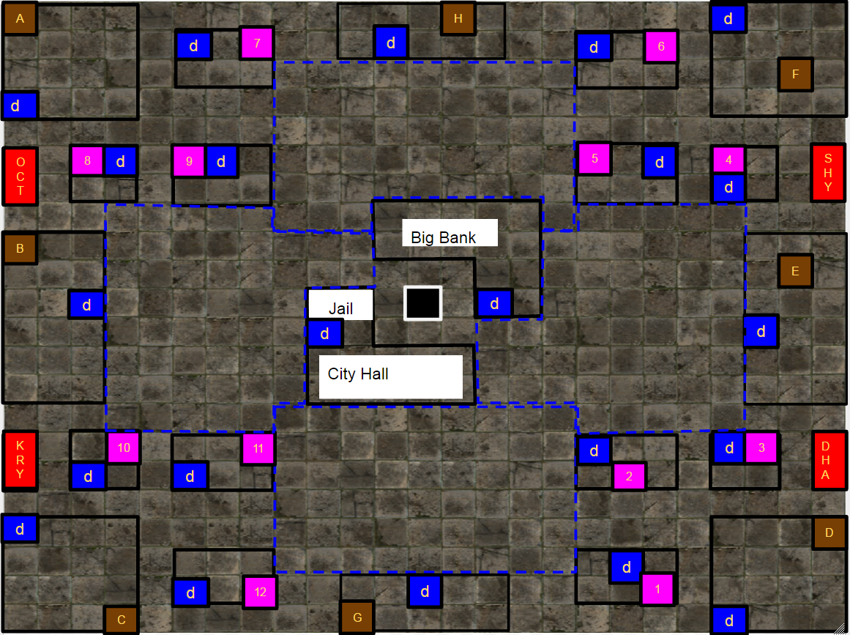

Map Legend:

Blue Dashed Areas - Main Road (See: Street Sweep)
Blue “d” Boxes - Doors/ Entrances
Brown Boxes - Advanced Theft Target Card Targets (identified using the LETTERS A - H)
Pink Boxes - Basic Theft Target Card Targets (identified using the NUMBERS 1 - 12)
Black Box (Center) - Black Market (identified by the black box with the white border)
Red Boxes - Syndicate Start Locations (identified by the red box with the yellow letters)

General Rules

- The end of a round is defined as all players completing their individual turns
- Players may move through another player’s piece, but may NOT occupy the same space.
- Players may NOT steal Thief Tools from opposing thieves, only Reputation Points. (See: Reputation Stolen (PVP)) “Honor amongst thieves.”
- Players may only purchase Tools from their Syndicate shop, or from the black market.
- Players may craft a more Advanced Tool from anywhere on the map, provided they have the necessary components.
- Legendary Tools can be crafted from either the 3 Basic Tools it describes OR an Advanced Tool plus a Basic Tool, as long as the necessary Basic Tools for that Legendary Tool are in that player’s possession. (e.x. A player combines their 3 Basic Tools of: a Rope, a Grappling Hook, and a Gun; into the Legendary Tool the Grappling Gun. This is an acceptable method also, a Player could have used the Advanced Tool, of a Grappling Rope plus a Gun to craft the Grappling Gun.)
- At any time, a player may return to their Syndicate and receive a new Theft Target Card, this replaces their previous Theft Target Card.
- Players can decide to do only Basic targets to obtain Reputation Points and then buy the required materials to create a Legendary Tools.
- Players can decide to deliberately steal from players to obtain their Reputation Points if they so choose instead of doing tasks to gain them.
- Players cannot block other players from entering a building deliberately.
- Once a player is ready to go after the Safe Storage Bank or City Hall, they have to identify which Theft Target they will be attempting before they begin moving on the heist. This is done from their Syndicate area. Fail to do so, and they have to go back to the Syndicate area and inform them of the anticipated job.
- Players who are ready to attempt the final job do not have to draw a new Theft Target card.
- Advanced Tool creation requirements were purposely created to limit the number of resources in Theft Target Card selection.
- If during the act of stealing your Thief Target your roll comes up “butterfingers” you must wait until your next turn to attempt to steal again. This restealing of the item must meet all the previous requirements including making a successful steal roll. Rolling butterfingers again repeats the process until you either get caught or steal the item.

Steal Breakdown (Player Vs. Player)
1 - 4: Failure (Player 2 steals Reputation Points from Player 1) 20% chance
5 - 14: Nothing happens. 50% chance
15 - 20: Success (Player 1 steals Reputation Points from Player 2) 30% chance

Reputation Stolen (PVP)
(Based on best tier Thief Tool owned)
Basic only: 1x 1d4 Reputation Points stolen
Advanced: 2x 1d4 Reputation Points stolen
Legendary: 3x 1d4 Reputation Points stolen
Stealing of Theft Target (Player Vs. Law)
**PVE Chance breakdown

Basic Theft Target - ~75% success rate roll a (6 - 20)
1 - 5: Failure (The Player is Arrested) 25% chance
6 - 20: Success (The Player takes a Theft Completion Token and their next turn proceeds normally) 75% chance

Advanced Theft Target- ~40% success rate roll a (13 - 20)
1 - 8: Failure (The Player is Arrested) 40% chance of failure
9 - 12: You have butterfingers and dropped the item. You must wait till your next turn to attempt to steal it again. 20% chance
13 - 20: Success (The Player takes a Theft Completion Token and their next turn proceeds normally) 40% chance of success

Legendary Theft Target- ~25% success rate roll a (16 - 20)
1 - 9: Failure (The Player is Arrested) 45% chance
10- 15: You have butterfingers and dropped the item. You must wait till your next turn to attempt to steal it again. 30% chance
16 - 20: Success (The Player takes a Theft Completion Token and their next turn proceeds normally) 25% chance

If you fail to roll a successful steal you go to jail

Mechanics

Combine
- Players will be able to combine two Thief Tools from the Basic Tools list to create Advanced Tools.
- Legendary Tools may also be crafted by combining three of the Basic Tools listed.

(The Culling)

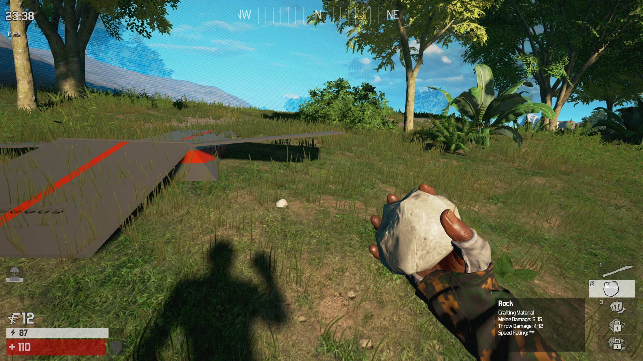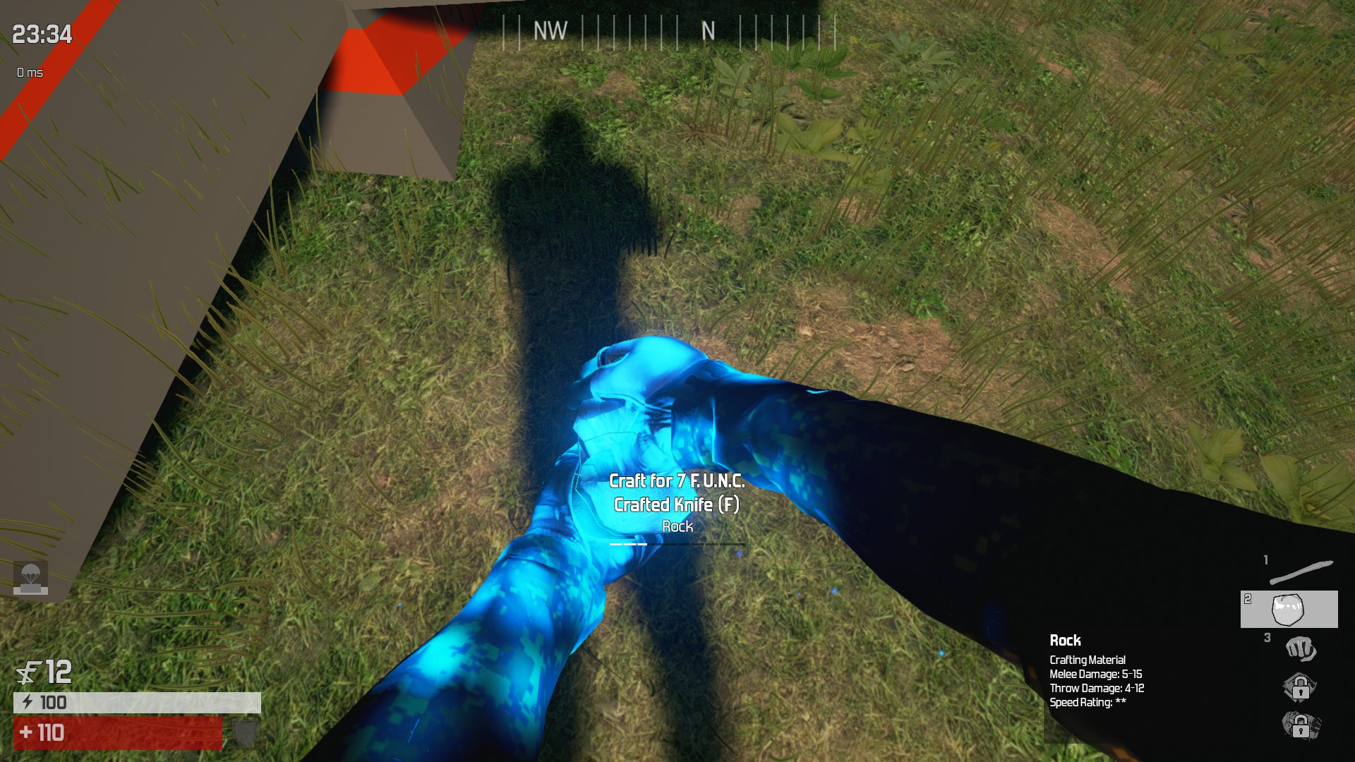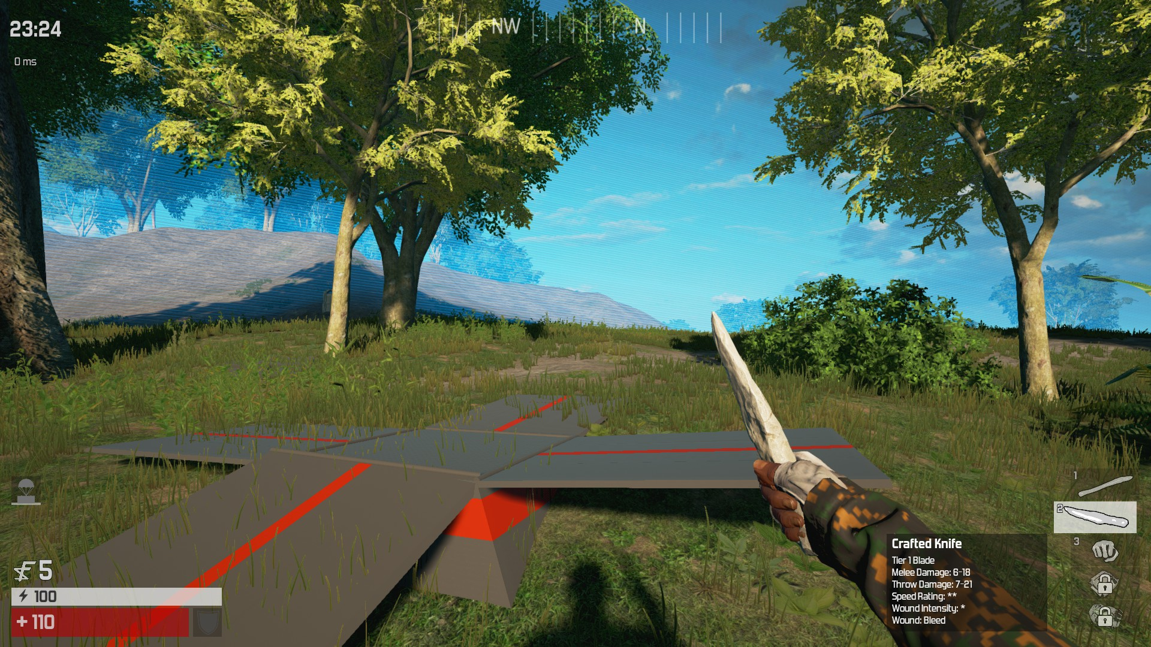

Translate (Movement)
- Enables the player to traverse the map making their way to either the syndicate store or job locations.
- Players are allowed to move up to the maximum number of spaces which is determined by a die roll.
(Warframe)
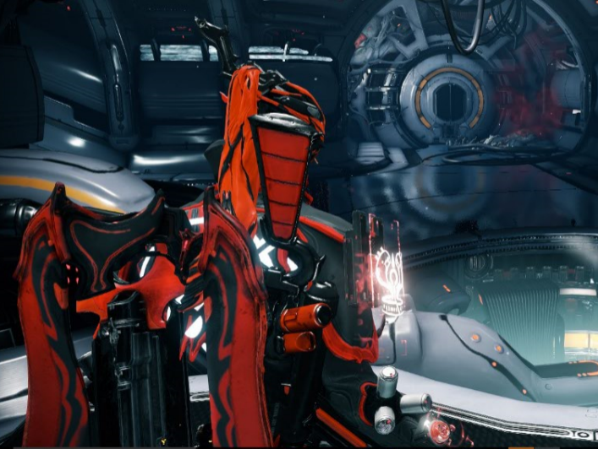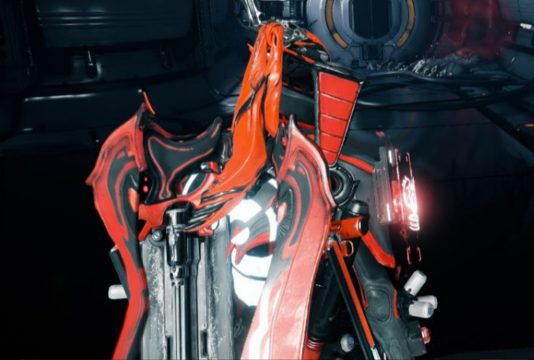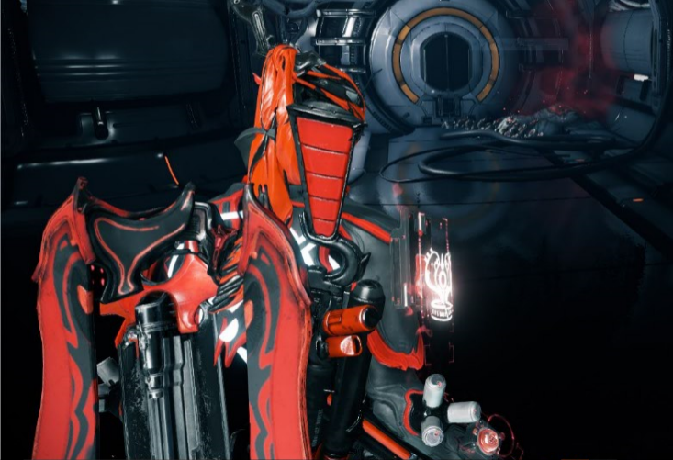

Steal- is represented through the follow actions in the game.
- Stealing from other players to acquire Reputation Points to obtain Thief Tools to advance in the game.
- Stealing specific items that are assigned to you to gain Reputation Points
- Stealing is also reflected when you get caught and sent to jail. It shows the reverse side of thieving and what will happen if you get caught.
(Rise of the Tomb Raider)
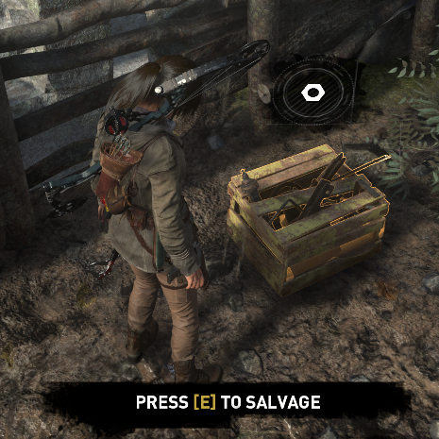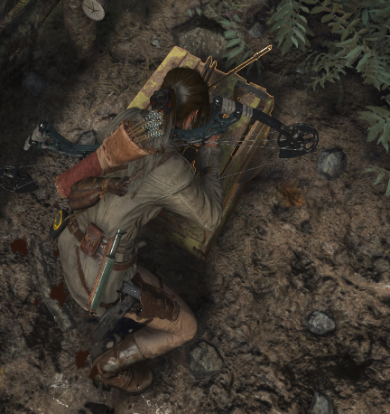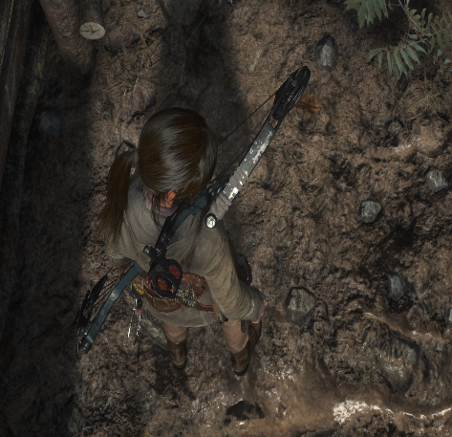

Disperse
- Players are given 2 resources to manage. Reputation Points and Thief Tools.
- It is your responsibility to keep track of your Reputation Points throughout the game, as well as the Thief Tool combinations you have made.
- Players must make smart decisions on how to spend their Reputation Points and on what Thief Tools to purchase.
- Players also must choose to purchase Basic Tools and craft their more Advanced Tools from the ground up, OR to purchase Advanced Tools and build up from there.
- Using their Thief Tools, Players attempt jobs to earn Reputation Points, the harder the
- Job the more Reputation Points are earned, as well as requiring more Advanced Tools to even attempt.

(Offworld Trading Company)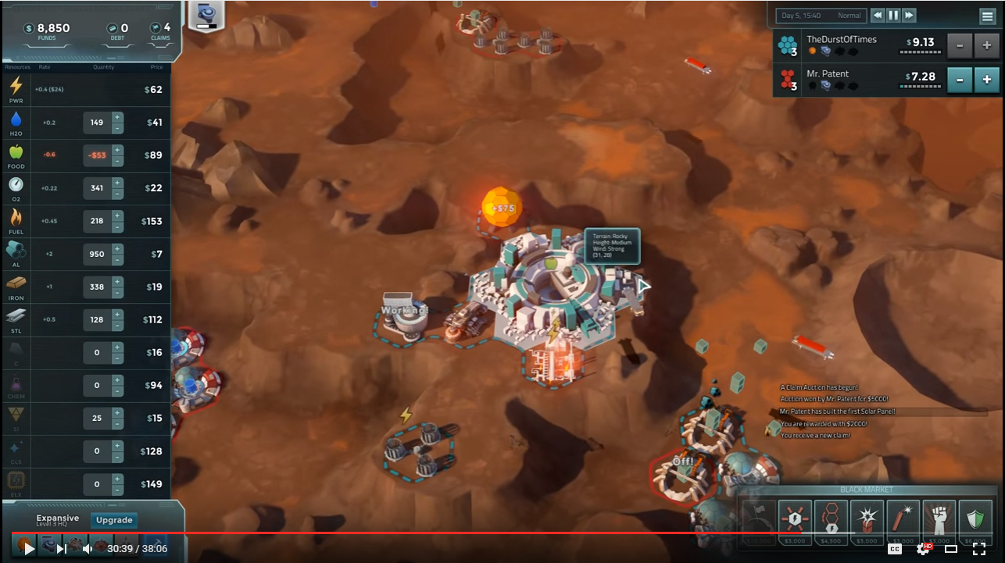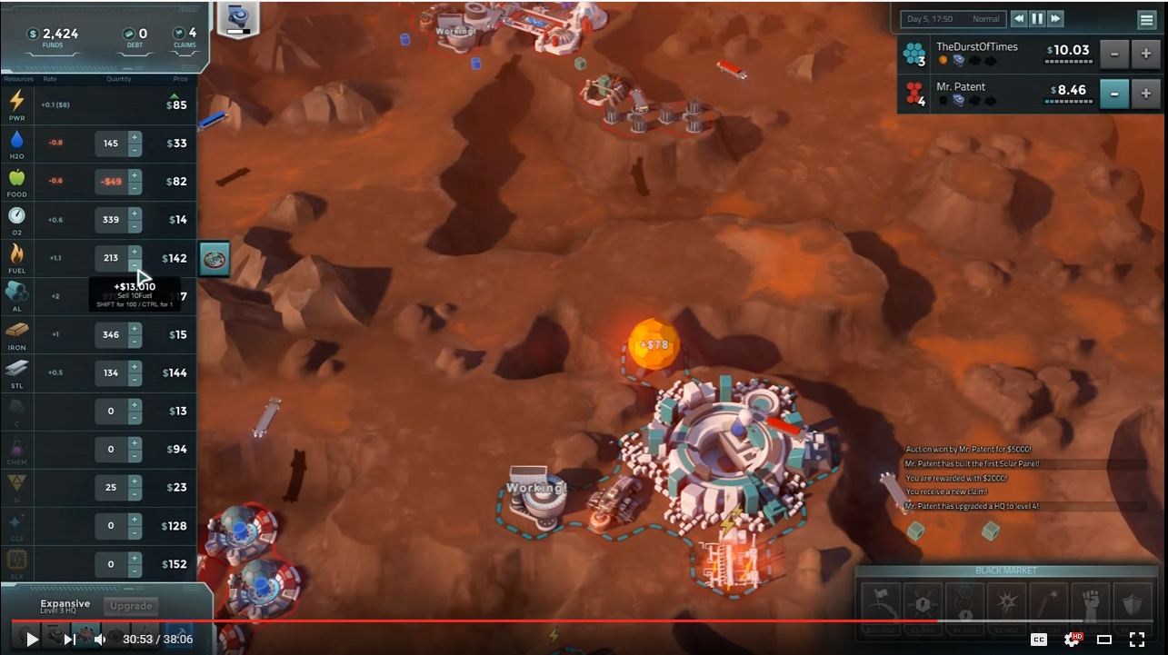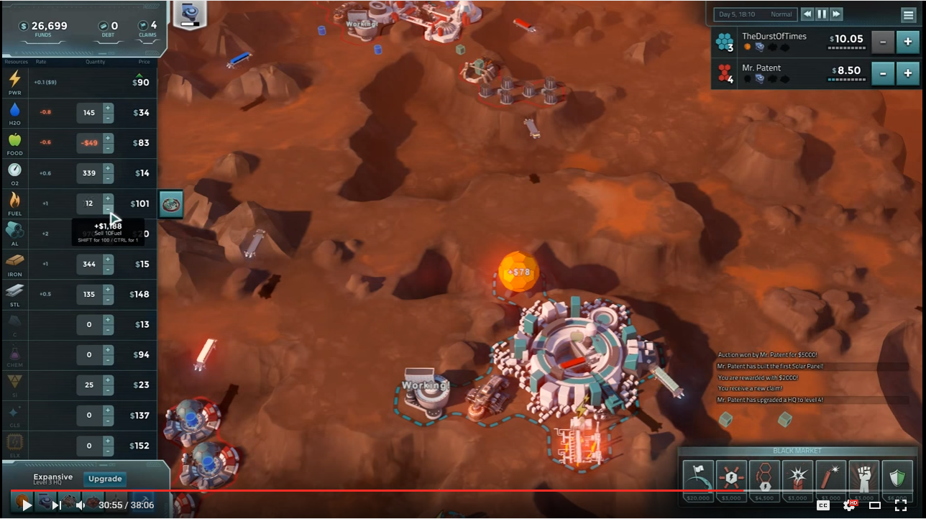

Thief Tools Page
Basic Tools: (Store Cost: 5) Advanced Tools: (Store Cost: 14)
Iron Thermite (Iron, Aluminum)
Detonation cord Frag Bomb (Iron, Detonation Cord)
Aluminum Grappling Rope (Rope, Grappling Hook)
Rope Hook Gun (Gun, Grappling Hook)
Gun Master Key (Keys, Lockpick)
Grappling Hook Intruder Set (Lockpick, Wire Cutters)
Wire Cutters Plan A (First Aid Kit, Intel)
Lockpick Field Kit (First Aid Kit, Dagger)
Keys
First Aid Kit Legendary Tools: (Crafted Only)
Intel Grappling Gun (Rope, Grappling Hook, Gun)
Dagger Vault Breaker (Iron, Aluminum, Detonation Cord)
Alarm Kit (Keys, Lock Picks, Wire Cutters)
Plan B (First Aid Kit, Intel, Dagger)

Theft Target Page
Basic Targets (Only require Basic Tools)
Basic Theft Target reward - 6 Reputation Points
- Pearl necklace- Location 1 requires Iron to attempt
- Royal Wallet - Location 2 requires Intel to attempt
- Diamond Ring - Location 3 requires Detonation Cord to attempt
- Emerald Broach - Location 4 requires Rope to attempt
- Fur coat - Location 5 requires a Gun to attempt
- Laptop Computer - Location 6 requires Aluminum to attempt
- Colbert 45 - Location 7 requires a Grappling Hook to attempt
- Ship in a bottle - Location 8 requires Keys to attempt
- Bicycle - Location 9 requires a Lockpick to attempt
- Camera- Location 10 requires a Dagger to attempt
- Stereo Receiver- Location 11 requires a First Aid Kit to attempt
- Flat Screen TV- Location 12 requires Wire Cutters to attempt

Advanced Targets (Requires at least one Advanced Tool)
Advanced Theft Target reward - 17 Reputation Points
- Gold Key to the City- Location A requires the Hook Gun
- Diamond Tiara - Location B requires a Master Key to attempt
- Fobarg egg- Location C requires Thermite to attempt
- Golden lamp- Location D requires Plan A to attempt
- Dondinchi’s Invention Notebook- Location E requires a Frag Bomb to attempt
- Gold backpack - Location F requires Field Kit to attempt
- Suit of Armor- Location G requires a Grappling Rope to attempt
- Jeweled Scepter- Location H requires an Intruder Set to attempt

Legendary Targets
Legendary Theft Target reward - Victory
- City Hall - requires Legendary Tools Grappling Gun and Alarm Kit
- Safe Storage Bank - requires Legendary Tools Vault Breaker and Plan B

Cards
Examples:
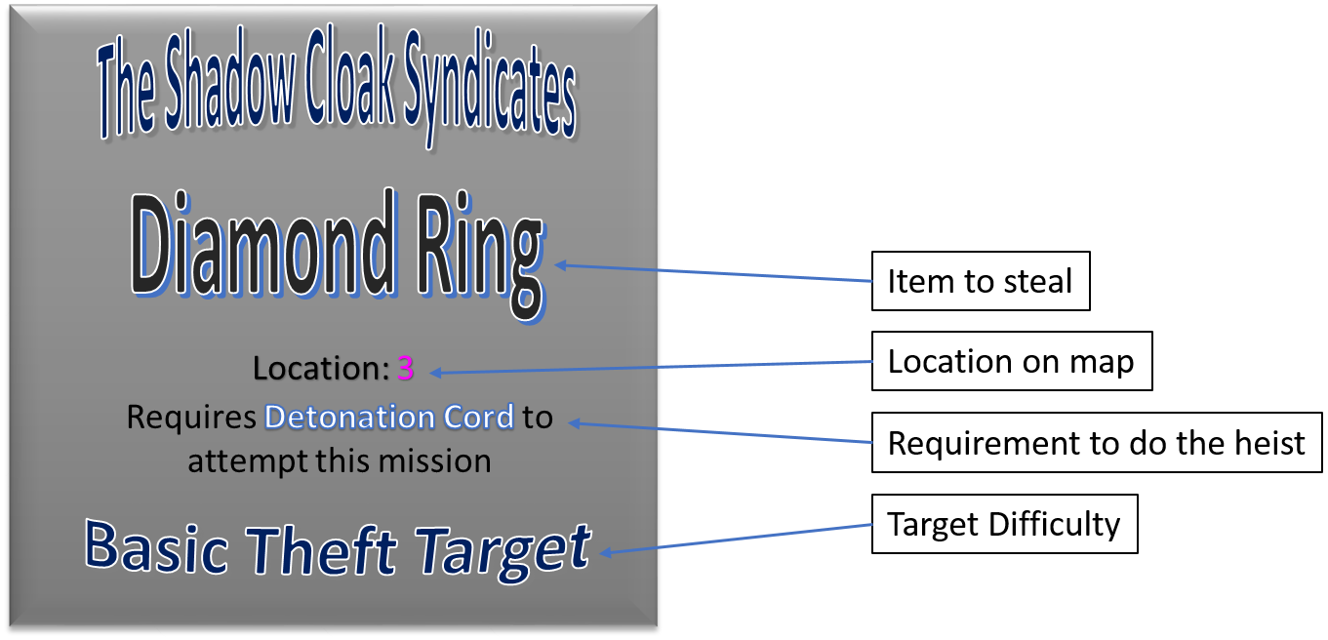

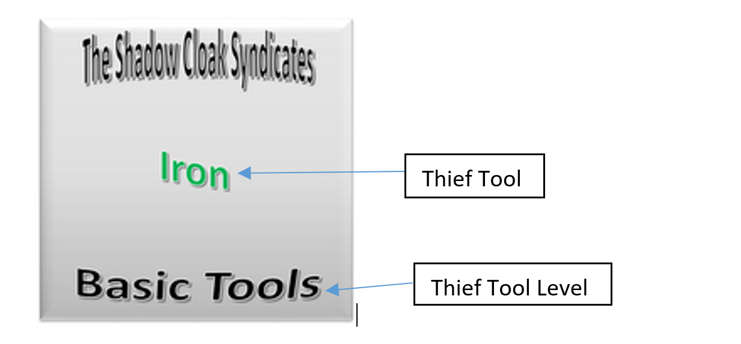

Tools and Theft Target Cards

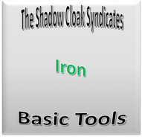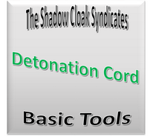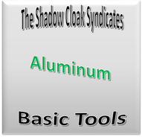
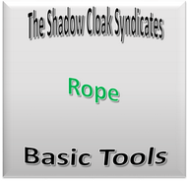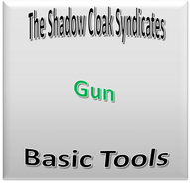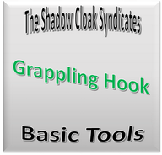
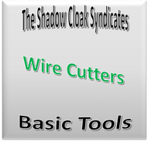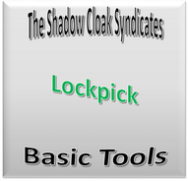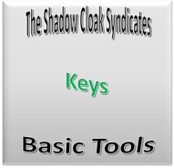
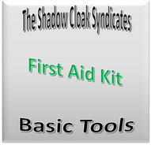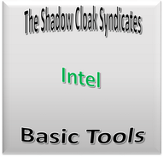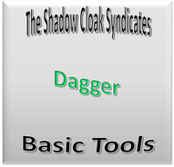

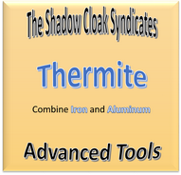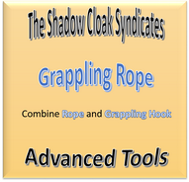
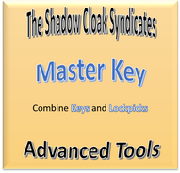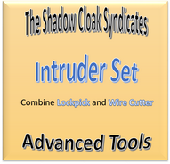
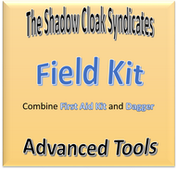
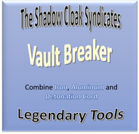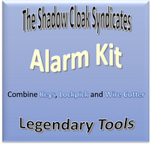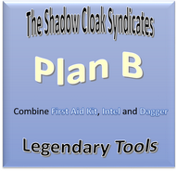

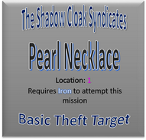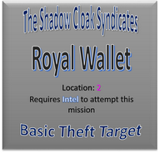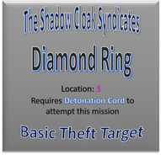
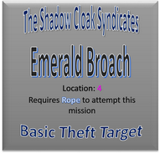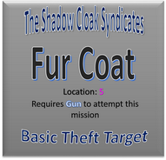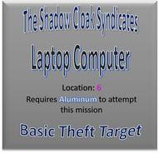
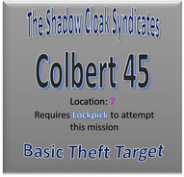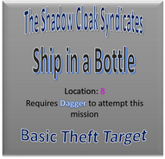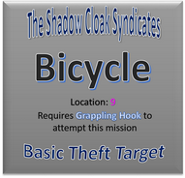
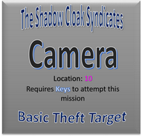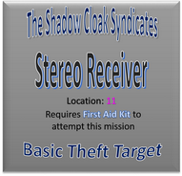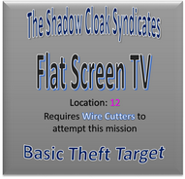
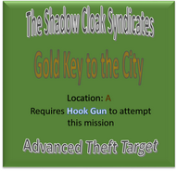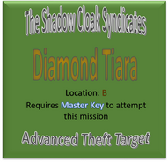
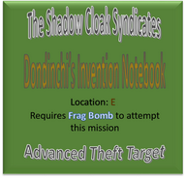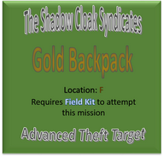
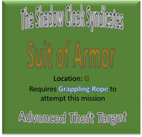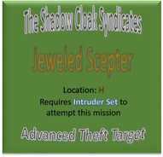

References

Culling, The (Combine). [Personal photographs taken on My computer]. (2016, June 11)
Rise of the Tomb Raider (Stealing) [Personal photographs taken on My computer]. (2016, June 8)
Schwartz, S. (n.d.). 10 Most Stolen Items from Burglaries. Retrieved June 11, 2016, from http://www.grandparents.com/food-and-leisure/did-you-know/most-stolen-items
Burglary stats
Warframe (Moving) [Personal screenshots taken of my own gameplay]. (2016, June 11th)
What's yours is mine [Thief Picture]. (2013, November 27). Retrieved June 10, 2016, from http://www.hdwallpapers.im/what_s_yours_is_mine-wallpaper.html
Thief Image
Zagorodnya, D. (2015, November 30). Most commonly stolen home possessions. Retrieved June 11, 2016, from http://www.confused.com/home-insurance/articles/household-items-most-likely-to-be-stolen Burglary
Northernlion. (2015). Let's Look At: Offworld Trading Company! [Video file] Retrieved June 12, 2016, from https://www.youtube.com/watch?v=UiFJtijiVLI

