The Shadow

Cloak Syndicates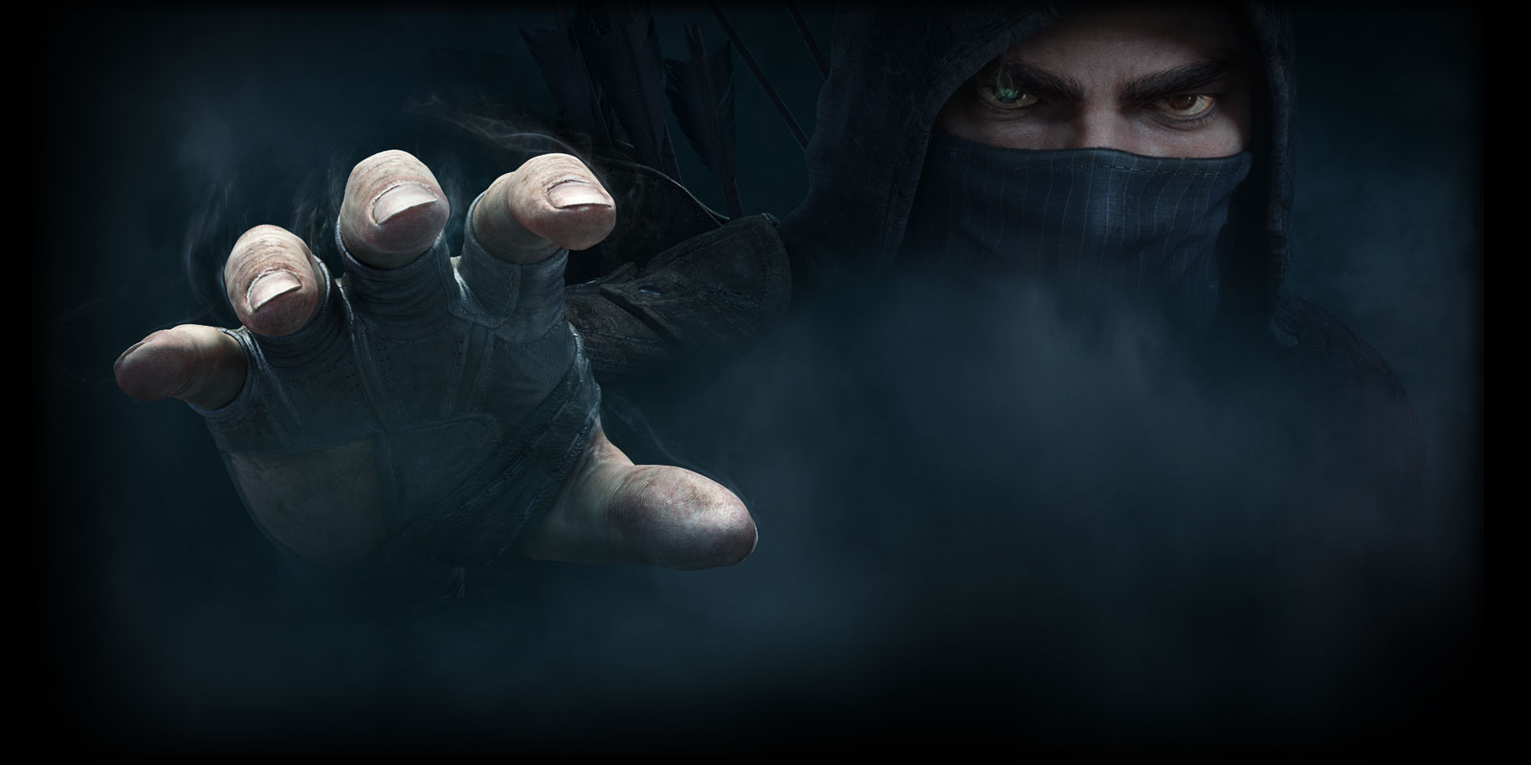
Thief Picture
*Picture used as a basic representation of the box’s art style.

Produced by:

Kyle Kolash
Michael Johnson
Andrew Kurtz
Jamie Jenkins
Description

This game is about The Shadow Cloak Syndicate and the story of the “Great Heist”. You are retelling the story of the Great Heist based on the Thief's Tools you had to work with at the time. However, that is the end of the story. The story actually begins with your Training as a Thief in the classroom. The classroom is not like you would think; you are actually on the Gallows with a rope around your neck. You are presented with a Theft Target and you have to assess what this target could be based on the six questions you are allowed to ask before you pass out. Get it wrong and your turn ends in a blackout. Getting it correct, however, will in turn give you Reputation Points that you can use to purchase Thief Tools, which you can use and combine together to help you pull off your big job that you are planning. With your lessons complete, it's time for the Final Exam. A real robbery worthy of going down in the school’s history books, just like the epic stories you read about. Your reputation as a Thief is on the line. Using the Thief Tools, you have purchased throughout class, you pull off an epic robbery and retell your story. The gameplay consists of 3-5 players assuming the role of any one of the syndicates. The game is based on the Players collecting specific resources that are required for the Great Heist. The Great Heist is a preconstructed story with holes in it. The players use their items to fill in these story gaps in order to make it fun, exciting, humorous, etc. There are also specific blanks in which players must combine their items. (e.x. A player combines their Rope and Grappling hook, creating a grappling rope in order to scale a wall in the story.) Only one Player can actually win though. The Player with the best story which includes the tools they have acquired, judged by his or her peers is declared the winner. How will your story go?

Designer’s Intent:

- Suggested for players ages 12 and up
- Recommended number of players is 3-5
- Geared toward both a male and a female audience
- Semi-Competitive game title without the standard means of “combat”
- Creative use of assets obtained during the early parts of the game to tell a Legendary Story
- Teaches resource management through small goal setting
- Teaches quick, creative decision-making skills.
- Further creative use in item combinations for story development
- Teaches players about the harshness of reality and the rewards of success
- Allows players to be a “bad guy” and still win
- Easily understood reward systems and victory conditions
- Relaxed and group focused game designed to inspire creativity and visual thinking

Materials List:

- 35 - 2”x3” Tool Cards (of varying values)
- 40 - 2”x3’” Theft Target Cards (of varying values)
- 1 pad of paper to keep track of Reputation Points
- 1 pen or pencil for writing
- 5 Great Heist Stories Copies
- 1 Thief Target Values page
- 1 Thief Tools Cost page

Rules

Setup

All players start with 0 Reputation Points and must be able to identify Thief Targets to attain Reputation Points in order to obtain Thief Tools. Players take one of the five stories from the pile and leave it face down until the end of the game where they flip it over and have to use it to create the Great Heist Story.

Turn Sequence

Pre-Draw Phase- The youngest player starts first. The player who goes first rotates to the left one person at the start of every new round after the first round.

Draw and Identify- When the current player starts his or her turn the player to the left of them draws a card from the Theft Target Pile. The Player then has 6 Questions in a “Guess Who?” style to identify the target from a list and obtain the Reputation Points the card rewards you with. Examples of a question are like “is it made of metal?” Failure to identify the item by the end of the 6th question and the Gallows claims your life for the rest of the turn.
Award Phase- Correctly guessing the item not only gets you out of danger but, also nets you a reward from the school. They grant you Reputation Points based on the value of the card.

Syndicate Purchases Phase - During this phase, Players may spend accumulated Reputation Points to obtain a Thief Tool to utilize later during their Great Heist story. When this Phase begins, any Tools for sale in the Black Market are shuffled into the pile and one Tool is put face-up on the table, next to the Thief Tools deck per each Player. These Tools are now available to purchase. The Player may choose to purchase any of the Tools that are available or even none of them.

End of Round

Trading Phase - During this phase, players may offer to trade any of their Thief Tools with any other player. What items those players are trading may be kept secret, however the trade itself must be made public to all Players. This means NO under-table trades, all players must be aware that a trade is occurring. Players may also trade Reputation Points, but the amount of Reputation Points traded must be made public knowledge.

Grand Heist Phase

Tell your story- During this phase Players create the legendary tale of their Grand Heist. To create this tale, they take the Thief Tools and plug them into the story to make the most interesting version and win the game. During the creation of the story there will be examples like, “I used the _____ and the _____ to create something new called _____.” Where the Red space is your Combined Tool that you made by mashing together two other Tools in the Blue Spaces. Lastly there are Black spaces where you also use your basic Tools. Players may use each of their Tools only twice, once in a Blue space, and once in a Black space.

Vote- After each story has been read out loud the players decide who did it the best. This can be based on funniest story, the one that made the most sense, the wackiest story or what whatever you decide on before the evaluation begins. Each Player must cast a vote and they may vote for themselves. The winner is the one that has the most votes. In case of tie, the player with the most Reputation Points will be declared the winner.

General Rules

- The end of a round is defined as all players completing their individual turns
- Players may only purchase Tools from their Syndicate.
- Players must make their guess as to what the Thief Target is after the 6th question has been answered. They may choose to answer what the item is before if they know it before.
- Guesses as to your Theft Target before the 6th Question count as questions asked. In this example the player guesses that his metal Theft Target is a sword. This is wrong, and now the player can ask one less question.
(E.x. A player’s Theft Target is the Crown. He asks, “Is it made of metal?” Yes, first question. “Is it a Sword?” No, second question.)
- When addressing the Red lines in the story, the items being combined Blue lines must not have been used in another combine and the combined item’s name must make sense in the newly created Red word.
- You may need to explain or possibly even draw out your Combined Tools for the group to understand its function or creation.
- You are only allowed to vote one time, per Voting Phase.
- The youngest player goes first at the start of the game.
- You can only possess 5 Thieves Tools at a time. If you gain a 6th, you must discard a Tool.
- Discarded Tools are shuffled back into the Thieves Tools.
- Any Thieves Tools left unpurchased at the end of the round get shuffled back into the piles at the end of the round.
- All players will write out the completed version of the Great Heist regardless of their writing skills.
- Players will present their story to the group out loud.
- Players can only use each Thief Tool once within The Great Heist story, by itself. These Lines are black in color. (e.x. _______)
- Players must create two combined items using four out of your five Thief Tools. This combine is separate from the basic use noted above. These lines are indicated by Blue sections (e.x. _______). In this case and only this case, a Thief Tool can a used again.
(A Player uses Rope to scale a wall. Rope can no longer be used as a basic use. However, the Player CAN use it later in a combine. The Player uses the same Rope later along with a Grappling Hook to get onto the roof with a Grappling Rope. This is proper and acceptable.)

Mechanics

Combine
- Players will combine together multiple Thief Tool names in a story format to create a new combined name (two names put together) that they will then use in their Great Heist Story.
- Player will combine single Thief Tool names into a fixed format to generate action or describe a part of their own Great Heist story.

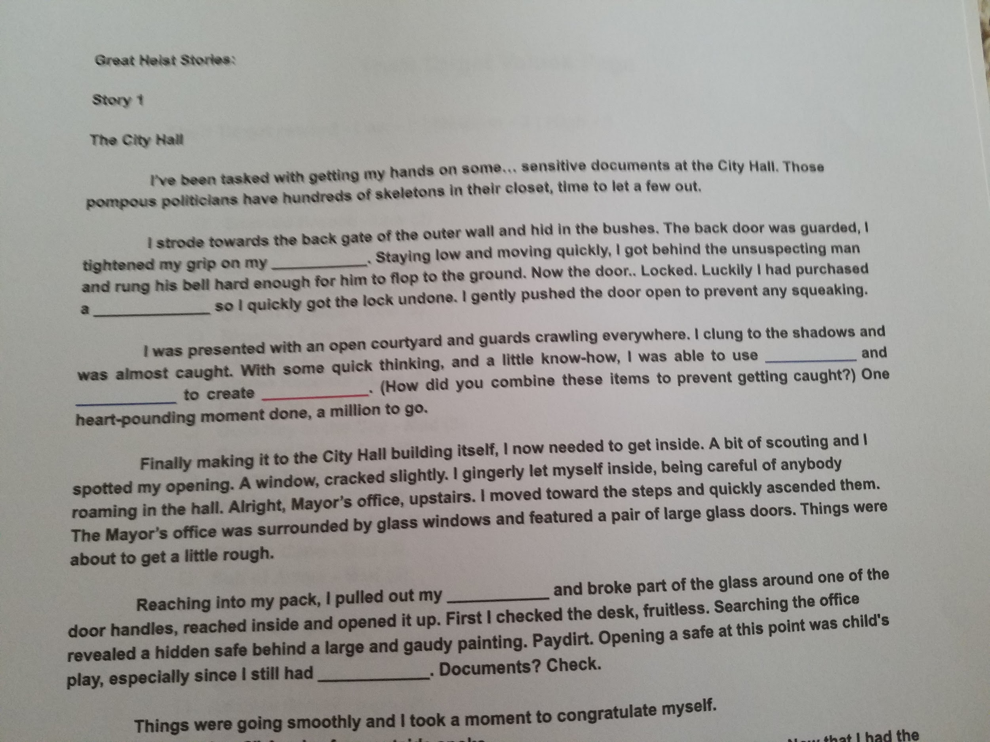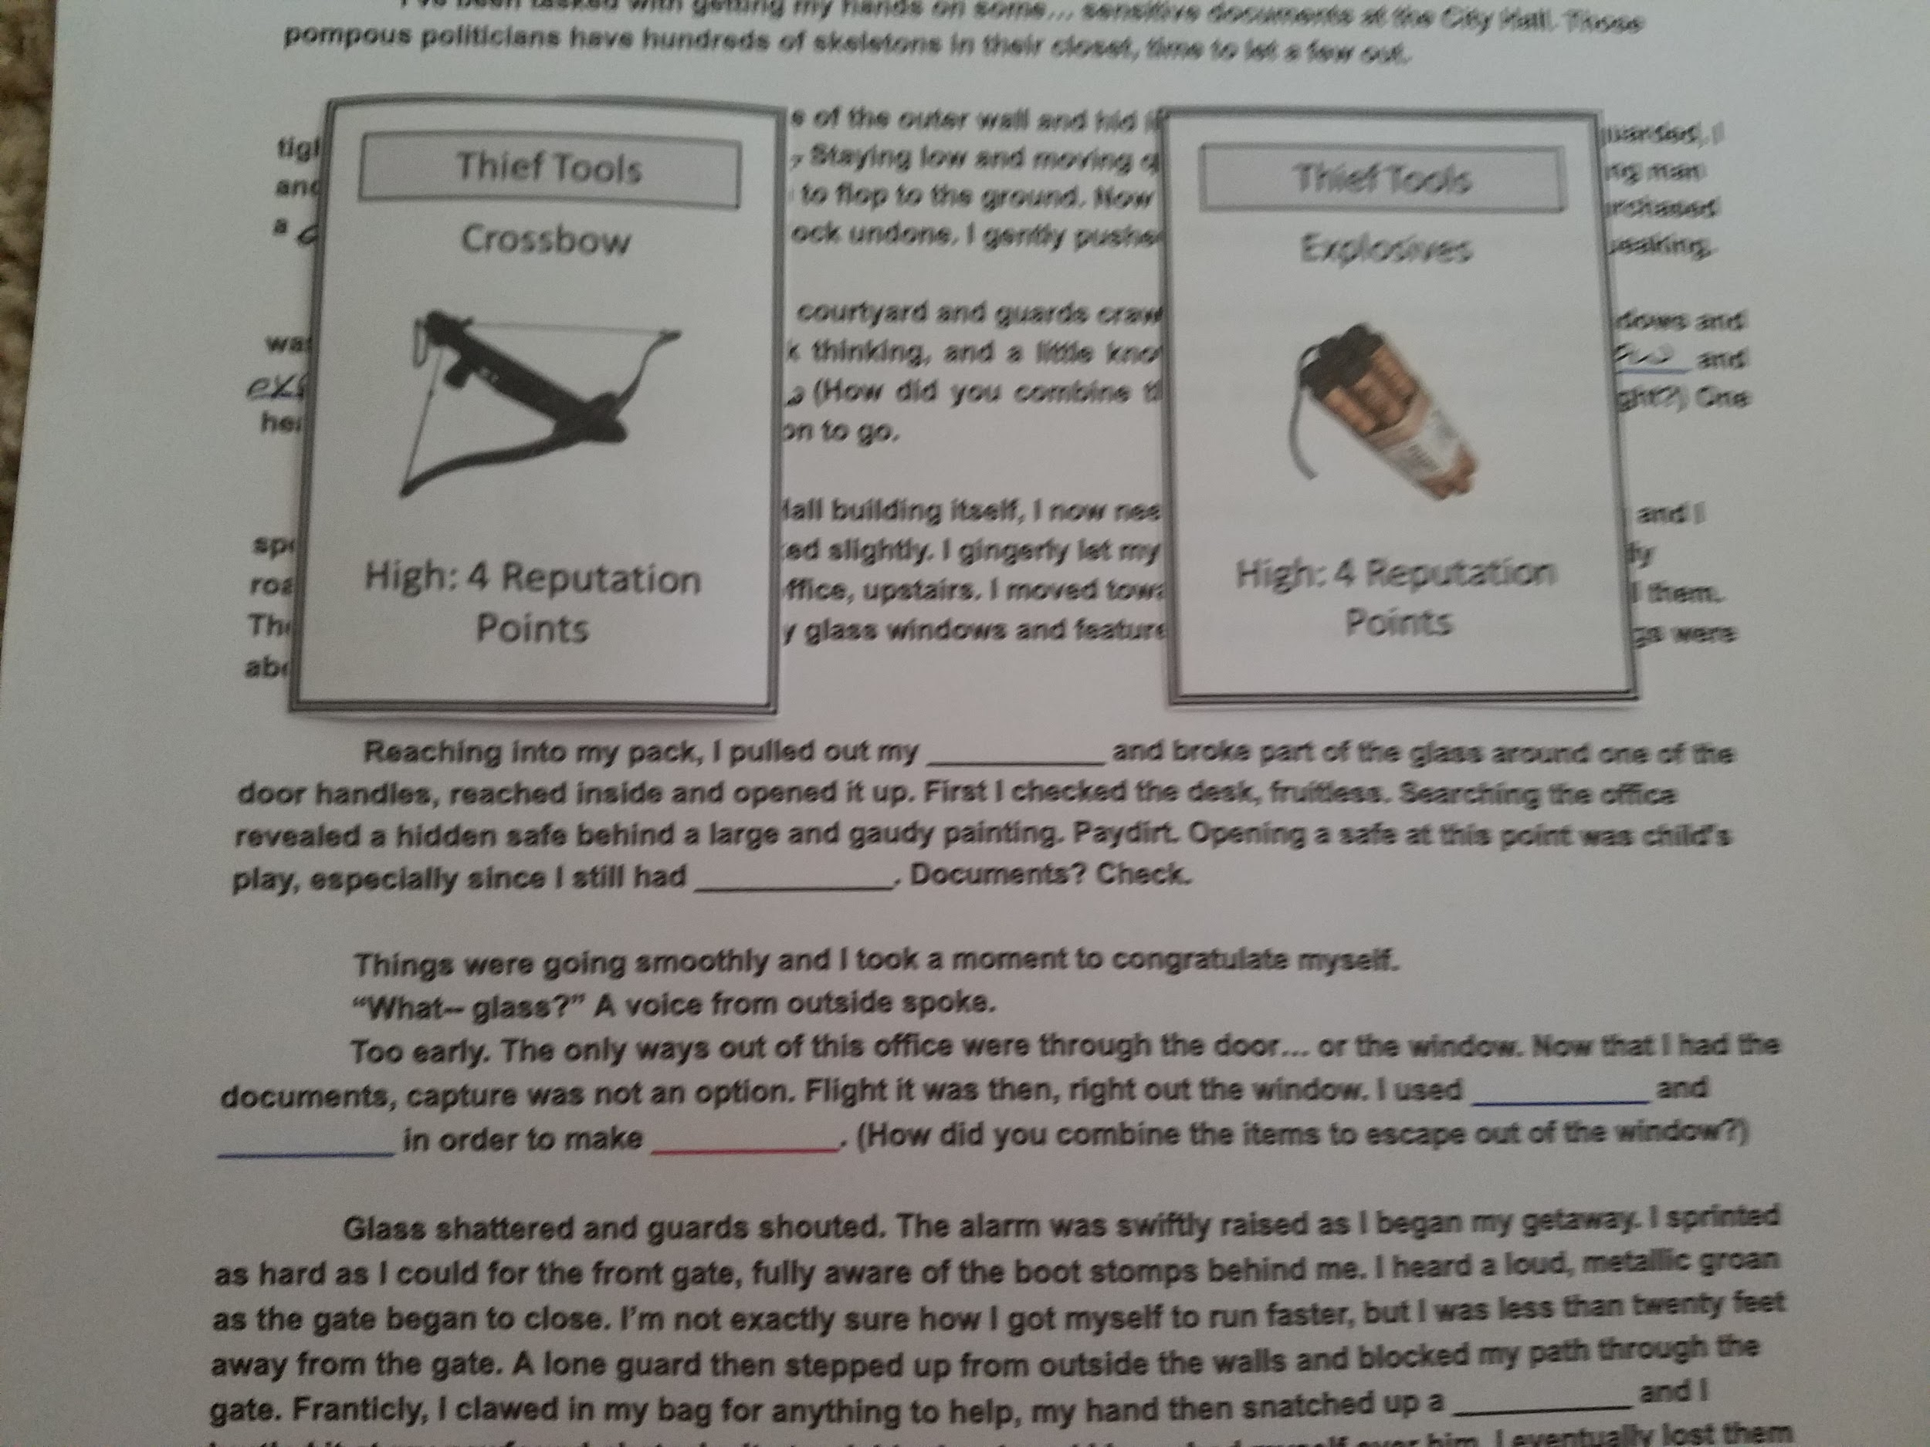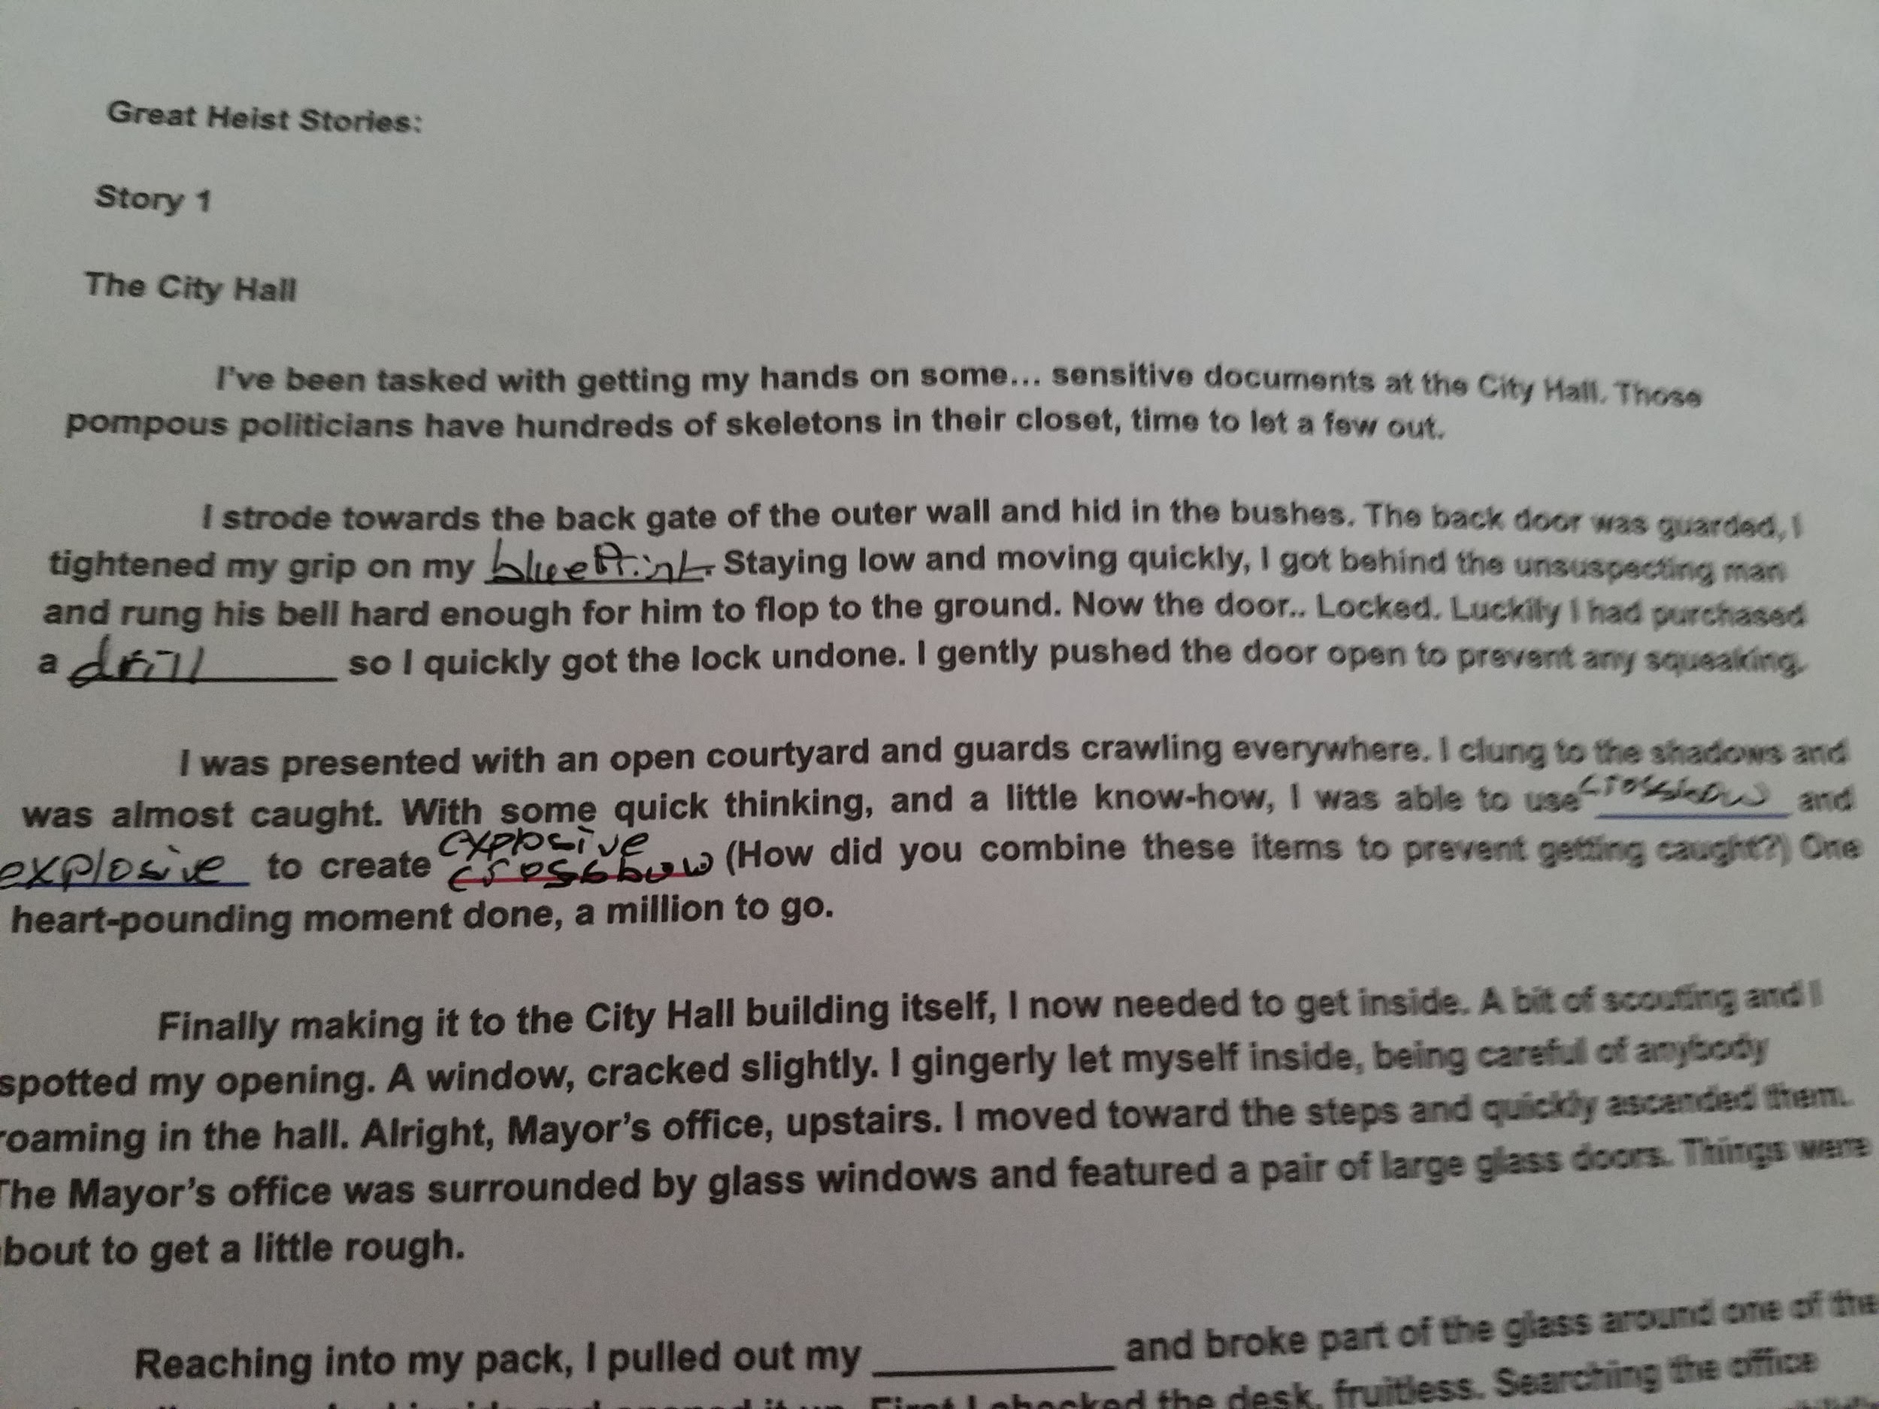

Guess
- Players guess on what items they are trying to steal through process of elimination post inquiry.
- Players gather information to guess the item with Yes or No based questions.
- Players are limited on the number of inquiries.
- Players guessing their Theft Targets functions very similarly to Guess Who?

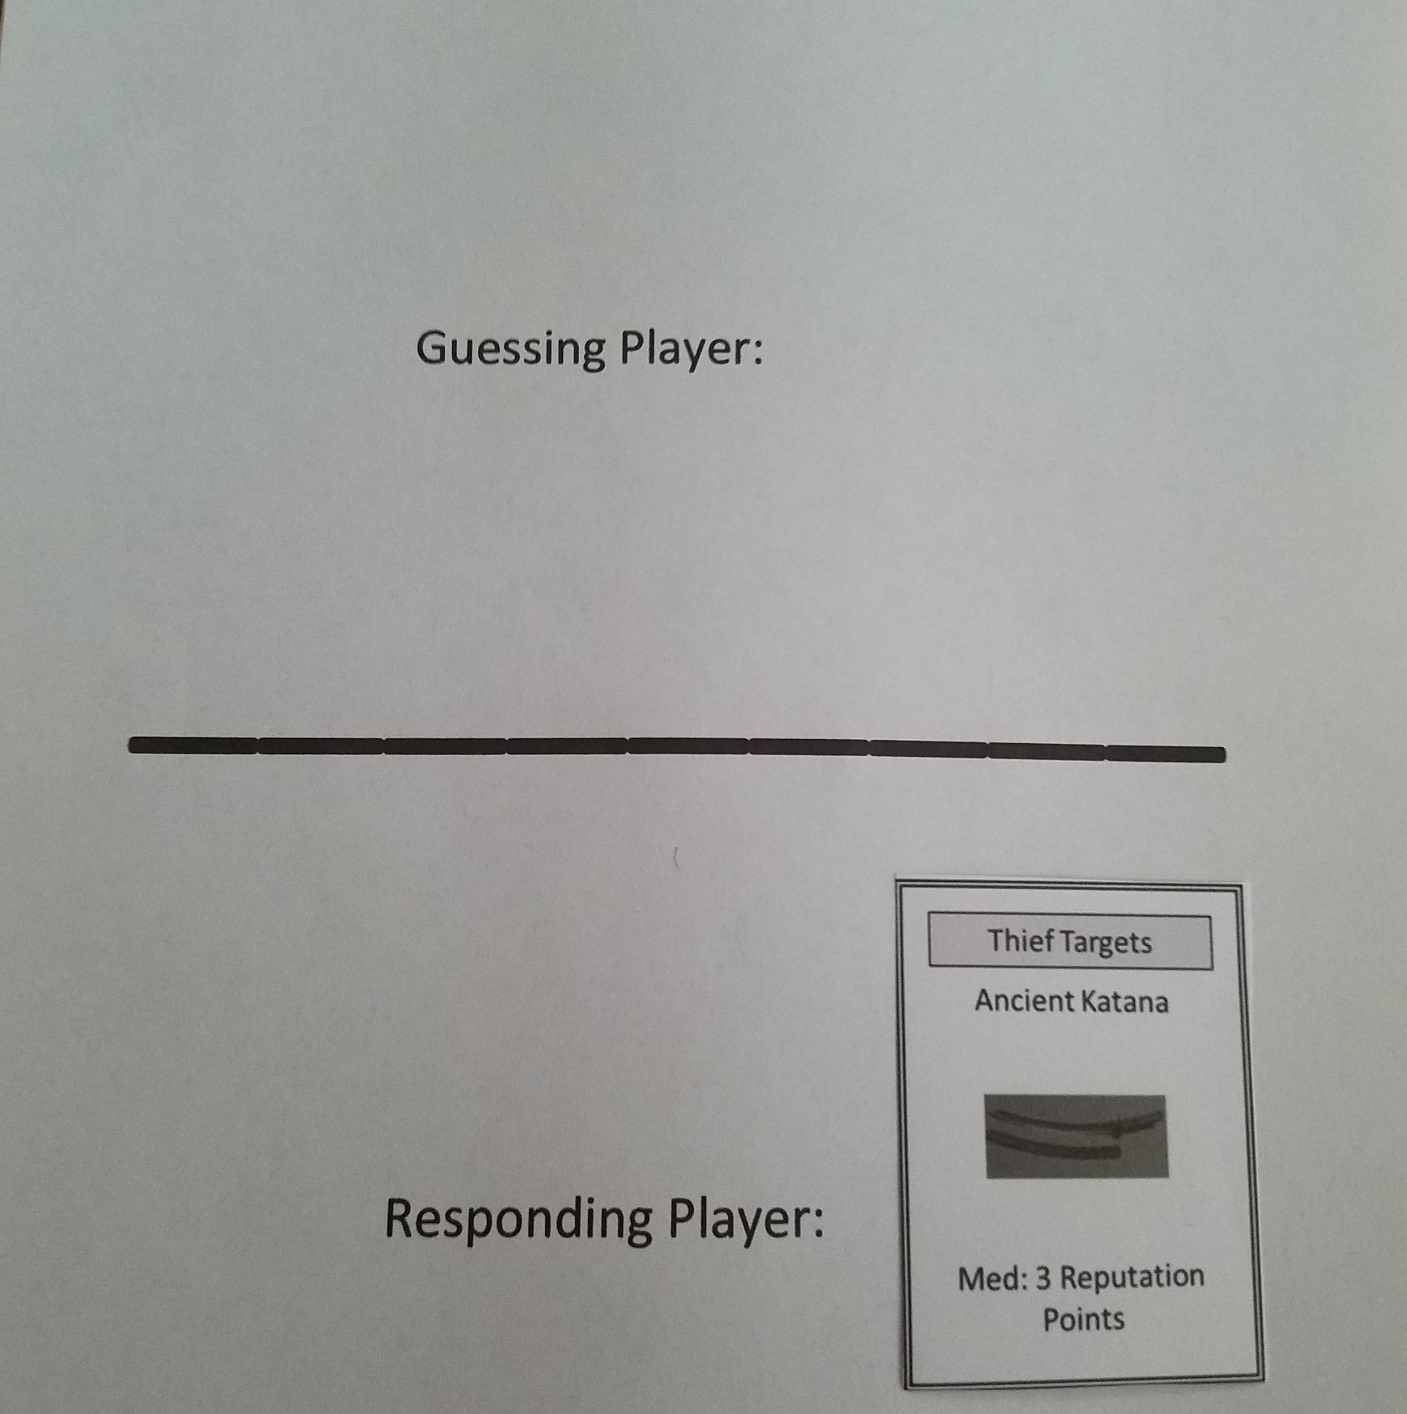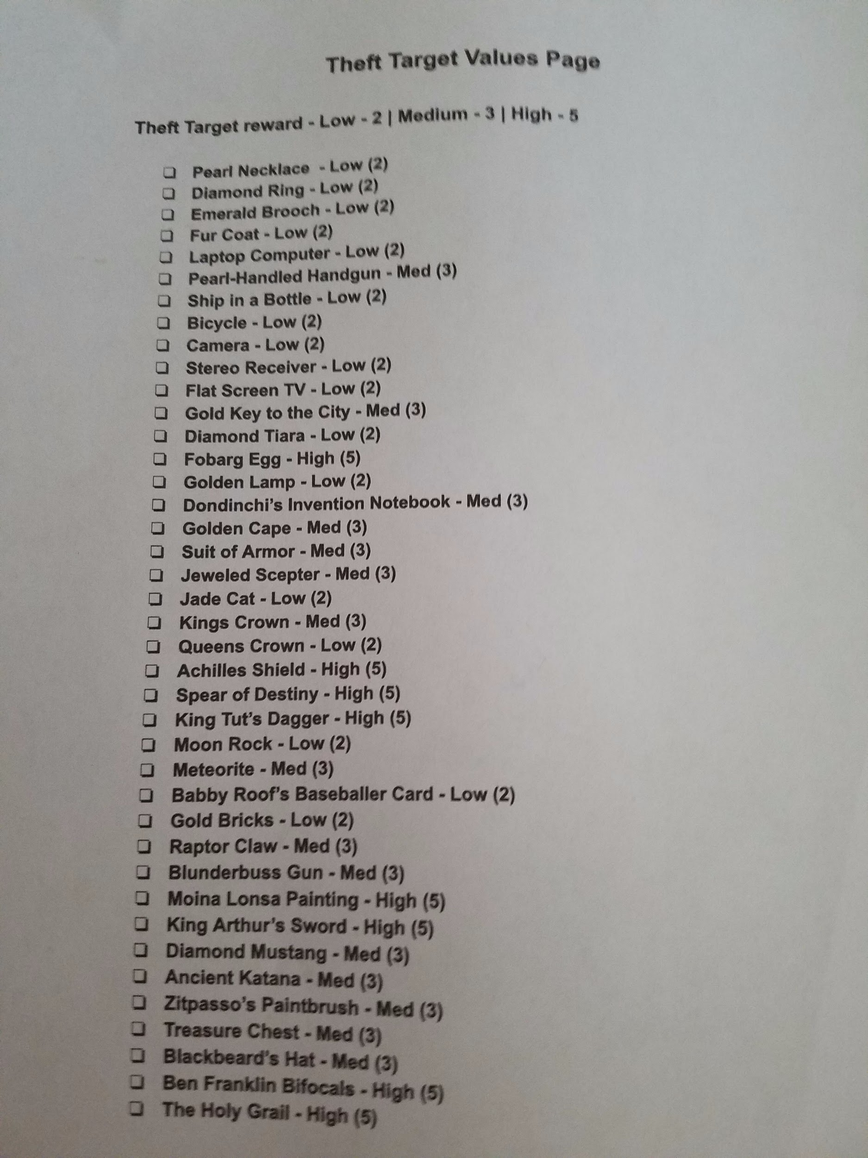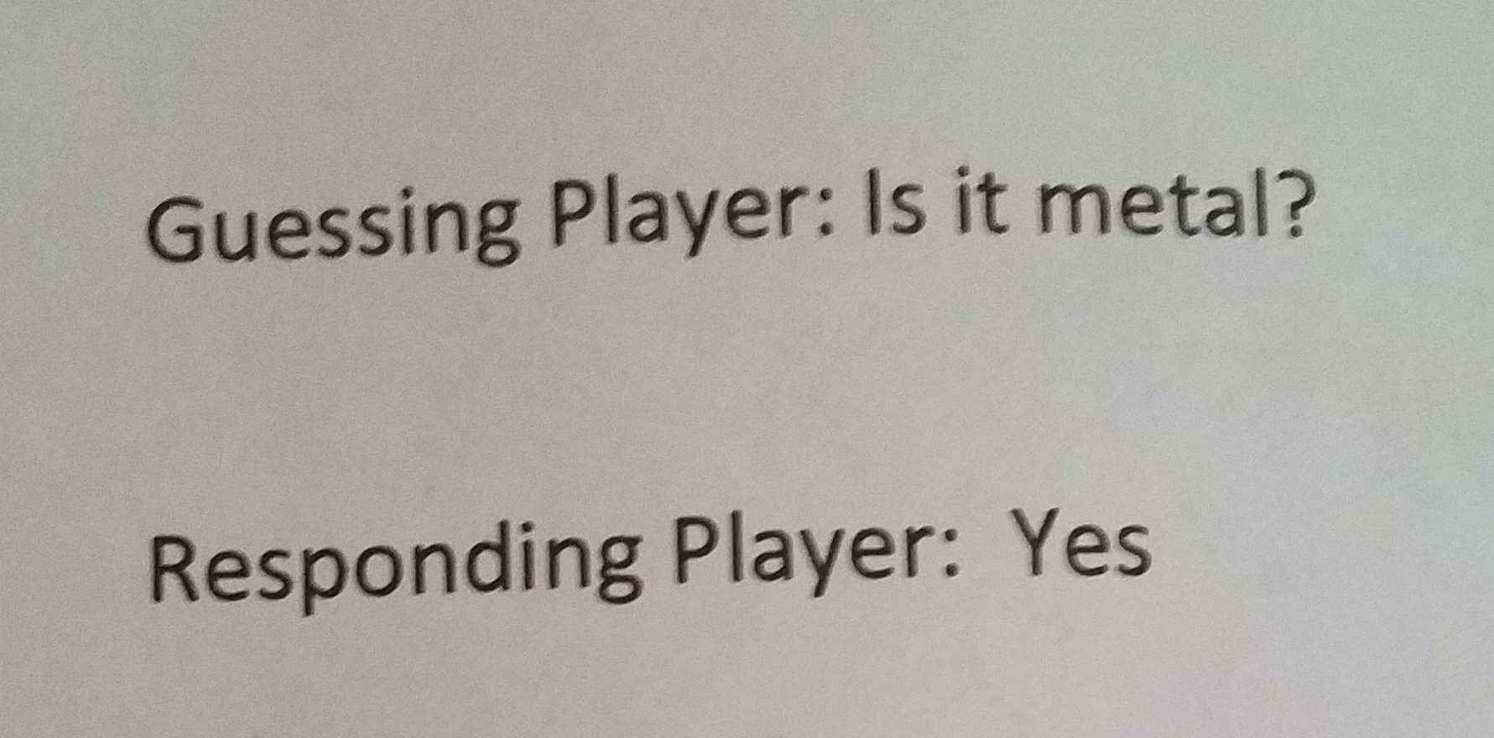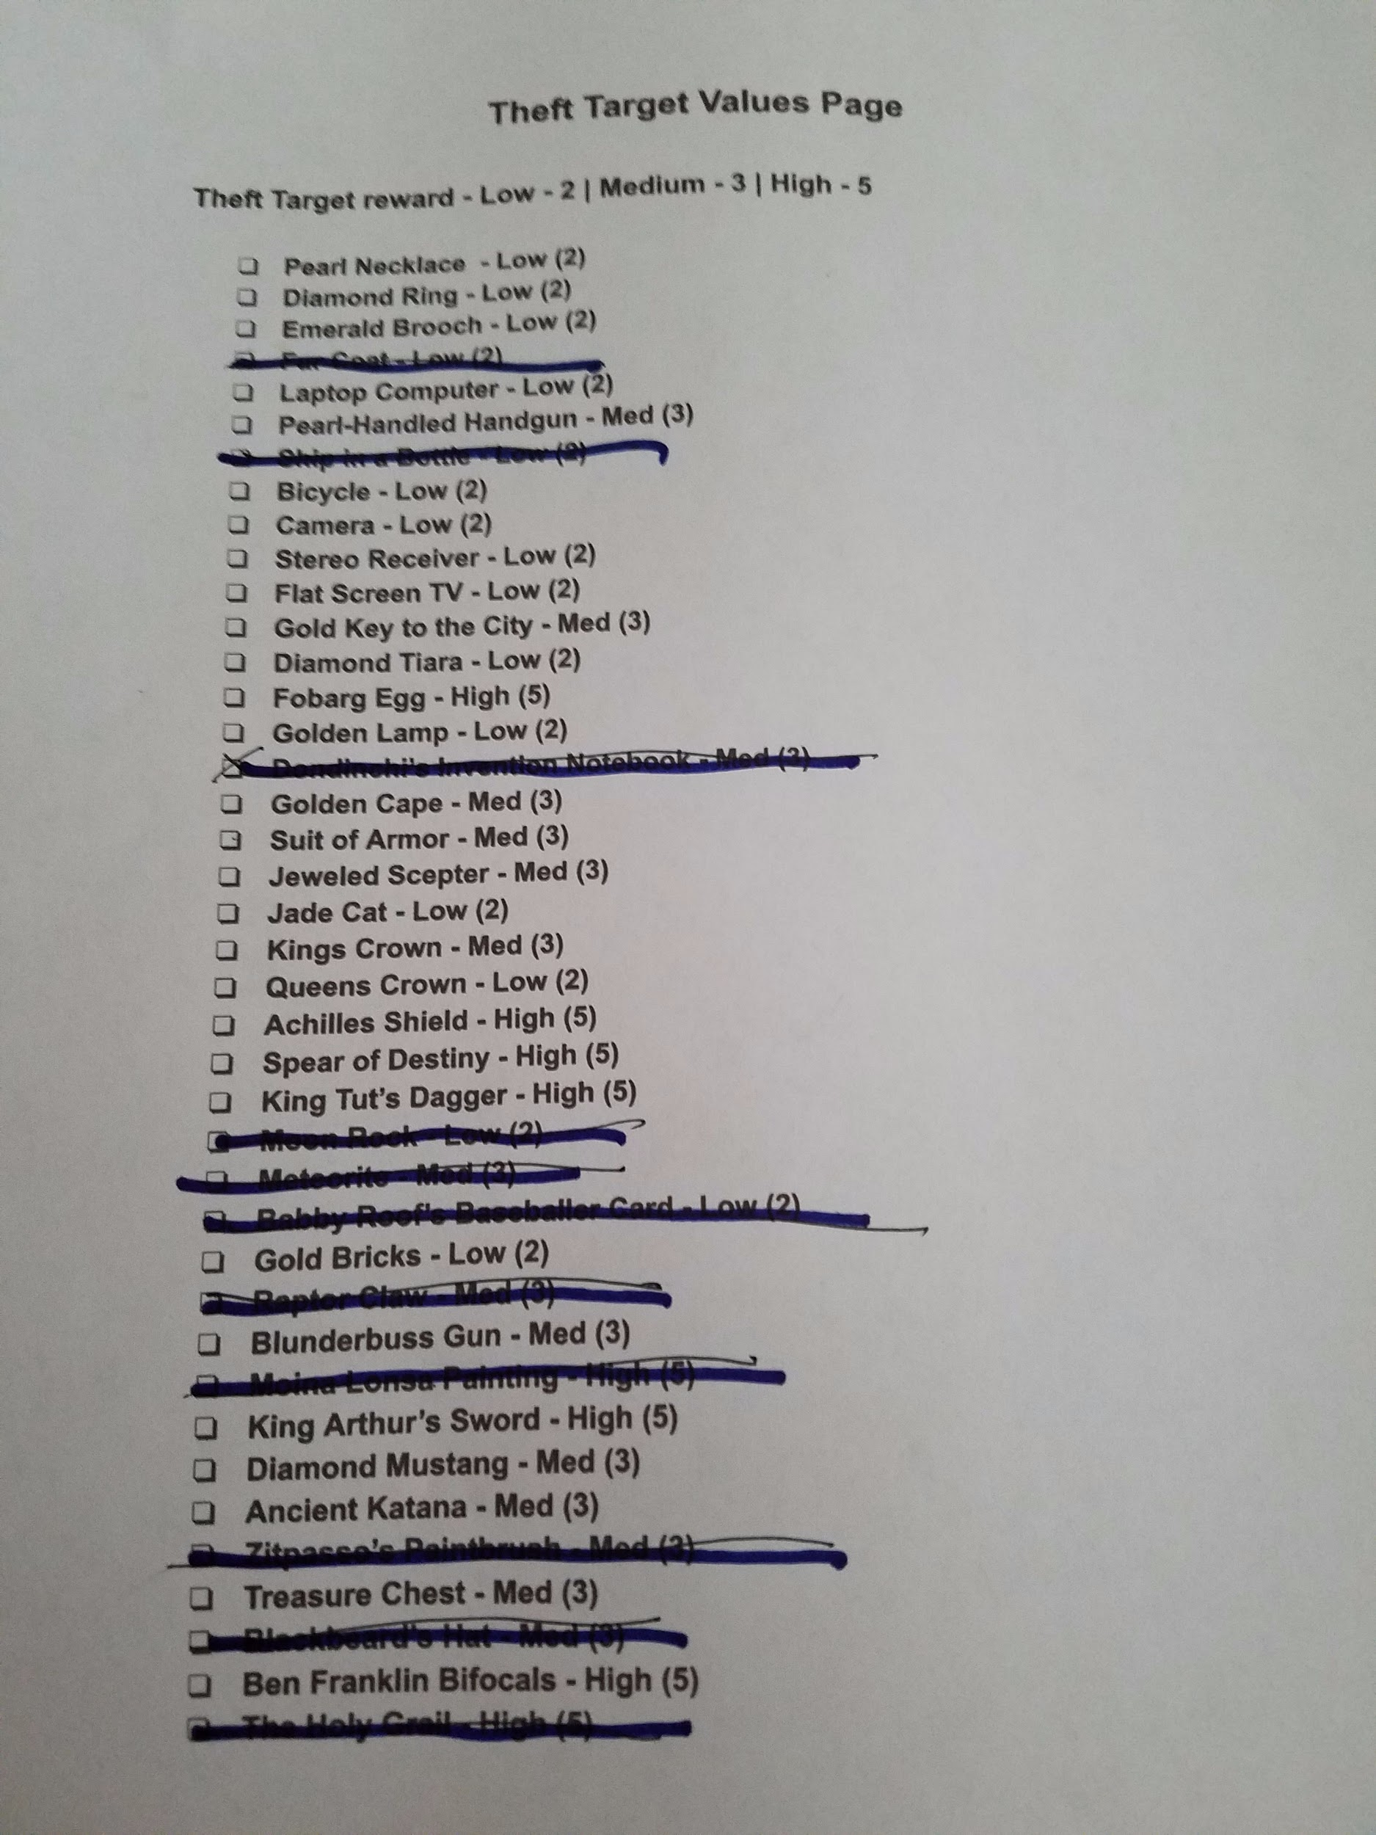

Write
- Players write in names of the Thief Tools into the blanks of The Great Heist story. The names you use can only be from cards you possess.
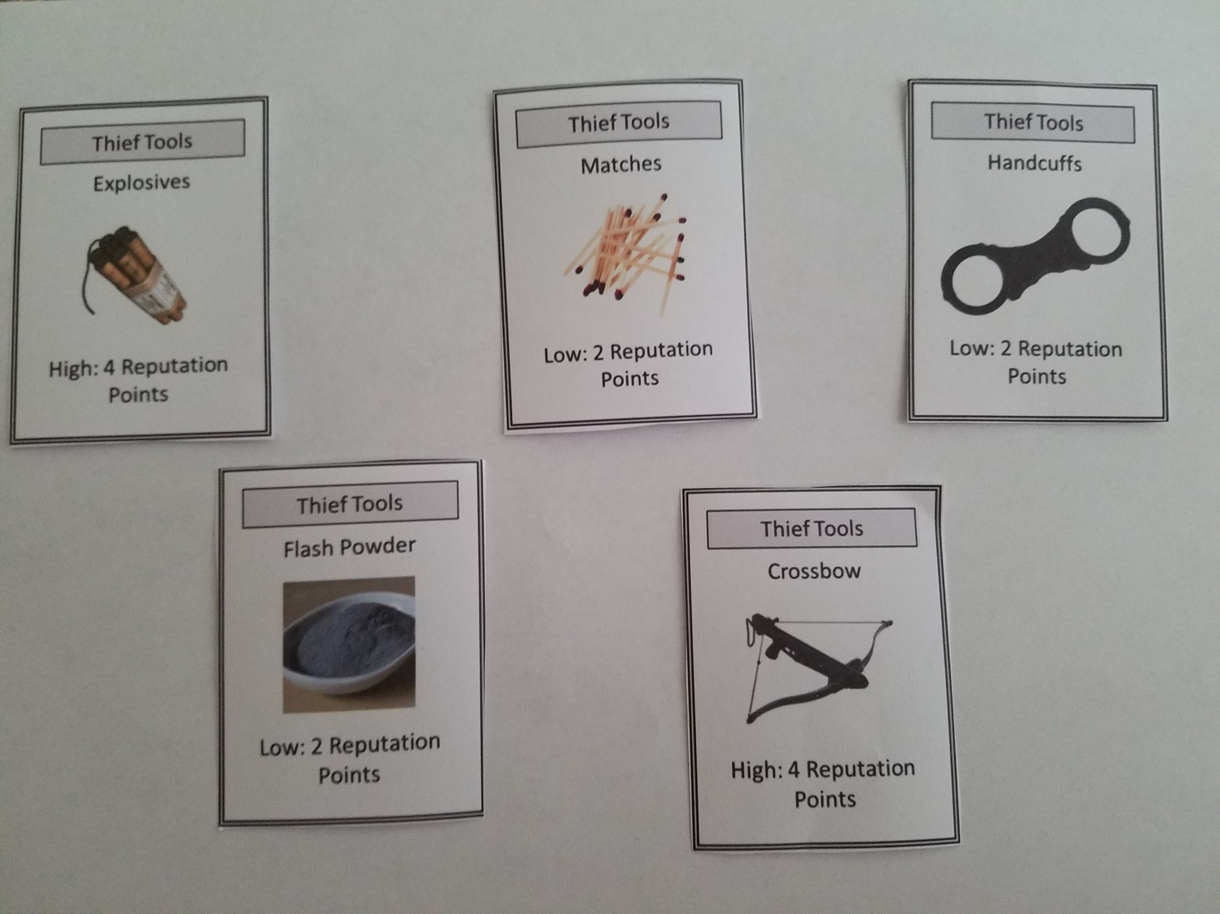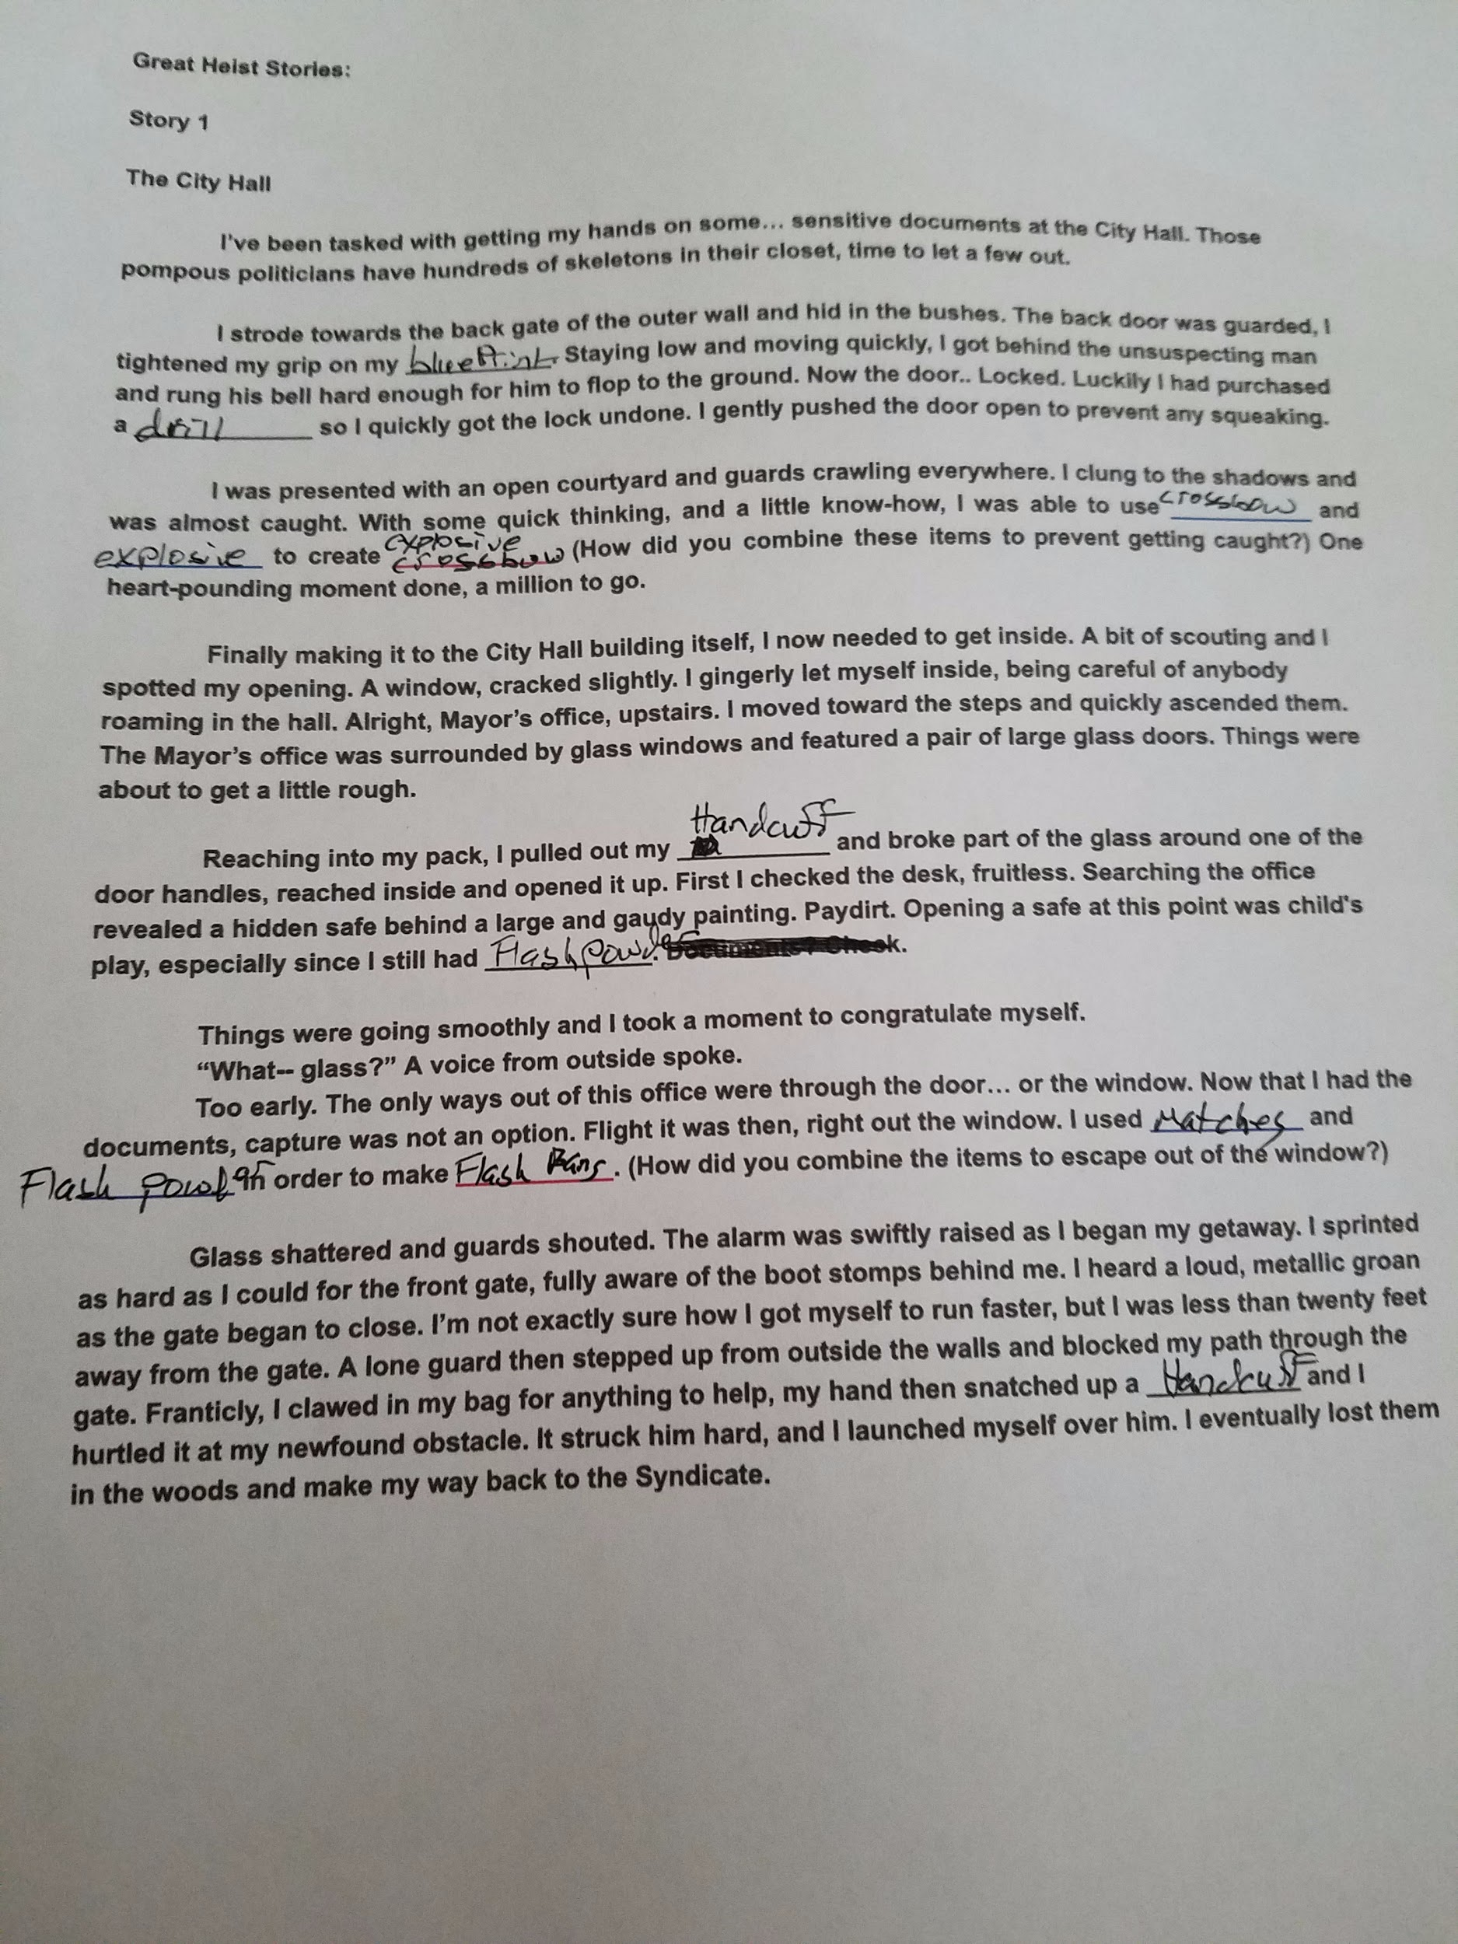

Trade
- Players may trade between other players during the Trade phase to obtain the ideal set up Thief Tools to make their story better.

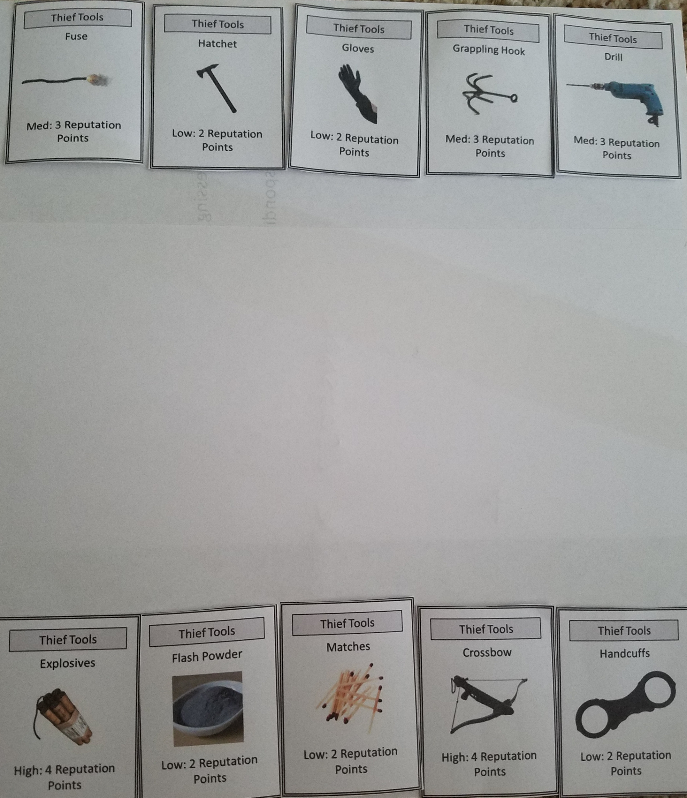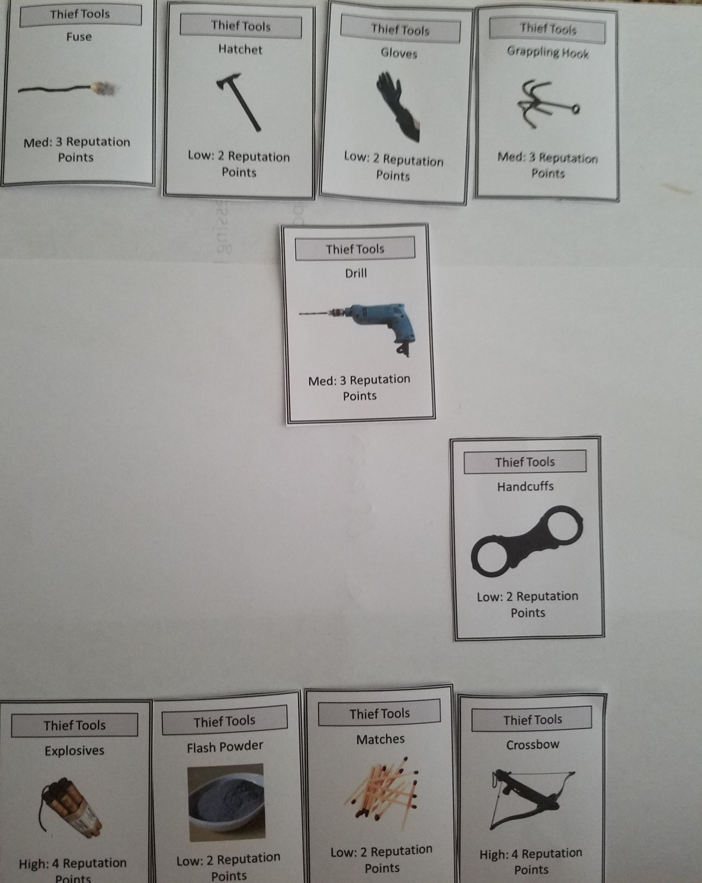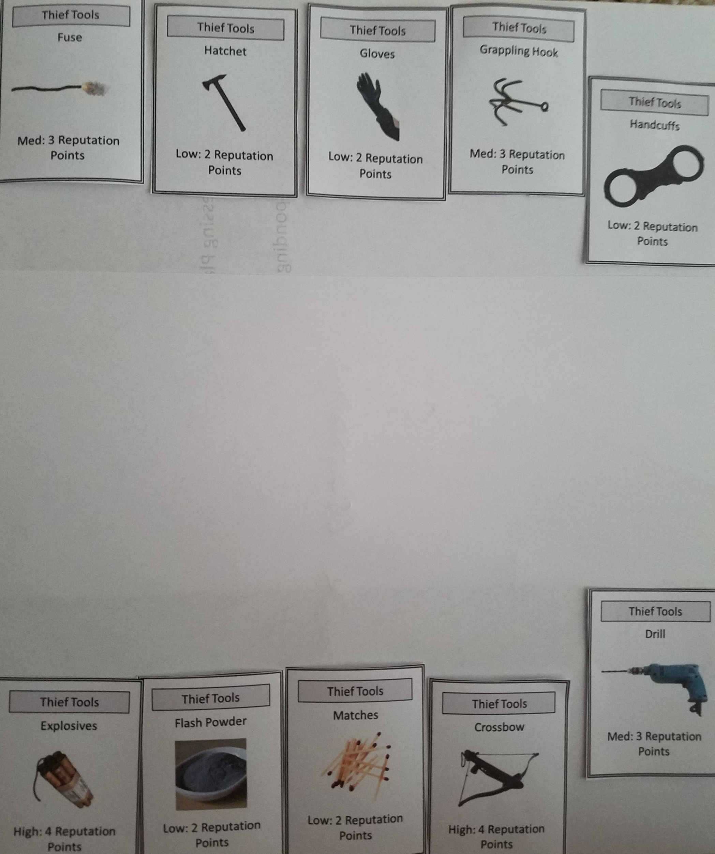

Disperse
- Players earn and spend reputation
- Players can spend their reputation on Thief Tools

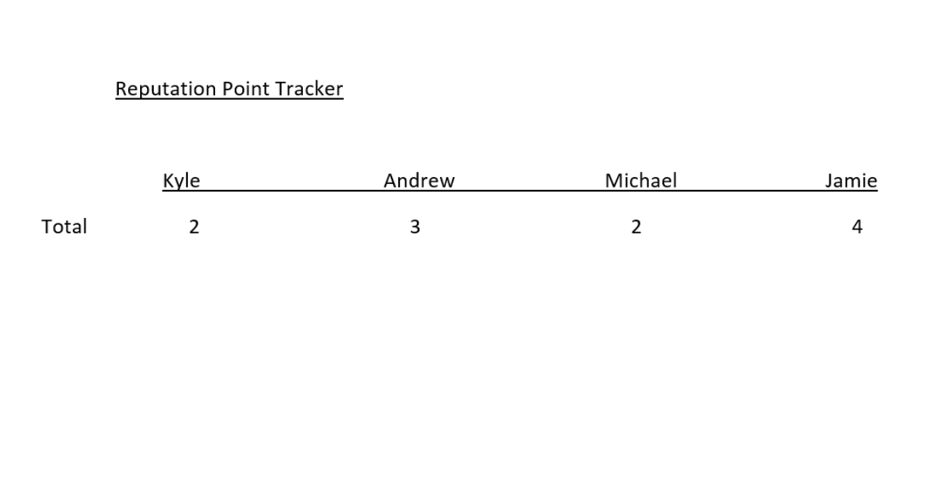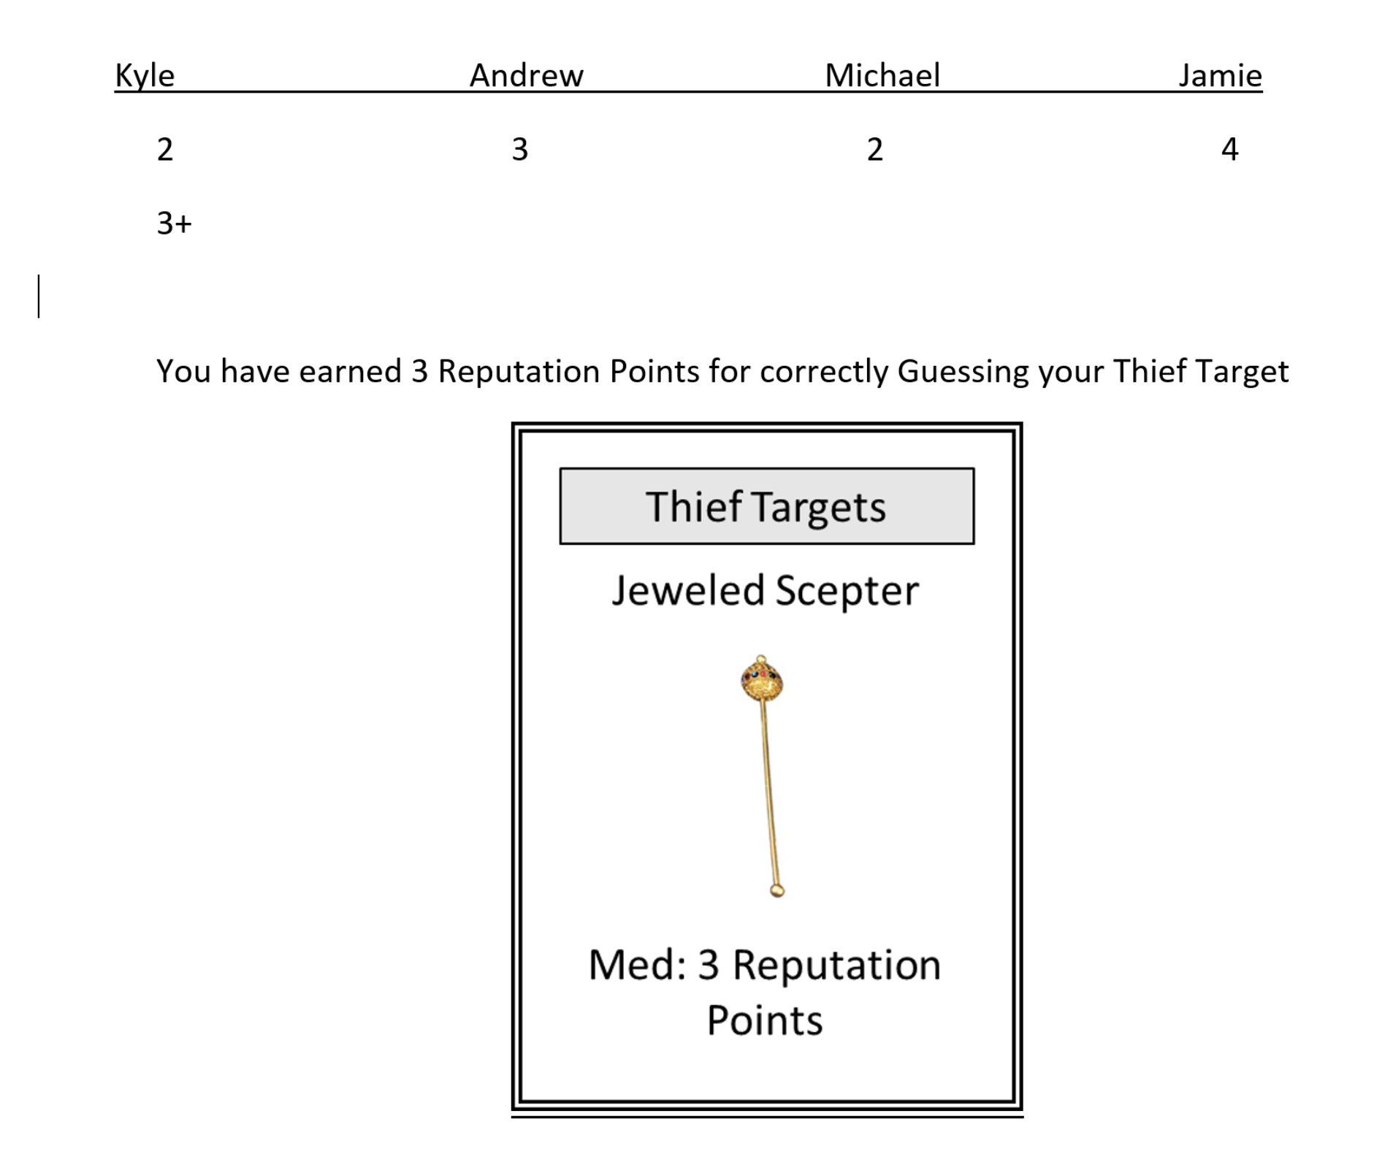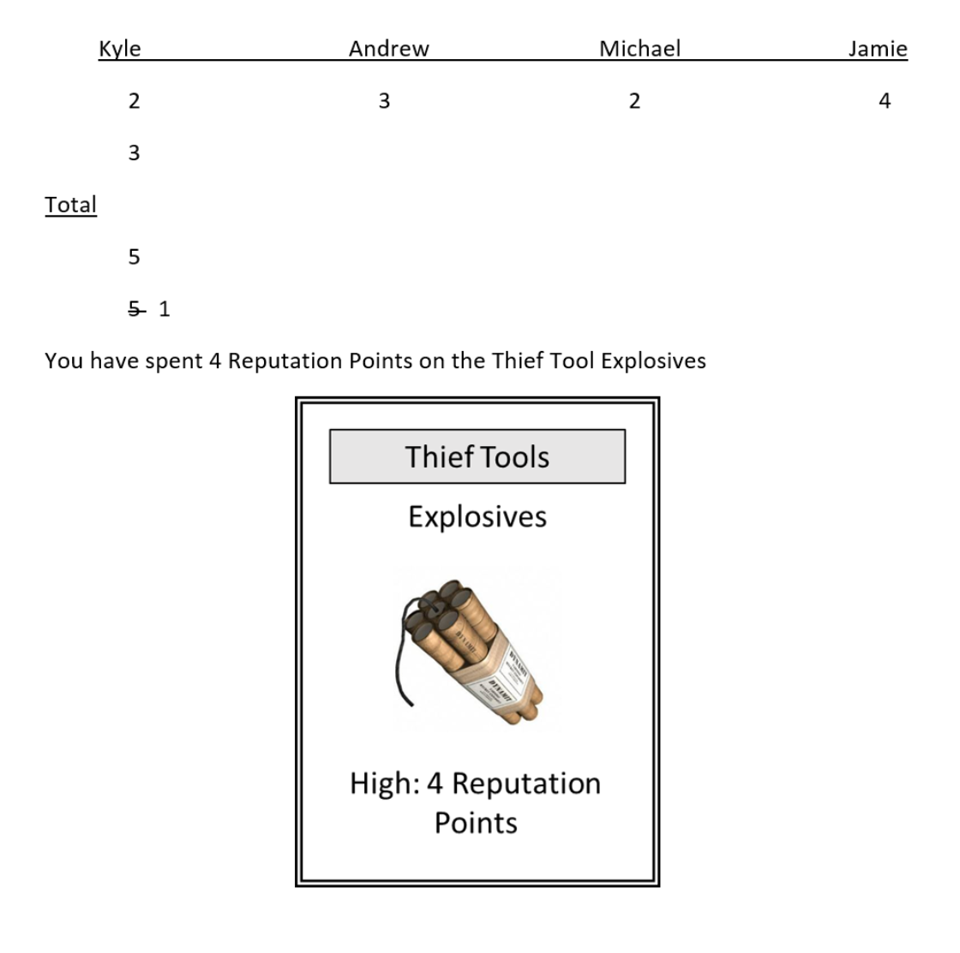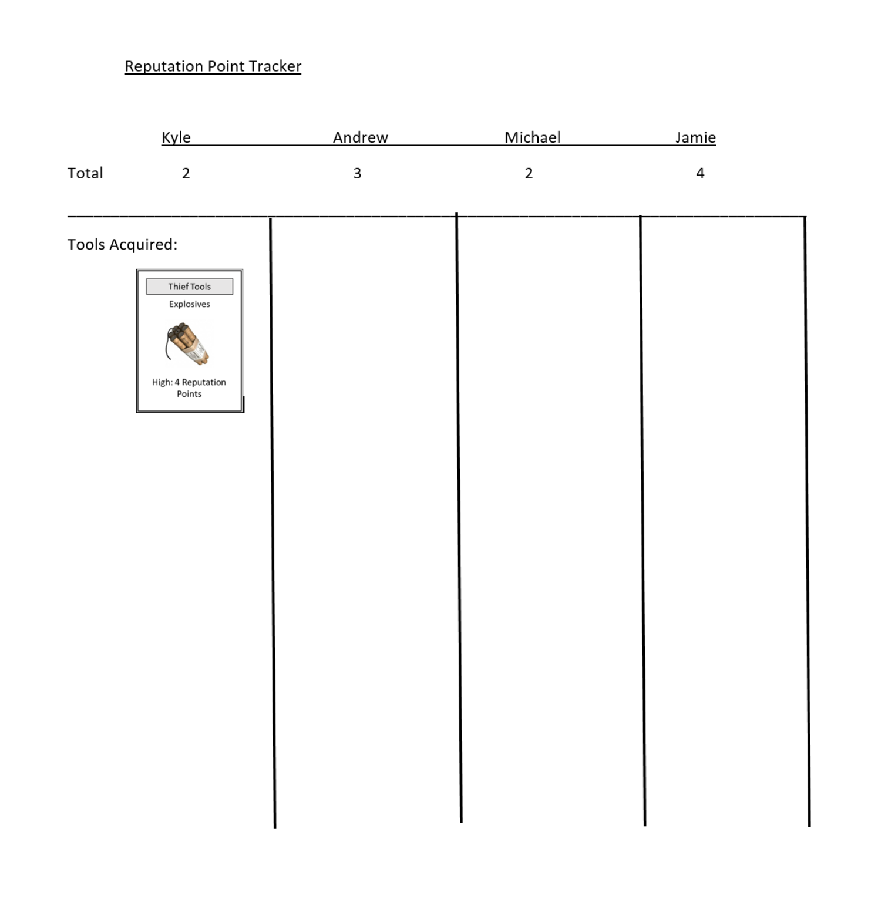

Developers Log

When we received the corrections from week 2, we were completely distraught. We lost two of the most fundamental mechanics in the game. While we were not allowed to completely rewrite the game from scratch we had to change a lot of mechanical implementations to make the new mechanics we received, work with the new direction we had been given. We probably had about 2 hours where everything we tried worked for one thing and not another. With the changes we were given our old design would not work anymore. For example, a guess based strategy game where the Syndicate head sends thieves out to find and heist specified targets at specified locations. This, however, didn’t take into account a write mechanic or the new fifth mechanic we did not have before that we had to implement as well. This presented us with some major rewrites and revisions to our process and how we approached the game. We were still going to have to use the card system we devised and a method of combining things that did not involving stealing or movement. This took our thief concept and turned it on it’s head respectively.

With the new changes to our mechanics worked out our game went from a strategy based game with some cards to a game that would be toned down considerably. It felt like the direction we were going to have to go was more family and learning oriented with the mechanics we were given. With all the new changes we removed a lot of random elements we had in the game like dice rolling for success, movement, a map for visualization and guidance. The gameplay overall slowed down a little bit in the fact that we now have a guess mechanic in place of a movement mechanic in the game. Whereas in our old game, there was always something going on. You had to keep your head on a swivel and pay attention to everything that is taking place, and now you only have to focus on constructing your story and deciding on the tools you will use to create it. This, in turn, slowed down the game and made it much less intense while still maintaining many of the card based elements of our original game.

In addition, we were still able to carry over our trade and disperse mechanics almost in their full contextual entirety from our original game to the new one. Players still can purchase and trade thief tools just as they could in the original game. Only now there’s a limit on both trades and purchases on a round by round basis. We also had to reformat many of the cards as they did not make sense in their current form. We removed the location based information and removed out some of the weaker cards, as well as any legendary tools or targets/jobs.

We also had to take a look at the reward system. Because, the aspect of stealing from people was now out of the design there was no longer any need to give such large rewards to counterbalance the possibility of being stolen from. We decided that we wanted to have a smaller tier based system for the cards consisting of Low, Medium, High for both Thief Tools and Thief Targets to keep it more simple. With the use of 2, 3, 4 we felt this gave us basic scalability while giving us the opportunity to add in a multiplicative factor later on if we so choose. For example, the reason we didn’t use is 1, 2, & 3 is because if you were just coming off a Thief Identity that was valued at one you would have the potential of having to go three rounds before you could get a shot at a better item at the rate of 1 per mission. Whereas in the case of 2,3, & 4 it scales up much faster and opens up the player up for options sooner. We chose you could not skip a round and get caught up.

We learned a lot about how what we think will work for a game may not always be what someone else wants you to do or thinks will work. As Designers, we need to be flexible and capable to make changes in our design. We may not always like the changes that are being suggested to us but, it is something we have to learn to adapt to as we move on in our careers.
Overall, the transition from the original iteration of our game to our finished iteration was a vast and turbulent one. We transformed the game from a strategy based game based on stealing, to a game where Mad Libs and stealing are combined with resource management.

Thief Tools Page

Low Cost Medium Cost High Cost

Matches - Low (2) NO2 - Med (3) Smoke Bombs – High (4)
Rope- Low (2) Bowie Knife - Med (3) Silenced Gun - High (4)
Hatchet - Low (2) Ninja Star - Med (3) Crossbow – High (4)
Razor- Low (2) Pressurized Air - Med (3) Explosives – High (4)
Nails- Low (2) Stethoscope - Med (3) Blueprint – High (4)
Chloroform - Low (2) Pepper Spray - Med (3) Liquid Nitrogen – High (4)
Glass Cutter - Low (2) Lockpick – Med (3) Taser – High (4)
Mirror - Low (2) Wire Cutters – Med (3)
Timer - Low (2) Keys - Med (3)
Handcuffs - Low (2) Grappling Hook - Med (3)
Flash Powder - Low (2) Fuse-Med (3)
Gloves - Low (2) Drill - Med (3)
Wire - Low (2)
Powder - Low (2)
Cloth - Low (2)
Magnets - Low(2)

Theft Target Values Page

Theft Target reward - Low - 2 | Medium - 3 | High - 5

- Pearl Necklace - Low (2)
- Diamond Ring - Low (2)
- Emerald Brooch - Low (2)
- Fur Coat - Low (2)
- Laptop Computer - Low (2)
- Pearl-Handled Handgun - Med (3)
- Ship in a Bottle - Low (2)
- Bicycle - Low (2)
- Camera - Low (2)
- Stereo Receiver - Low (2)
- Flat Screen TV - Low (2)
- Gold Key to the City - Med (3)
- Diamond Tiara - Low (2)
- Fobarg Egg - High (5)
- Golden Lamp - Low (2)
- Dondinchi’s Invention Notebook - Med (3)
- Golden Cape - Med (3)
- Suit of Armor - Med (3)
- Jeweled Scepter - Med (3)
- Jade Cat - Low (2)
- Kings Crown - Med (3)
- Queens Crown - Low (2)
- Achilles Shield - High (5)
- Spear of Destiny - High (5)
- King Tut’s Dagger - High (5)
- Moon Rock - Low (2)
- Meteorite - Med (3)
- Babby Roof’s Baseballer Card - Low (2)
- Gold Bricks - Low (2)
- Raptor Claw - Med (3)
- Blunderbuss Gun - Med (3)
- Moina Lonsa Painting - High (5)
- King Arthur’s Sword - High (5)
- Diamond Mustang - Med (3)
- Ancient Katana - Med (3)
- Zitpasso’s Paintbrush - Med (3)
- Treasure Chest - Med (3)
- Blackbeard’s Hat - Med (3)
- Ben Franklin Bifocals - High (5)
- The Holy Grail - High (5)

Great Heist Stories:

Story 1

The City Hall

I’ve been tasked with getting my hands on some… sensitive documents at the City Hall. Those pompous politicians have hundreds of skeletons in their closet, time to let a few out.

I strode towards the back gate of the outer wall and hid in the bushes. The back door was guarded, I tightened my grip on my ___________. Staying low and moving quickly, I got behind the unsuspecting man and rung his bell hard enough for him to flop to the ground. Now the door… Locked. Luckily I had purchased a _____________ so I quickly got the lock undone. I gently pushed the door open to prevent any squeaking.

I was presented with an open courtyard and guards crawling everywhere. I clung to the shadows and was almost caught. With some quick thinking, and a little know-how, I was able to use ___________ and ___________ to create ____________. (How did you combine these items to prevent getting caught?) One heart-pounding moment done, a million to go.

Finally making it to the City Hall building itself, I now needed to get inside. A bit of scouting and I spotted my opening. A window, cracked slightly. I gingerly let myself inside, being careful of anybody roaming in the hall. Alright, Mayor’s office, upstairs. I moved toward the steps and quickly ascended them. The Mayor’s office was surrounded by glass windows and featured a pair of large glass doors. Things were about to get a little rough.

Reaching into my pack, I pulled out my ___________ and broke part of the glass around one of the door handles, reached inside and opened it up. First I checked the desk, fruitless. Searching the office revealed a hidden safe behind a large and gaudy painting. Paydirt. Opening a safe at this point was child's play, especially since I still had ____________.
Things were going smoothly and I took a moment to congratulate myself.
“What-- glass?” A voice from outside spoke.
Too early. The only ways out of this office were through the door… or the window. Now that I had the documents, capture was not an option. Flight it was then, right out the window. I used ___________ and __________ in order to make ___________. (How did you combine the items to escape out of the window?)

Glass shattered and guards shouted. The alarm was swiftly raised as I began my getaway. I sprinted as hard as I could for the front gate, fully aware of the boot stomps behind me. I heard a loud, metallic groan as the gate began to close. I’m not exactly sure how I got myself to run faster, but I was less than twenty feet away from the gate. A lone guard then stepped up from outside the walls and blocked my path through the gate. Franticly, I clawed in my bag for anything to help, my hand then snatched up a ___________ and I hurtled it at my newfound obstacle. It struck him hard, and I launched myself over him. I eventually lost them in the woods and make my way back to the Syndicate.

Story 2

Safe Storage Bank

It was a quiet night, perfect for causing trouble. After months of planning the day has finally come to pull off the heist that would make me famous. I gathered my tools and made my way towards my target. Upon my arrival it took out my __________ and got myself ready for anything to happen that was unexpected. As I made my way inside I came across some upgrades that I was not expecting. They must have heard I was coming. It won’t matter, I took out my __________ and got to work. It only took a little while and I was in. Having seen that there was some surprises waiting for me already I decided to take no chances. I took out my _________ and my __________ and combined them together to make ___________. Using this new tool, I quickly surveyed the area and figured out what my next move was going to be.

As I approached the vault I took out my ___________. It may not seem like much but, it will do the job just fine. Wanting to be careful is an understatement. After months of research I knew that this was no ordinary vault and would require a special touch. I had to be careful as I did not want to set off the alarm before I was ready for it to go off. I heard a click and then a pop and I knew that I was in. I am glad I took the time to acquire ___________ as it really helped out. Just then I heard a sound no Thief ever wants to hear. “Put your hands up!” And turn around slowly. Panic set in as I knew for sure I was caught. With some quick thinking. I replied calmly “Can I help you? I am from the alarm company we received a silent alarm and I came to check it out.” The voice behind me said, “I didn’t hear anything and how did you get in? This place is sealed up tight.” I replied it’s part of our procedures to find the weakness in our systems. We told the bank about it and they didn’t care. So now someone has come in and exploited exactly that weakness. It looks like I was here just in time. I must have scared them off. They had just combined ____________ and __________ to create this ________ as I turned around I showed him the new tool I had made while distracting him with my story. Finally, I convinced that stupid guard that my story was true and he began to trust me, that sucker! I said if you will let me finish I need to finish opening up the vault so that I can make sure it’s not damaged any further. The guard reluctantly agreed after some convincing. I told him he has to still be inside as the only way in was how I got in. See if you can find him. I bet if you catch him you will be a hero.
The guard got excited at the notion of being called a “Hero” and began searching for the Thief. I quickly finished up my work and used the last of my tools a __________ to bypass the final obstacle. I opened up the vault door and helped myself to the prize of a lifetime. A program on a USB thumb drive that the bank uses to manage the accounts. How stupid they were. Did they think nobody could get past their security given enough time? I slipped the device into my pocket and put everything back the way it was to cover my tracks. I found the guard who was still looking for me and told him. “It looks like the Thief got away with the goods. I have rebuilt the alarm and the interlocking systems but, someone is going to be really unhappy about the theft. I am truly sorry about that. Had the Bank listened to us we could have prevented this from happening.
Having a change in my plan was certainly unexpected but, walking out of the front of the bank instead of sneaking out the way I came always puts a smile on my face.
I quickly went home and activated the program on my secure laptop and took all the money I dared. I know life the “Sweet life” and nobody's the wiser about how I got all this money.

Story 3

Town Hall Houdini

“I’ve had enough” I said to myself, I will not stand by while this crooked man we call a Mayor continues to pillage this city of its riches. When will the citizens of the city learn? How can they not see what is going on here? I will just have to do something about this myself. From that day on I began my plan to take down the Mayor. I knew things would never change unless I took action myself.

So on a rainy night I finally decided it was time to steal the Mayor and free the city from his corrupted influence. The city was not able to make the budget for this year’s Police and Firefighters and it was all because of him. He was stealing from the city’s finances and nobody but I knew about it. Working in the Mayor’s office did make this job a little easier but, I still had to be careful, and cover my tracks. I left a window open that day by shoving a _______ in the jam. I had tested this out before and the guard never found my little test. I slipped around to my window and made my way inside of my office. I grabbed the ________ I had hidden there previously and started to make my way to my objective, The Mayor’s Office. I knew he would be there tonight as it was the end of the month and he had to make the money he had stolen match up on the books. When I got outside the Mayor's office I slipped on the recently waxed floor and made a terrible commotion.

This of course alerted the Mayor and he came to see what was going on. I can’t believe it I slipped on the floor before my greatest triumph. He called out to the door and said, “Who is there?”
I told him, “It’s me Mr. Mayor, I forgot some stuff in the office and came to retrieve it. I tried the front door but, I just got soaked getting inside.”
“Hang on I think I have a towel.” the Mayor’s voice called out.
The door unlocked and this was my chance.

I could hear his footsteps coming I had to work fast. I took the _______ and my _______ and created something new a _______ this was going to be my ticket for pulling this off. He opened the door and I made my move. I jumped at him and was able to wrestle him to the floor and get on top of him. I quickly tied and gagged him to keep him quiet. I dried myself off took my ______ out of my bag and got to work with it. Reaching into my bag I pulled out my ______ this was going to be my ace in the hole he would never give me the evidence freely, so it was going to have to be by force. I used it make quick work of the drawer that was locked. I had seen the Mayor stuff paperwork into this drawer when I surprised him from time to time. I decided I was going to go for broke. I had to do it for the citizens of the town I owed it to them. This was not my original plan but, that is all out of the window now. Washing down the drain like all this rain outside. JACKPOT!!!! I had found the information I needed to dispose of the crooked Mayor once and for all. Picking up the documents and putting them in my shirt to protect them from the rain. Taking inventory of what I still had to work I needed to have a plan getting out. I couldn’t just walk out with the Mayor in tow all tied up. I took the _______ that I had used earlier and I combined it with _______ to make ________ and made this job easier. I moved the Mayor to the door and took him to my office so that I could think. I almost forgot that I left ______ in my desk. It would be the tool I needed to get the Mayor out through my window. After all it's just not something you leave lying around after you have committed a crime of this sort. I knew I could never come back to this life but, the citizens would be free of this crooked Mayor.

As we slipped out the windows the Mayor learned of his fate and what would be happening to him when we got to the Police station. I told him, “You are not going to get off easy.” With that we left town. I took him to a Dark Place I knew he would never be found again. The people there viewed the Mayor as giving them a bad name because he was doing it so recklessly. They had a plan for him. I had the documents in my shirt the whole time they were still dry. I gave them to a shadowy figure, “You know what to do.” He crept back into town and planted the documents and made an anonymous call to the Police to set it all up. Things changed drastically after that. A special election was then had and the citizens choose me. Little do they know that it was me who set the whole thing in motion. These days I am on the straight and narrow but, they will never know that their New Mayor was what started all of this.

Story 4

The Penthouse

Tomorrow should be a great day; it is my birthday after all. I can’t believe I will be sixteen years old tomorrow. My dad has been repeating himself a lot lately to me saying, “Son, you are about to become a man. You are going to have more and more responsibilities the older you get.” I know he means well but it is getting kind of annoying.
I have a big day planned tomorrow so I am off to bed. I have to get up early and go pick up my best friend Eli and my girlfriend Jasmine. We are going to go to the water park to hang out all day and then we have to be back here for my birthday party. I text both of them and tell them goodnight and I’ll see them in the morning. After that, I fall asleep.
I wake up after what seems like only a few minutes later to find myself bound and gagged in what appears to be the trunk of a car. I try yelling for help but no one comes. It is so dark and hot in here and it feels like I am lying in a pool of my sweat, at least I hope that is what it is. There is only a little bit of light coming through a hole in the trunk door. I managed to get my hands free and I shuffle around in the dark to find something to help me get out of here. Yes! I found a ____________! I use it to open the trunk and as I climb out, I have no idea where I am. How did I get here? Why am I here and why can’t I remember anything? As I make my way around the car, I see a piece of paper stuck to the window with writing on it.
Using the light coming from the light pole I read the note. “Hello Michael, you have been selected to get into this building and remove a laptop computer from the safe in the master bedroom of the Penthouse Suite on the top floor.” “If you do not complete this task, you will never see your girlfriend again.” “There is a bag in the car with items to help you and a picture to give you incentive.” Shocked, I nervously open the door to the car and see a picture of Jasmine gagged with a gun in her face. Next to the picture is a bag with some tools that would be handy for a job like this. My hands are shaking as I turn back to the letter. “You have one hour to retrieve the bag and return to the car.” “Once there, place the bag in the driver’s seat and get back into the trunk and close the trunk door and if the police are alerted, you will fail and she will die.” I don’t know how I do it, but I scrape up enough courage to begin.
I make my way up to a door of the building and grab the knob. Dang it! It is locked. I look up and see a window is open on the second floor. I scrounge through the tool bag and find a __________ and a __________. I take these two items and make a __________. I use it and make it up to the open window.
I am very cautious when climbing in the window as I have no idea what or who is inside. I run to the first door I see and peek around a corner and see a security guard walking down the hallway. I also see an elevator that I must use to get up to the Penthouse. I reach into the tool bag and grab a __________. I throw this away from the elevator to get the attention of the guard and get him away from it. Once clear, I desperately run to the elevator, go in and push the button for the Penthouse…Noooo! I have to use a card to reach the top floor. Not knowing what to do now, I feel pretty uneasy about what I have to do but, I have to if I want to see Jasmine again. I sneak up behind the guard and grab him. He struggles for a moment but eventually falls to the floor with a thud. I check to see if he is still breathing and thank god he is! I don’t want to be responsible for anyone dying. I quickly grab his keys and security card and head back to the elevator.
After reaching the top floor, the door opens and I see the door leading into the Penthouse. “Of course it is locked!” I murmur while trying to open the door. None of the security guard’s keys work and I have to get in. I look into the bag once again and pull out a __________ that I use to get through the door. It is very dark and cold in the room and I can’t seem to find a light switch anywhere. I remember seeing ­­__________ in the tool bag so I search blindly through it until I find it. With this I can somewhat see my way around the Penthouse.
As I am making my way to the master bedroom, I hear a deep growling sound coming from across the room. I immediately stop and pan back and forth trying to find the source and then I see it. It is a big scary looking Doberman Pincher and it isn’t happy to see me. The dog takes off running towards me barking loudly. I frantically reach in the bag and pull out a __________ and before I could use it, the dog stops, looks at it, and turns and runs the opposite direction into another room. Confused by this, I keep moving to the master bedroom.
I finally reach the safe and being that I have no idea how to crack a safe, I once again turn to the bag. Inside I find a __________ and __________. With these, I create a __________ and somehow manage to get the safe unlocked. I reach inside for the laptop but it is not there. Instead there is another piece of paper that only has two words on it. “TURN AROUND”. I’m almost too scared to turn around but I do it anyway. When I do, I see and hear several people yelling, “Surprise, Happy Birthday!” It felt like my heart was going to jump out of my chest. There are a lot of people here. I see my parents, the security guard, Eli and Jasmine and even the dog. Jasmine comes running up to me and grabs me and says she is sorry to put me through that but it was all for a big surprise party. As it turns out, the Penthouse and the dog belong to the security guard who is also a good friend of my dad’s. It was a crazy hour and I am glad it was just an elaborate game, but it was kind of cool getting to play the role of a thief.

Story 5

The Sinkhole

It was a week ago that the sinkhole opened up outside of the town. Huge and gaping with depths ominous and unexplored, the sinkhole called to me. Looking back now it took all of my skills plus the knowledge I had gained for what lied beneath. The city’s scouts have gotten pretty deep but no one as far as I, especially that last night…
It was dark and the city had gone quiet, I approached the stark-black hole in the world glad I had my __________ to help me traverse this thing. At this point this entrance was muscle memory to descend, having been here for the past 4 nights in a row. A quick climb down and I’m in the newly found tunnels that run under the forest near the city. But these tunnels I had mapped days ago, just simple caves, I had to make my way farther in. Feeling the need to move fast, I reached in my bag, pulled out a ___________ as well as a ___________. With these items I made a ___________, this greatly accelerated my rate of travel.
Approaching my target, I slowed to a walk. An unassuming cave wall wouldn’t be much to the average spelunker, but I was no spelunker. My skills as a thief told me, this wall was much too flat. Arrgh! I can’t see thing, last time I was in here the moon’s light from the ceiling gave enough for me to see the wall switch. Oh well, I needed some way to shed some light on the situation, err the wall. Quickly I grabbed my trusty _________ and illuminated the wall.
It took a bit of time to find the slightly off-colored stone set within the wall, one press and the flat portion slid down and out of sight. I had reached the farthest I ever had, last night I hadn’t dared to step inside the cold and ancient corridor. Taking a breath, I checked my equipment not knowing what to prepare myself for, only know that I had to steel myself.

Hmm… steel. A Weapon!

I put my light in my other hand and reached for whatever I could arm myself with, my hand found a __________ and I gripped it tight. Stepping forward into the corridor my heart quickened. The hallway was about a full arm span across, solid and well-constructed. Who knows how long these tunnels have stood the test of time?
My internal questions were silenced as my light suddenly died out. I froze in the darkness hearing only my own breathing. But my heart just continued to beat faster, am I going to have a heart attack? Just as I thought my heart would burst, I was met by a gleaming, white visage and the crack-cackling sound of an undead skeleton. I was able to release all of my pent of fear right into its permanently smiling face, good thing I was ready.
I got my light functioning again and pressed on ever deeper. After a few minutes of uneventful walking in the dank corridor, I saw a faint light flickering just a bit ahead of me. Reaching it, I was greeted by a larger tunnel of perfectly smooth stone and a pedestal at the end. My eyes locked on my perspective bounty, a diamond easily larger than my fist.
Something didn’t feel right… long tunnel, only one “guard”, easy visible treasure, it was all too easy. Feeling cautious, some scouting was in order. Without moving, I pulled out a _________ and observed the room. I knew it, trapped, all of it; the hallway, the floor, even the pedestal. This was going to be very hard, but I after seeing that jewel, I had to have it.
I stood still for a while, analyzing and contemplating ways that I could get across. Until it hit me, I have everything I need right here! Excited, I up-turned my bag of its last remaining contents. I snatched up my ____________ and a ___________ and quickly built up a ______________. (How did you use the combined item to avoid the traps?)
Finally having made it to the pedestal I got a nice long look at my future prize. It was a perfectly smooth, single chunk of diamond fashioned into the shape of an egg. Time for the last obstacle, the pedestal trap. I wracked my mind for ideas, bypasses, and work-arounds. Going miles a minute, my brain pumped furiously to give me the thought that I needed, I may not have much more time. Suddenly, I was struck with a memory: myself sitting watching one of my favorite action plays; the dashing hero making away with the treasure. I laughed aloud.

It couldn’t possibly be that simple, could it?

One final time I looked into my near-empty bag and pulled out what remained.

“Okay little ____________, I’m just going to put you here and all will be well. Okay?”

Just like that dashing hero, my hands dashed out swapping my own item for the diamond egg and I held my breath. Nothing happened, so escape became my main priority, it was time to get out. I went into a dead sprint ignoring the clicks of pressure plates on the floor. Arrows, darts, spikes, javelins and spears: anything that could poke, cut, maim or generally harm came spilling out of holes that appeared in the smooth stone walls. But I just ran, adrenaline cutting off any feeling of pain as my legs pounded down the distance to my deliverance. My muscles and lungs were screaming but I didn’t stop until I was outside and back under the open sky. Flopping down and breathing raggedly, I looked up at the rising sun and laughed again, I just risked my life for an egg.

Cards
Examples:

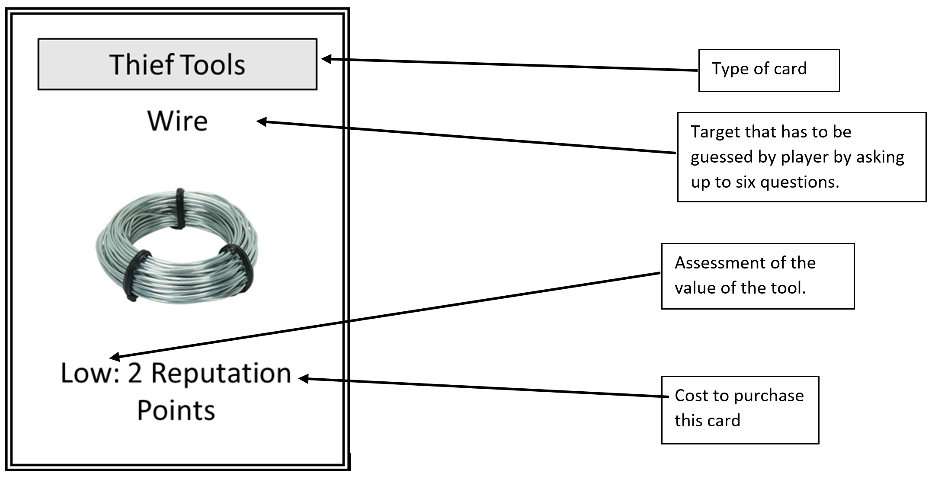
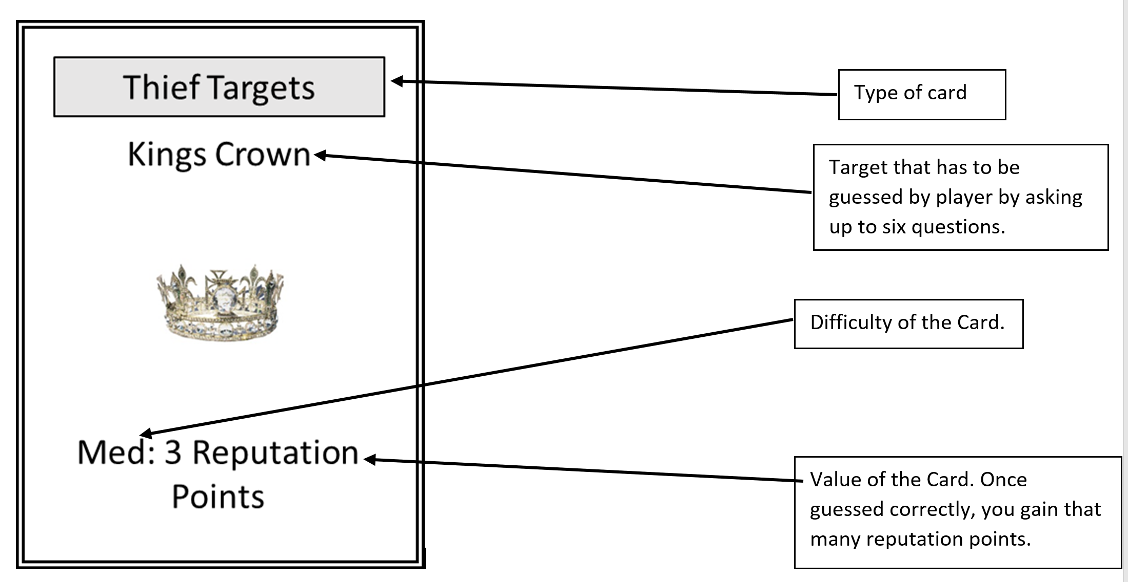

Thief Tools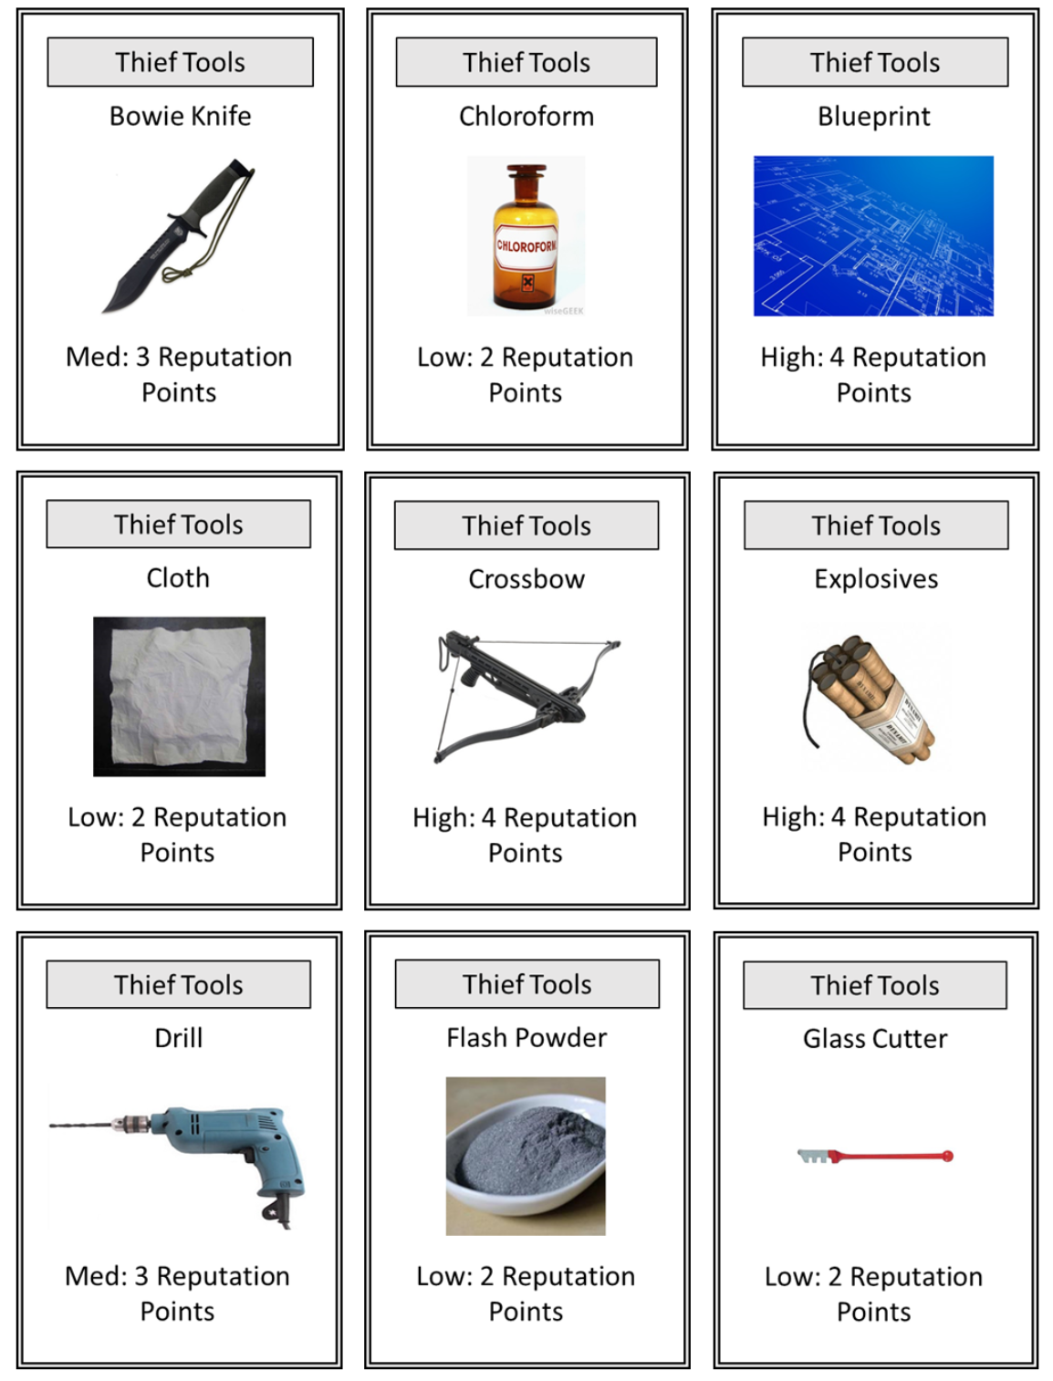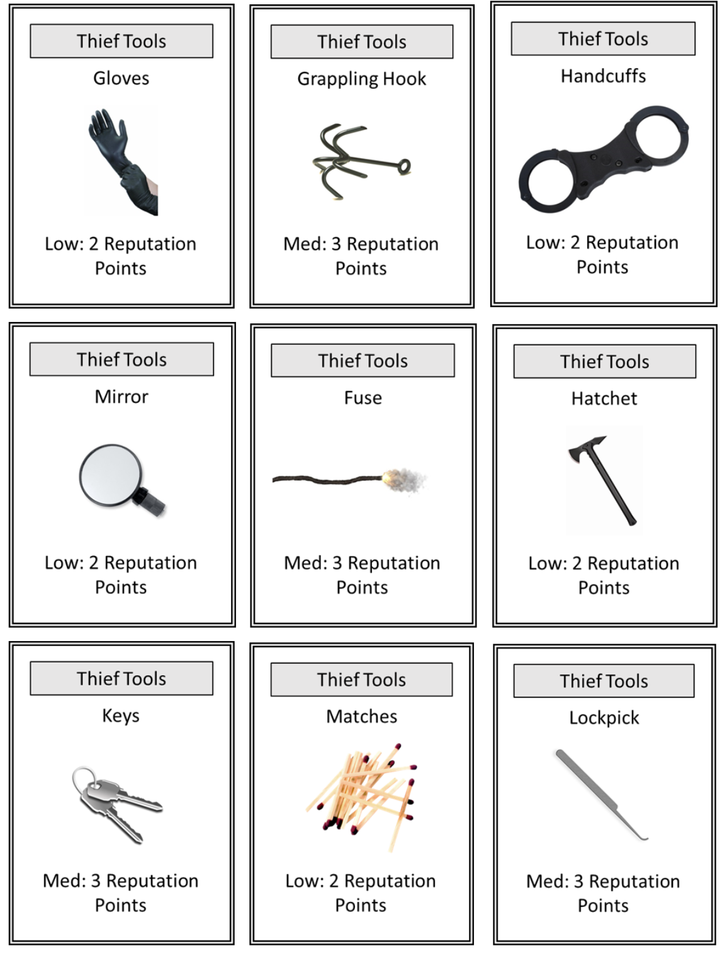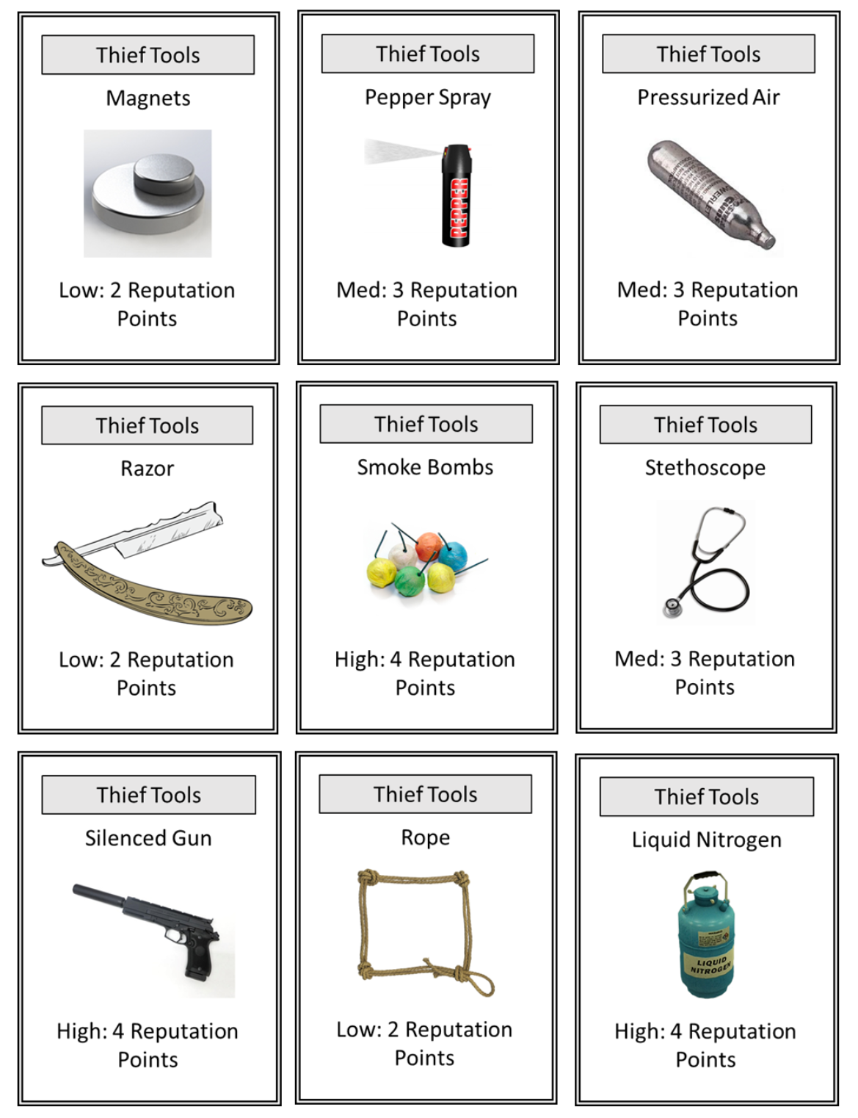
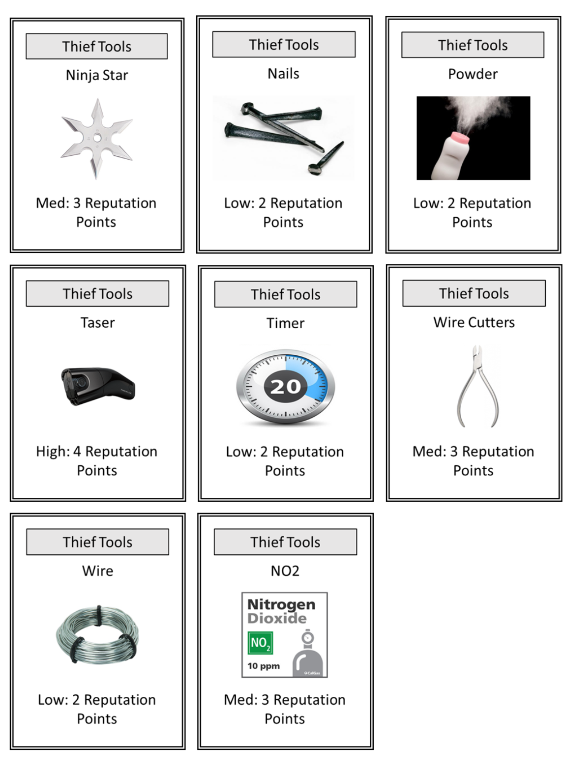
Thief Targets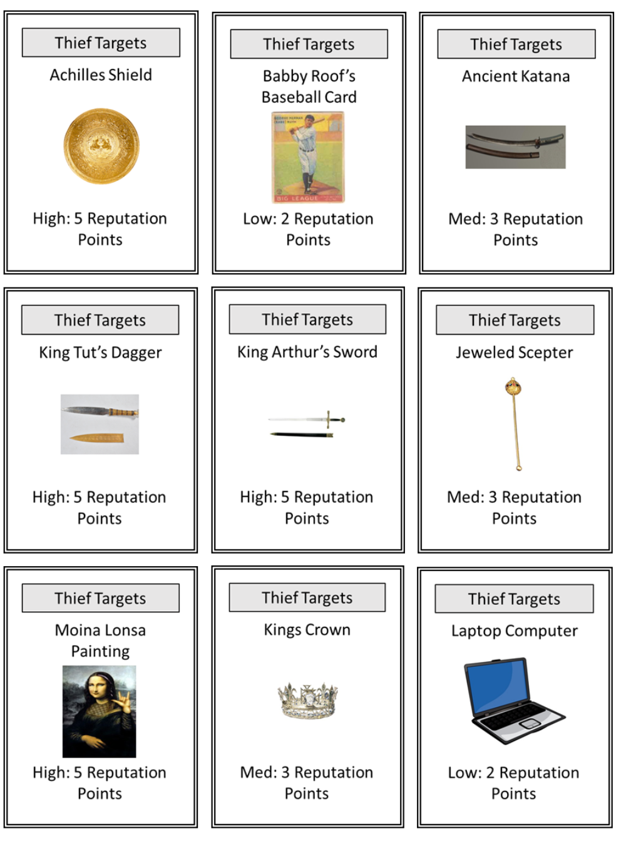
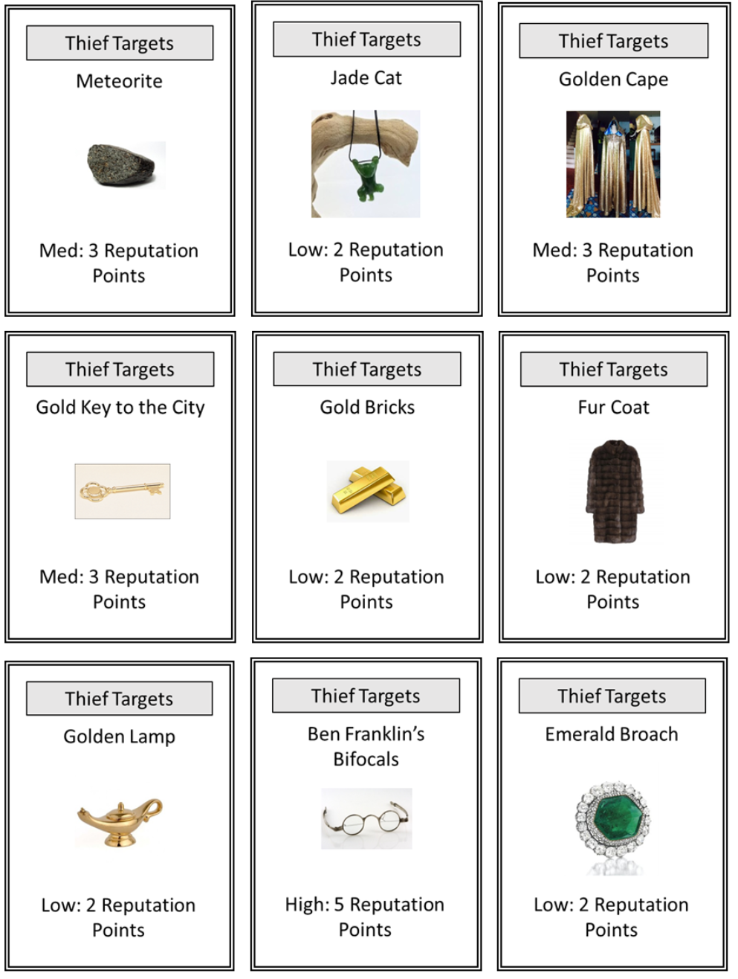

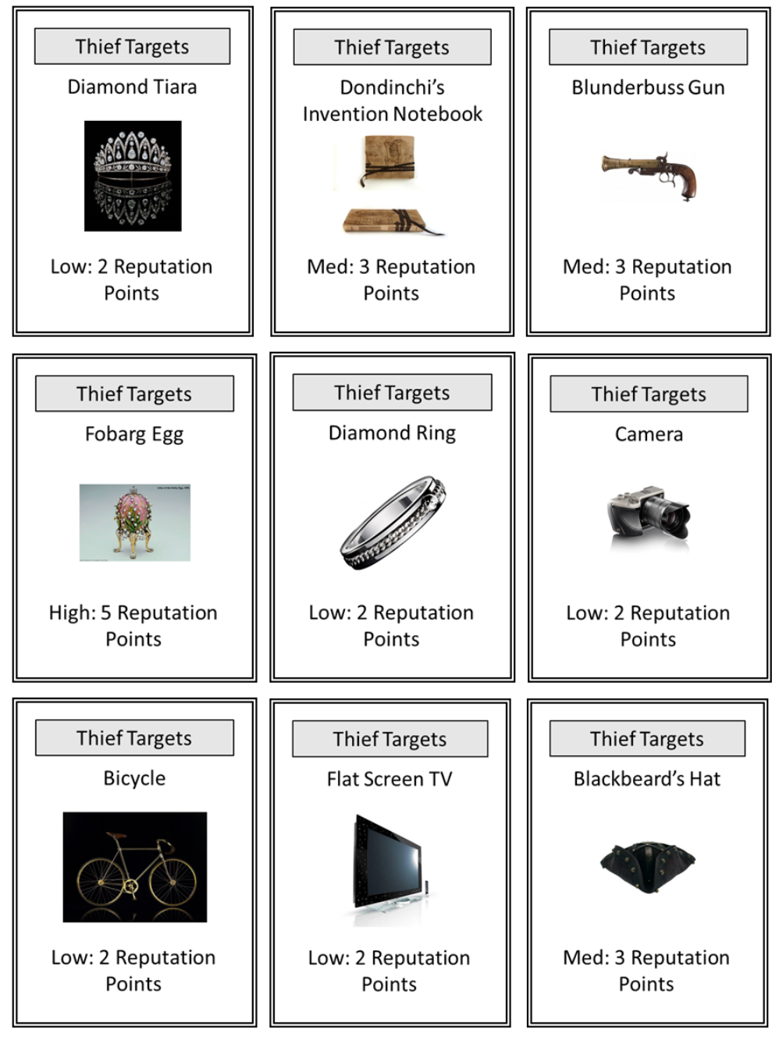
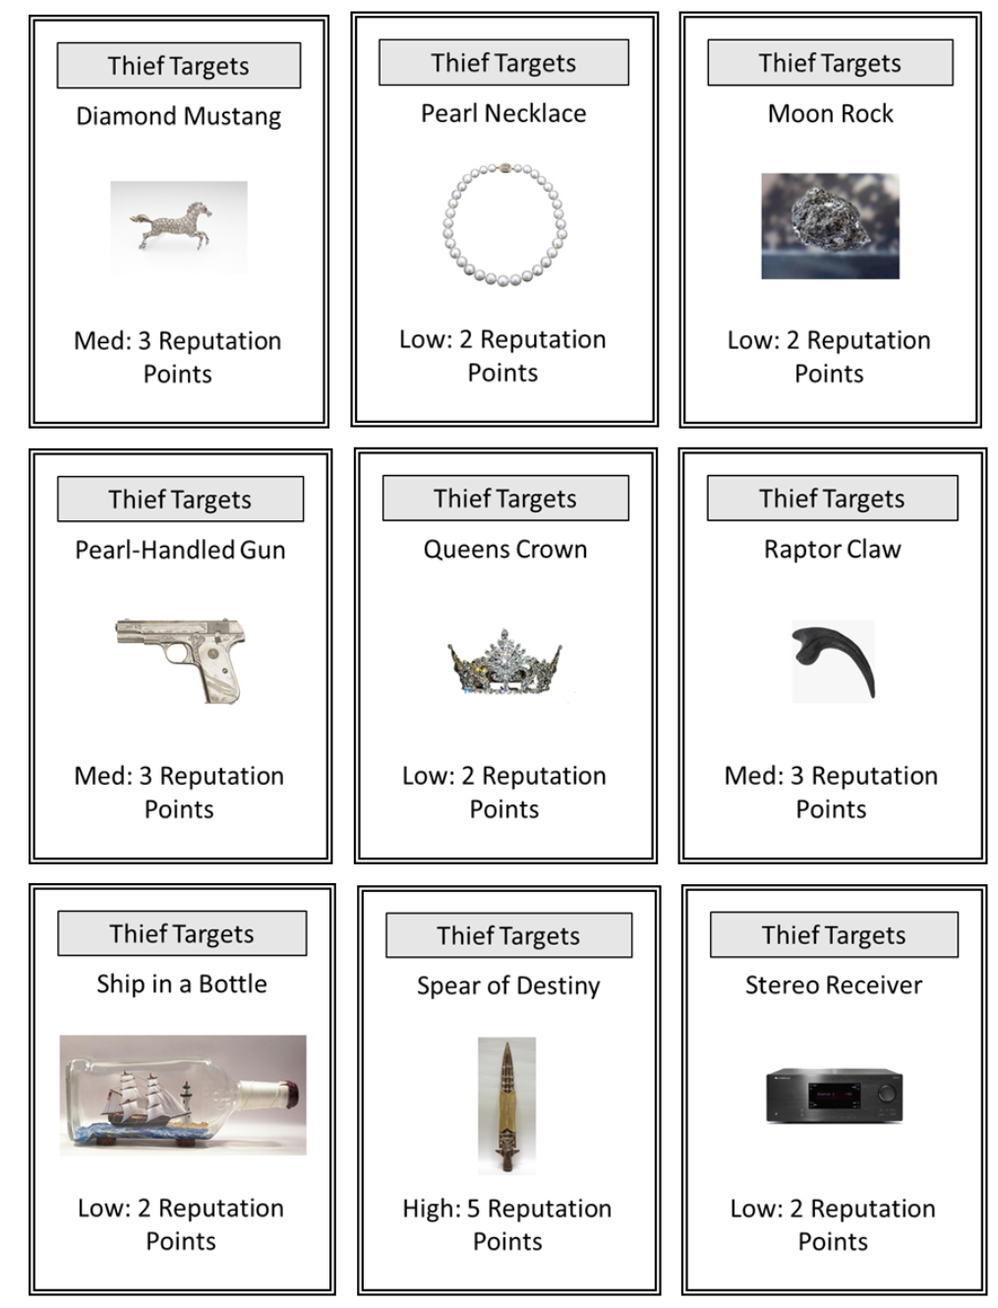

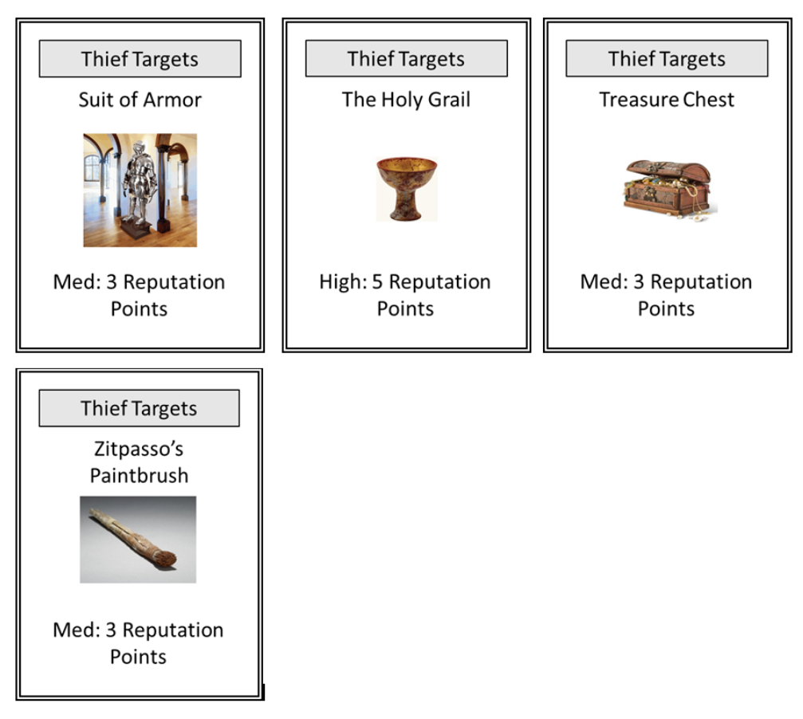

References

Burglary stats What's yours is mine [Thief Picture]. (2013, November 27). Retrieved June 10, 2016, from http://www.hdwallpapers.im/what_s_yours_is_mine-wallpaper.html Thief Image

Most commonly stolen home possessions. Retrieved June 11, 2016, from http://www.confused.com/home-insurance/articles/household-items-most-likely-to-be-stolen Burglary

Neuromancer2. Ancient Katana. Digital image. Neuromancer2.deviantart.com. N.p., n.d. Web. 18 June 2016. http://neuromancer2.deviantart.com/art/antique-katana-side-128533207

Achilles Shield. Digital image. Jaysanalysis.com. N.p., n.d. Web. 18 June 2016. https://jaysanalysis.com/2011/05/03/platos-cosmology-and-achilles-shield-compared-full/

Babby Roof's Baseballer Card. Digital image. Bbcemporium.com. N.p., n.d. Web. 18 June 2016. http://bbcemporium.com/1933-goudey-babe-ruth-144-counterfeit-guide/

Ben Franklin Bifocals. Digital image. College-optometrists.org. N.p., n.d. Web. 18 June 2016. http://www.college-optometrists.org/en/college/museyeum/online_exhibitions/artgallery/bifocals.cfm

Blackbeard's Hat. Digital image. Costumeexpress.com. N.p., n.d. Web. 18 June 2016. http://www.costumeexpress.com/p/800931/disney-pirates-of-the-caribbean-on-stranger-tides-blackbeard-hat-adult

Blueprint. Digital image. Americanbar.org. N.p., n.d. Web. 18 June 2016. http://www.americanbar.org/groups/delivery_legal_services/initiatives_awards/blueprints_for_better_access.html

Bowie Knife. Digital image. Trueswords.com. N.p., n.d. Web. 18 June 2016. http://www.trueswords.com/special-forces-survival-bowie-knife-p-5667.html

Chloroform. Digital image. Wisegeek.org. N.p., n.d. Web. 18 June 2016. http://www.wisegeek.org/what-is-chloroform.htm

Clipart Kid. Pearl Necklace. Digital image. Clipartkid. N.p., n.d. Web. 18 June 2016. http://www.clipartkid.com/pearl-necklace-clip-art-5uWMAJ-clipart/Diamond Ring. Digital image. Cliparts.co. N.p., n.d. Web. 18 June 2016. http://cliparts.co/clipart/491767

Cloth. Digital image. Rux-tex. N.p., n.d. Web. 18 June 2016. http://rust-tex.com/html/image_transfer.html

Crossbow. Digital image. Thespecialistsltd.com. N.p., n.d. Web. 18 June 2016. http://www.thespecialistsltd.com/crossbow-folding-stock-0

Davis, D. Moina Lonsa. Digital image. Joblo.com. N.p., n.d. Web. 18 June 2016. http://www.joblo.com/movie-news/mona-lisa-heist

Diamond Mustang. Digital image. Cowanauctions.com. N.p., n.d. Web. 18 June 2016. http://www.cowanauctions.com/auctions/item.aspx?id=78265

Dondinchi's Notebook. Digital image. Etsy.com. N.p., n.d. Web. 18 June 2016. https://www.etsy.com/listing/97872232/leather-journal-hand-painted-vintage?utm_source=google&utm_medium=cpc&utm_campaign=shopping_us_a-books_movies_and_music-books-blank_books&utm_custom1=47cb3878-4f24-4fd0-a210-f9080682f494&gclid=Cj0KEQjw4pO7BRDl9ePazKzr1LYBEiQAHLJdRwAAroLwAqwgrEksHMbEG-kTDc7VtuTTqxlYXpnyhggaAjK58P8HAQ

Drill. Digital image. HarborFreight.com. N.p., n.d. Web. 18 June 2016. http://www.harborfreight.com/1-2-half-inch-low-speed-electric-drill-97594.html

Explosives. Digital image. Giantbomb.com. N.p., n.d. Web. 18 June 2016. http://www.giantbomb.com/explosives/3055-91/characters/

Flash Powder. Digital image. Pyrodata. N.p., n.d. Web. 18 June 2016. http://pyrodata.com/definitions/Flash-powder

Fuse. Digital image. GettyImages.com. N.p., n.d. Web. 18 June 2016. http://www.gettyimages.com/detail/video/bomb-fuse-burning-stock-footage/462085590

Glass Cutter. Digital image. Home Depot. N.p., n.d. Web. 18 June 2016. http://www.homedepot.com/p/General-Tools-5-in-Glass-Cutter-in-Red-8501/100169741

Gold Brick. Digital image. Exportersindia.com. N.p., n.d. Web. 18 June 2016. http://www.exportersindia.com/msrobinjewellers/gold-bricks-hoshiarpur-india-674624.htm

Golden Cape. Digital image. Etsy.com. N.p., n.d. Web. 18 June 2016. https://www.etsy.com/listing/248100795/golden-sequin-cape-blue-silk-lining?utm_source=google&utm_medium=cpc&utm_campaign=shopping_us_a-clothing-unisex_adult_clothing-costumes&utm_custom1=47cb3878-4f24-4fd0-a210-f9080682f494&gclid=Cj0KEQjw4pO7BRDl9ePazKzr1LYBEiQAHLJdR0ePdg6f9zFRjpRIfmV6VSfpQCwP9eqvJzdKsTrpLmAaAkQS8P8HAQ

GONZALEZ, S. BlunderBuss. Digital image. Oralradiology.wordpress.com. N.p., n.d. Web. 18 June 2016. https://oralradiology.wordpress.com/tag/blunderbuss-apex/

Grappling Hook. Digital image. Westerchrigging.com. N.p., n.d. Web. 18 June 2016. http://www.westechrigging.com/grappling-hook-cmi.html

HandCuffs. Digital image. Cliparts.co. N.p., n.d. Web. 18 June 2016. http://cliparts.co/clipart/575702

Hatchet. Digital image. Cliparts.co. Cliparts.co, n.d. Web. 18 June 2016. http://cliparts.co/clipart/1625685

Holy Grail. Digital image. Jw-archive.org. N.p., n.d. Web. 18 June 2016. http://www.jw-archive.org/post/135880768013/does-the-holy-grail-really-exist

Jade Cat. Digital image. Etsy.com. N.p., n.d. Web. 18 June 2016. https://www.etsy.com/listing/253112182/canadian-jade-cat-pendant-3190-green?utm_source=google&utm_medium=cpc&utm_campaign=shopping_us_a-jewelry-necklaces-pendants&utm_custom1=47cb3878-4f24-4fd0-a210-f9080682f494&gclid=Cj0KEQjw4pO7BRDl9ePazKzr1LYBEiQAHLJdR6YfoG0f9KOnxSSpFp7XS_PwcmToAvd86niQ2slWqncaAi_w8P8HAQ

Jeweled Scepter. Digital image. Fostersfunshop.com. N.p., n.d. Web. 18 June 2016. http://fostersfunshop.com/gold-jeweled-scepter/?utm_source=googlepepla&utm_medium=adwords&id=18283950120

JohnnyEgo. Silenced Gun. Digital image. NMA-fallout.com. N.p., n.d. Web. 18 June 2016. http://www.nma-fallout.com/threads/the-guns-and-ammo-thread.165578/page-148

Keys. Digital image. Cliparts.co. N.p., n.d. Web. 18 June 2016. http://cliparts.co/clipart/22809

King Arthur's Sword. Digital image. Www.reliks.com. N.p., n.d. Web. 18 June 2016. http://www.reliks.com/merchant.ihtml?pid=5368

King Tuts Dagger. Digital image. Finance.yahoo.com. N.p., n.d. Web. 18 June 2016. http://finance.yahoo.com/news/king-tuts-dagger-forged-falling-173100884.html

King's Crown. Digital image. Cliparts.co. N.p., n.d. Web. 18 June 2016. http://cliparts.co/clipart/3647909

Lockpick. Digital image. Lockpickshop.com. N.p., n.d. Web. 18 June 2016. https://www.lockpickshop.com/SP-13.html

Liquid Nitrogen. Digital image. Deadrising.wikia.com. N.p., n.d. Web. 18 June 2016. http://deadrising.wikia.com/wiki/Liquid_Nitrogen_(Dead_Rising_3)

Magnets. Digital image. Amazing Magnets.com. N.p., n.d. Web. 18 June 2016. https://www.amazingmagnets.com/

Matches. Digital image. Pngimg.com. N.p., n.d. Web. 18 June 2016. http://pngimg.com/upload/matches_PNG4786.png

Meteorite. Digital image. En.wikipedia.org. N.p., n.d. Web. 18 June 2016. https://en.wikipedia.org/wiki/Meteorite

Mirror. Digital image. Cliparts.co. N.p., n.d. Web. 18 June 2016. http://cliparts.co/clipart/1115539

Nails. Digital image. Elmwoodreclaimedtimber.com. N.p., n.d. Web. 18 June 2016. https://www.elmwoodreclaimedtimber.com/store/sq-nails-pegs

Ninja Star. Digital image. The Covert Teye.com. N.p., n.d. Web. 18 June 2016. http://m.thecoverteye.com/203.html

NO2. Digital image. Ecalgas.com. N.p., n.d. Web. 18 June 2016. http://ecalgas.com/products/nitrogen-dioxide-calibration-gas-10-ppm

Pepper Spray. Digital image. Twitter.com. N.p., n.d. Web. 18 June 2016. https://twitter.com/peppersprayk

Powder. Digital image. Essence.com. N.p., n.d. Web. 18 June 2016. http://www.essence.com/2016/03/02/yikes-can-putting-baby-powder-down-there-give-you-cancer

Pressured Air. Digital image. Cableas.com. N.p., n.d. Web. 18 June 2016. http://www.cabelas.com/product/Air-Rifle-Buyers-Guide/531966.uts

Queens Crown. Digital image. Cliparts.co. N.p., n.d. Web. 18 June 2016. http://cliparts.co/clipart/3647936

Razor. Digital image. Cliparts.co. N.p., n.d. Web. 18 June 2016. http://cliparts.co/clipart/237633

Rapter Claw. Digital image. Turbosquid.com. N.p., n.d. Web. 18 June 2016. http://www.turbosquid.com/3d-models/3d-model-raptor-claw-fossil-2/804316

Rope. Digital image. Cliparts.co. Cliparts.co, n.d. Web. 18 June 2016. http://cliparts.co/clipart/51582

Smith, S. Moon Rock. Digital image. Space.com. N.p., n.d. Web. 18 June 2016. http://www.space.com/13878-nasa-apollo-moon-rocks-misplaced-lost-report.html

Smoke Bomb. Digital image. Keyword-suggestions.com. N.p., n.d. Web. 18 June 2016. http://www.keyword-suggestions.com/Y29sb3JlZCBzbW9rZSBib21icw/

Spear of Destiny. Digital image. Evilyoshida.com. N.p., n.d. Web. 18 June 2016. http://www.evilyoshida.com/thread-1592.html

Stethoscope. Digital image. Medicalstorlb.com. N.p., n.d. Web. 18 June 2016. http://medicalstoreslb.com/?product=stethoscope

Suit of Armor. Digital image. Armorvenue.com. N.p., n.d. Web. 18 June 2016. http://www.armorvenue.com/gothic-suit-of-armor.html?utm_source=googlepepla&utm_medium=adwords&id=132212427137&gclid=Cj0KEQjw4pO7BRDl9ePazKzr1LYBEiQAHLJdR5952cQj0f1ff7d9npX2aafCfXG1KGU9CMZWFMi-nLQaAmoE8P8HAQ

Taser. Digital image. Buy.taser.com. N.p., n.d. Web. 18 June 2016. https://buy.taser.com/pages/taser-c2

Timer. Digital image. Cliparts.co. N.p., n.d. Web. 18 June 2016. http://cliparts.co/clipart/53516

Treasure Chest. Digital image. Chainimage.com. N.p., n.d. Web. 18 June 2016. http://www.chainimage.com/stocks/wrapped-for-life-treasure-chest-gable-box

Wire. Digital image. HarborFreight.com. N.p., n.d. Web. 18 June 2016. http://www.harborfreight.com/25-ft-mechanics-wire-97773.html

Wire Cutters. Digital image. Orthostock.com. N.p., n.d. Web. 18 June 2016. http://www.orthostock.com/products/Hard-Wire-Cutter.html

Zitpasso's Paintbrush. Digital image. Britishmuseum.org. N.p., n.d. Web. 18 June 2016. http://www.britishmuseum.org/research/collection_online/collection_object_details.aspx?objectId=119102&partId=1

Emerald Brooch [Digital image]. (April 27). Retrieved June 18, 2016, from http://www.whatonemillionbuys.com/the-catherine-the-great-emerald-brooch-sold-for-1650500

MyTheresa. (n.d.). Fur Coat [Digital image]. Retrieved June 18, 2016, from http://www.mytheresa.com/en-us/barguzin-sable-fur-coat.html?gclid=Cj0KEQjw4pO7BRDl9ePazKzr1LYBEiQAHLJdR0hDivmv-kWIqzlLNmqeHSk9tdwjLuoliBUvMQR7macaAtIK8P8HAQ

Laptop [Digital image]. (n.d.). Retrieved June 18, 2016, from http://www.clipartpanda.com/clipart_images/laptop-clip-art-images-3621715

Colt. (n.d.). Pearl-Handled Handgun [Digital image]. Retrieved June 18, 2016, from http://www.icollector.com/Custom-Engraved-Colt-Model-1903-Hammerless-Semi-Automatic-Pistol-with-Pearl-Grips_i9514486

VillageCraftsmen. (n.d.). Ship in a Bottle [Digital image]. Retrieved June 18, 2016, from http://www.villagecraftsmen.com/goodwin1.htm

Auramania. (n.d.). Bicycle [Digital image]. Retrieved June 18, 2016, from https://financesonline.com/the-worlds-10-most-expensive-bikes-cycling-with-style/

NewEgg. (n.d.). Camera [Digital image]. Retrieved June 18, 2016, from http://www.newegg.com/Product/Product.aspx?Item=9SIA1K52UF5013&nm_mc=KNC-GoogleMKP-PC&cm_mmc=KNC-GoogleMKP-PC-_-pla-_-Compact Mirrorless System Camera-_-9SIA1K52UF5013&gclid=Cj0KEQjw4pO7BRDl9ePazKzr1LYBEiQAHLJdR-wJ3LoYIjCxxUpowyzrWGQicKcFp10z5aQ9-X9Z5KYaAkGe8P8HAQ&gclsrc=aw.ds

Cambridge. (n.d.). Stereo Reciever [Digital image]. Retrieved June 18, 2016, from http://www.musicdirect.com/p-314628-cambridge-audio-cxr200-surround-receiver.aspx?utm_source=googlepepla&utm_medium=adwords&id=152906334530&gclid=Cj0KEQjw4pO7BRDl9ePazKzr1LYBEiQAHLJdR-_iDOdfwT5PPgufZgKz9Hp9dg-ZZW51c7DOpC_amwkaAlk78P8HAQ

Yalos. (n.d.). Flat-Screen TV [Digital image]. Retrieved 2016, from http://www.gizmag.com/go/6398/pictures

Specialty. (n.d.). Gold Key to the City [Digital image]. Retrieved June 18, 2016, from http://www.drydenspecialtytrophy.com/products/key-to-the-city

Faberge. (2007, June 13). Diamond Tiara [Digital image]. Retrieved June 18, 2016, from http://www.christies.com/lotfinder/jewelry/a-magnificent-antique-diamond-tiara-by-faberge-4928143-details.aspx

HolyArt. (n.d.). Golden Lamp [Digital image]. Retrieved June 18, 2016, from http://www.holyart.co.uk/liturgical-accessories/lamps-and-lanterns/large-aladdin-golden-lamp

